Guess Paper – 2013
Class – X
Subject – Mathematics
Time: 3 hours Maximum marks: 90
- All questions are compulsory.
- The question paper consists of 34 questions divided into 4 sections, A, B, C, D Section-A comprises of 8 questions of 1 mark each. Section-B comprises of 6 questions of 2 marks each. Section-C comprises of 10 questions of 3 marks each and Section D; comprises of 10 questions of 4 marks each.
- Question numbers 1 to 8 in Section-A are multiple choice questions where you select one correct option out of the given four.
- There is no overall choice. However, internal choice has been provided in 1 question two marks, 3 questions of three marks each and 2 questions of four marks each have to attempt only one of the alternatives in all such questions.
- Use of calculators is not permitted.
Section - A
Question numbers 1 to 8 carry 1 mark each. For each question, four alternative choices have been provided of which only one is correct. You have to select the correct choice.
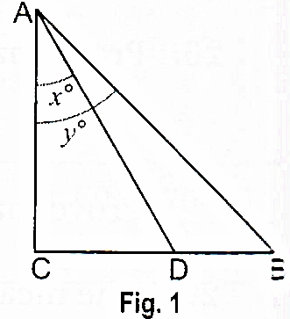
- In Fig. 1, if D is mid-point of BC, the value of tan x / tan y is
  - 1/3
  - 1
  - 2
  - ½
- If x = 3see² θ -1,y = tan² θ - 2, then x - 3y is equal to
  - 3
  - 4
  - 8
  - 5
- In Fig. 2, angle ACB = 90°, angle BDC = 90°, CD = 4 cm, BD = 3 cm, AC = 12cm. cos A - sin A is equal to
  - 5/12
  - 5/13
  - 7/12
  - 7/13
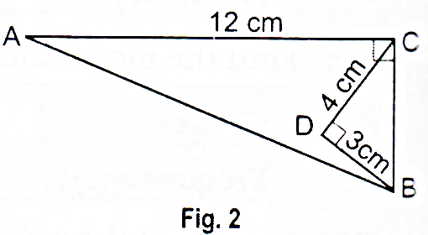
- For a given data with 50 observations the 'less than Ogive' and the 'more than Ogive' intersect at (15.5, 20). The median of the data is
  - 4.5
  - 20
  - 50
  - 15.5
- The perimeters of two similar ∆ABC and ∆LMN are 60 cm and 48 cm respectively. If LM = 8 cm, length of AB is
  - 10 cm
  - 8 cm
  - 5 cm
  - 6 cm
- If α,β are zeroes of polynomial f(x) = x ² + px + q then polynomial having 1/α and 1/β as Its zeroes is:
  - x²+qx+p
  - x²-px+q
  - qx²+px+1
  - px²+qx+1
- If a, b are co-prime, then a², b² are
  - Co-prime
  - Not co-prime
  - odd numbers
  - both equal
- n ² -1 is divisible by 8, if n is
  - an integer
  - an odd integer
  - a natural number
  - an even integer
Section - B
Question numbers 9 to 14 carry 2 marks each.
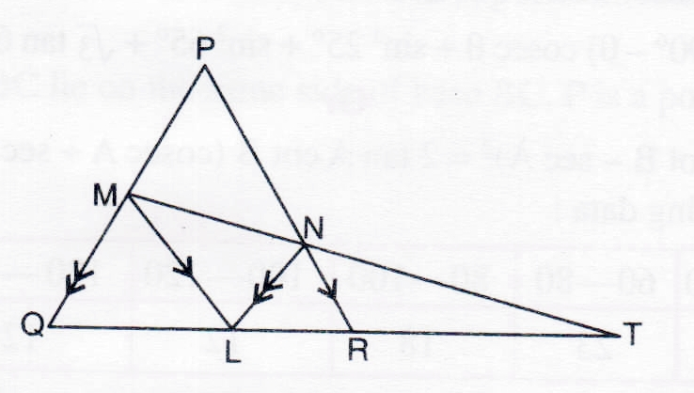
- Find the greatest number which when divided by 2053 and 967 leaves remainders 5 and 7 respectively.
- L is point on side QR of a triangle PQR. If LM // PR and LN // PQ and a line MN meets the produced line QR in T as given in figure. Prove that LT² = RT x TQ.
- If sin (2A + 45°) = cos (30° - A) and 0° < A < 90°. Find the value of A.
- The following data gives the information on the observed life span (in hours) of 225 electrical components :
Life span (m hour") | 0-20 | 20-40 | 40-60 | 60-80 | 80-100 | 100-120
Frequency | 10 | 35 | 52 | 61 | 38 | 29
Find the modal life span of the components.
- Explain why 7 x 11 x 13 + 11 is a composite number?
- If sin 3θ = cos (θ - 6°) and 3θ and θ - 6° are acute angles, find the value of θ.
Or
If sin A = cos B, can you say A and B are complementary?
Section - C
Question numbers 15 to 24 carry 3 marks each.
- If A, B, C are interior angles of ∆ABC, show that 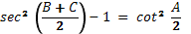
- If sin θ =m / n-, find the value of
- If2cosθ – sin θ = x and cos θ – 3 sin θ = y. Prove that 2x ² + y²- 2xy = 5.
- Find the mode of the following frequency distribution:
Class interval | 5-15 | 15-25 | 25-35 | 35-45 | 45-55 | 55-65 | 65-75
Frequency | 2 | 3 | 5 | 7 | 4 | 2 | 2
- The mean of the following frequency distribution is 25.2. Find the missing frequency x.
Class interval | 0-10 | 10-20 | 20-30 | 30-40 | 40-50
Frequency | 8 | X | 10 | 11 | 9
OR
The median of the distribution given below is 35. Find the value of x and y, if the sum all frequencies is 170.
Class | 0-10 | 10-20 | 20-30 | 30-40 | 40-50 | 50-60 | 60-70
Frequency | 10 | 20 | X | 40 | Y | 25 | 15
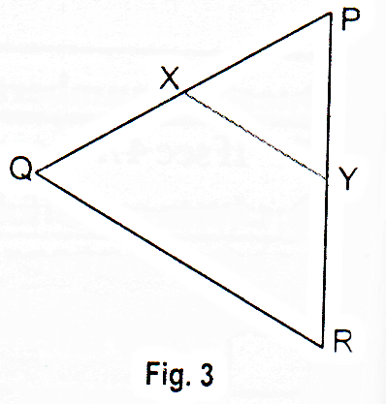
- In Fig. 3, XY // QR, PQ /XQ = 7/3 and PR = 6.3 cm. Find YR.
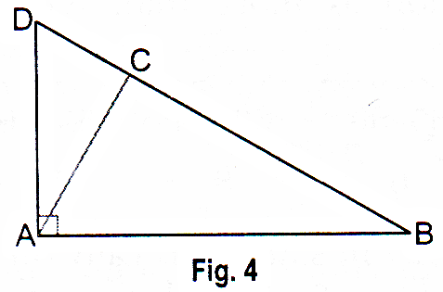
- In Fig. 4, ABD is a triangle in which angle DAB = 90° and AC ┴ BD. Prove that AC² = BC x DC.
- Show that 5 + √2 is an irrational number.
OR
Prove that √3 + √5 is irrational.
- If 4 times the area of a smaller square is subtracted from the area of a large square, the result is 144 m 2. The sum of the areas of the two squares is 464 m² Determine the sides of the two squares.
OR
Solve for x and y; x / a +y / b=2 and ax- by = a ² -b ².
- On dividing x ³ - 3x ² + X + 2 by a polynomial g(x), the quotient and remainder were x - 2 and -2x + 4 respectively. Find g(x).
Section - D
Question numbers 25 to 34 carry 4 marks each.
- Prove that, if a line is drawn parallel to one side of a triangle, the other two sides are divided in the same ratio.
- Prove that : 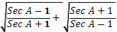 = 2 cosec A
- In a ∆ABC, angle C = 3angle B = 2(angle A + angle B). Find the three angles.
Or
The age of father is equal to the sum of ages of his 6 children. After 15 years, twice the age of the father will be the sum of the ages of his children. Find the age of father.
- The heights (in cm) of 60 persons of different age groups are shown in the following table:
Height (in cm) | 145 -150 | 150 -155 | 155 -160 | 160-165 | 165 -170 | 170-175
No. of persons | 8 | 10 | 9 | 15 | 10 | 8
Using the above table, draw (i) less than ogive (ii) more than ogive.
Or
The following table gives the daily income of 50 workers of a factory:
Daily income (in Rs) | 100-120 | 120-140 | 140-160 | 160-180 | 180-200
Number of workers | 12 | 14 | 8 | 6 | 10
Find the Mean, Mode and Median of the above data.
- If x + a is a factor of the polynomial x² + px + q and x² + mx + n, prove that a =
- Show that 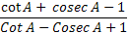 = 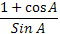
- Solve the following system of equations for x and y : 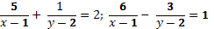
- Places A and B are 100 km apart from each other on a highway. A car starts from A and another from B at the same time. If they move in same direction, they meet in 10 hours and if they move in opposite direction, they meet in 1 hour and 40 minutes. Find the speed of the cars.
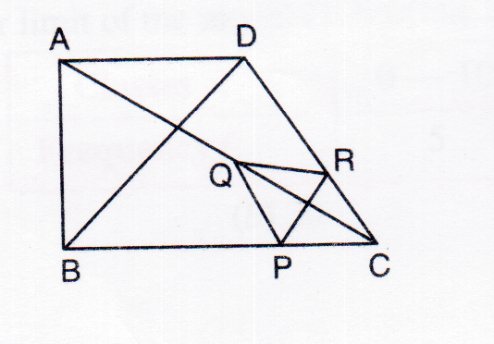
- In figure, two triangles ABC and DBC lie on the same side of base BC. P is a point on BC such that PQ // BA and PR // BD. Prove that QR // AD.
- The median of the following data is 525.
C I | 0-100 | 100-200 | 200-300 | 300-400 | 400-500 | 500-600 | 600-700 | 700-800 | 800-900 | 900-1000
Freq | 2 | 5 | x | 12 | 17 | 20 | y | 9 | 7 | 4
Find the values of x and y if the total frequency is 100.

Paper Submitted By:
Name Rahul Varshney
Email rahulpcm101@rediffmail.com
Phone No. 9759979695

