Guess Paper – 2013
Class – X
Subject – Mathematics

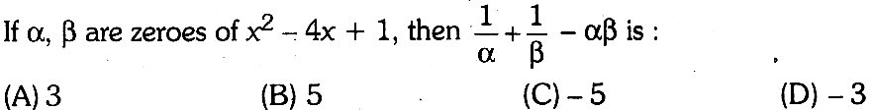
SECTION – A (1 mark each)

- The modal class of the following frequency distribution is:
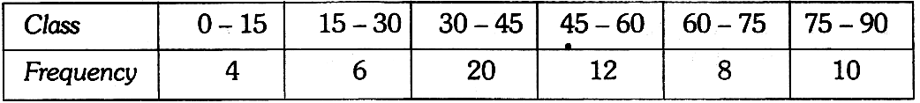
(A)15—30 (B) 45—60 (C)30—45 (D)75—90

- ΔABC ~ ΔPQR, M is the mid-point of BC and N is the mid-point of QR. If the area of ΔABC = 64 sq. cm and the area of ΔPQR 144 sq. cm. If AM = 4 cm, then PN is:
(A)6cm (B)4.8cm (C)4cm (D)l2cm
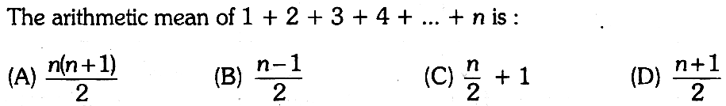

SECTION – B (2 marks each)

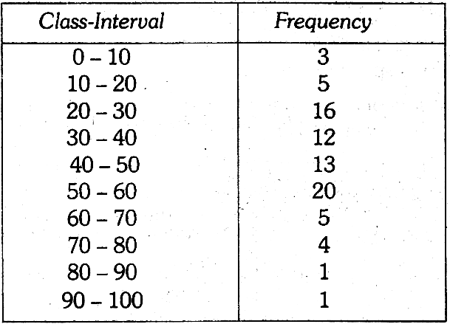
- The marks in science of 80 students of class 10 are given below. Find the mode of these marks obtained by the students in science.:

- (i) Solve for x and y: mx—ny = m² + n², x—y = 2n
(ii)

- (i) Find values of p and q for which the system of linear equations has infinite number of solutions: 3x—y = 14; (p + q)x—2qy = 5p + 2q + 1
(ii) S and U are two points on the side PQ of ΔPQR, such that QU = PS. If ST||QR and UV|| PR, then prove that TV ||PQ.

SECTION – C (3 marks each)

- The daily expenditure of 100 families are given below. Calculate f₁ and f₂, if the mean daily expenditure is Rs.188.
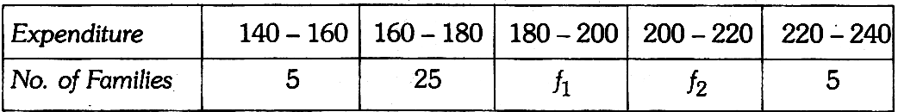.

- (i) Show that any positive odd integer is of the form 6q + 1 or 6q + 3 or 6q + 5, where q is some integer.
(ii) If the polynomial f(x) = x⁴ — 6x³ + 16x² — 25x + 10 is divided by another polynomial x² — 2x + k, the remainder comes out be x + a, find k and a.

- (i) There are some students in the two examination halls A and B. To make the number of students equal in each hall, 10 students are sent from A to B. But if 20 students are sent from B to A, the number of students in A becomes double the number of students in B. Find the number of students in the two halls.
(ii) In ΔPQR, PD⊥QR such that D lies on QR. If PQ=a, PR=b, QD=c and DR=d and a, b, c, d are positive units, prove that (a + b) (a — b) = (c + d) (c — d).

- (i) The sum of a 2 digit number and number obtained by reversing the order of digits is 99. If the digits of the number differ by 3, find the number.
(ii) In a sports meet, the number of players of football, hockey and athletics are 48, 60 and 132 respectively. Find the minimum number of rooms required, if in each room the same number of players are to be seated and all of them being in the same sports.

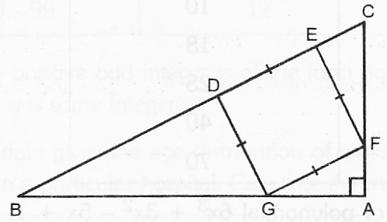
- (i) In the given figure, DEFG is a square and ∠BAC = 90°, show that DE² = BD.EC.
(ii) If α, β, γ are zeroes of polynomial 6x³ + 3x² — 5x + 1, then find the value of α⁻¹ + β⁻¹ + γ⁻¹

SECTION – D (4 marks each)

- (i) If the median of the following data is 32.5. Find the value of x and y.
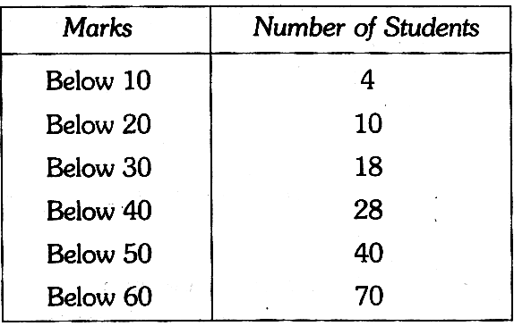
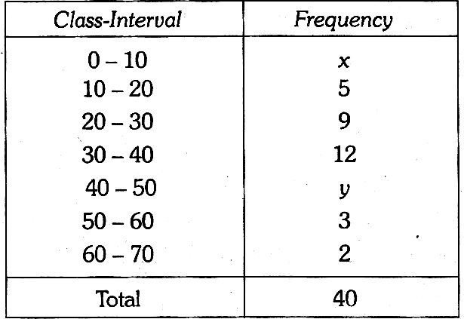
(ii) Find the mean marks from the following data:

- (i) State and prove Basic Proportionality theorem.
(ii) Use Euclid’s Division Lemma to show that the square of the any positive integer is either of the form 3m or 3m + 1 for some integer m.

- (i) Draw the graphs of the equations 4x — y —8 = 0 and 2x — 3y + 6 = 0. Also, determine the coordinates of the vertices of the triangle formed by these lines and the x-axis.
(ii) PQR is a triangle right-angled at P and M is a point on QR, such that PM ⊥ QR. Show that PM² QM.MR.
- In a right ∠ABC, right-angled at C, P and Q are the points on the sides CA and CB respectively which divide these sides in the ratio 2: 1. Prove that: (i) 9AQ² = 9AC² + 4BC² (ii) 9BP² = 9BC² + 4AC² and (iii) 9(AQ² + BP²) = 13AB²
- (i) Find all the zeroes of the polynomial 2x⁴ + 7x³ — 19x² — 14x + 30, if two of its zeroes are $\sqrt{2}$, —$\sqrt{2}$
(ii) A person travels 600 km partly by train and partly by car. If he covers 400 km by train and the rest by car, it takes 6 hours 30 minutes. But if he travels 200 km by train and the rest by car, he takes half an hour longer. Find the speed of car and that of the train.

^{Paper Submitted By:}

^{Name} ^{Vandana bansal}
^{Email} vandanakukreja.bansal@gmail.com
^{Phone No.} ⁰⁹⁸⁵⁵¹⁸⁸⁷⁹⁷

