Sample Paper – 2013
Class – IX
Subject – Mathematics

Time: 3 hrs Marks: 90
General Instructions:
- All questions are compulsory.
- The question paper is of 34 questions divided into four sections –A, B, C and D. Section A contains 8 questions of 1 marks each. Section B is of 6 questions of 2 marks each , section C is of 10 questions of 3 marks each and Section D is of 10 questions of 4 marks.
- There is no overall choice. However ,internal choice has been provided in 2 questions of three marks each and 3 questions of four marks each.
- Question numbers 1 to 10 in section A are multiple choice questions where you are to select one correct option out of given four.

Section- A

- Decimal representation of 1/9 is (a) (b) (c) (d)

- If p(x) = 4x²+3x+7/2, then the value of p (-3/2) is equal to: (a) 2 (b) 4 (c) 6 (d) 8.

- If is divided by x+1, the remainder is: (a) 1 (b) 0 (c) -1 (d) 2.

- The value of p(x) =3x²-1 at x=- is (a) -2 (b) 2 (c) -1 (d) 0.

- In the given figure, if then is:(a) (b) (c) (d)
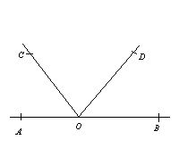
myguru@coolguru.net www.coolGuru.net

- Two sides of a triangle are 8 cm and 3 cm. Third side of the triangle cannot be : (a) 4 cm (b) 6 cm (c) 5.5 cm (d) 6.5 cm.

- The perimeter of a triangle is 30cm.If its sides are in the ratio 1:3:2 then its smallest side is: (a) 1cm (b) 5cm (c) 10cm (d) 15cm.

- The area of an equilateral triangle whose sides are 6cm. (a) 6√3cm² (b) 9√3cm² (c) 12√3cm² (d) 15√3cm².

Section-B

- Find two irrational numbers between 3 and 4.

- Simplify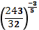.
- If 2a + 3b = 13 and ab = 6, find the value of .

- In the given figure, line XY and MN intersect at O. IF and a : b = 4:5, find c.

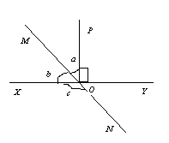
- State five postulates of Euclid
.
- Write the coordinate point (i) below x-axis, lying on y axis at a distance of 5 units (ii) lying on x-axis to the left of origin at a distance of 6 units.

Section-C

- Simplify

- Represent on the number line.

- Factorize a³-3a²+3a+7.

- In If
OR
Factorise (x²-y²)³+(y²-z²)³+(z²-x²)³

- In the given figure, OP bisects BOC and OQ bisects AOC, show that POQ=90⁰

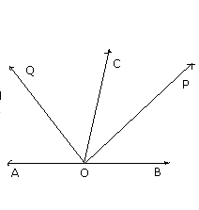

- Prove that medians bisecting the equal sides of an isosceles triangle are also equal. OR If two parallel lines are intersected by a transversal, show that the bisectors of any pair of alternate interior angles are parallel.

- In the given figure, OB and OC are bisectors of and , find x and y.
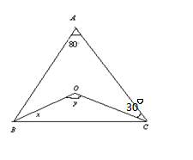

- In Figure two straight lines PQ and RS intersect each other at O. If ∠ POT = 75º, find the values of a,b and c.

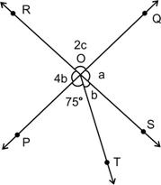

- In the given figure, ABCD is a quadrilateral in which AB || DC and P is the midpoint of BC. On producing, AP and DC meet at Q.
Prove that
(i) AB = CQ, (ii) DQ = DC + AB.
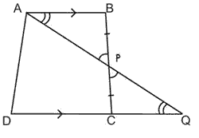

- The sides of a triangle are in the ration of 13 : 14 : 15 and its perimeter is 84 cm. Find the area of the triangle. Also find the altitude of the triangle corresponding to the longest side.

Section-D
- If the Find the values of a and b 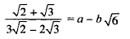
OR
If x = 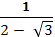 , find the value of x³ – 2x² -7x + 5

- Find the values of a and b if 2√6 - √5 = a + b √30 .
√45 - √24

- If f(x)= is divided by (x-1) and (x+1) the remainders are 5 and 19. Determine the remainder when f(x) is divided by (x-2). OR Evaluate 103 x 107 and factorize 1-p⁶.

- Using the factor theorem, factorize the polynomial
x⁴ + 2x³ – 13x² – 14x + 24.

- Factorize: 8x⁴ + 2x² -1.

- Side BC of a triangle ABC is produced to a point D as shown in figure. The bisector of meets BC at L. Prove that
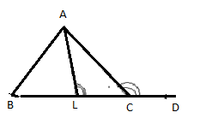
- Prove that side opposite to greater angle is the longer.
- If O is any point in the interior of ∆ABC. Prove that OA+OB+OC> (AB+BC+CA).

- ABC is a triangle, in which altitudes BE and CF to sides AC and AB are equal. Show that ΔABE≅ ΔACF. Also show that ΔABC is an isosceles triangle.
OR .
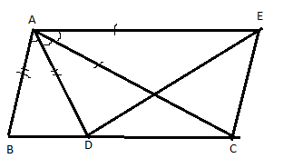
In the given figure AB = AD, AC=AE and ∠BAD = ∠CAE. Prove that BC= DE.
- Plot the following (-1,0) (1,0) (1,2) (-1,2) . Find the perimeter of the figure so formed.

Paper Submitted By:

Name Coolguru.net
Email myguru@coolguru.net
Phone No. (650) 762-6654

