Sample Paper – 2013
Class – IX
Subject – Science
Matter in Our Surroundings

Question 1 ( 1.0 marks)
State whether True or False.
(i) Water has no definite shape; therefore, it is not matter.
(ii) Gases expand to fill the space available.
Solution:
(i) False
(ii) True
Question 2 ( 1.0 marks)
A substance has a definite volume, but no definite shape. State whether this substance is solid, liquid or gas.
Solution:
Liquid
Question 3 ( 1.0 marks)
Which physical state of matter is the densest?
Solution:
Solid
Question 4 ( 2.0 marks)
What are the different factors affecting evaporation?
Solution:
Different factors affecting evaporation:
(i) Surface area
(ii) Temperature
(iii) Wind speed
(iv) Humidity
Question 5 ( 2.0 marks)
The following figure shows a block of ice. Give two reasons as to why this block is considered as matter.

Solution:
The block of ice is considered as matter because:
(i) It occupies space
(ii) It has a definite mass
Question 6 ( 2.0 marks)
Why does matter change state?
Solution:
Temperature determines the state of a substance. Change of state takes place because the molecules of matter that make up a substance vibrate faster when the substance is heated. When heated, the solid state changes into the liquid state, and the liquid state changes into the gaseous state.
When cooled, the gaseous state condenses into the liquid state, and the liquid state condenses into the solid state.
Question 7 ( 2.0 marks)
It is observed that water boils at lower temperature at higher altitudes. Why?
Solution:
Atmospheric pressure is much less at higher altitudes. So, less thermal energy is required to get the vapour pressure equal to the atmospheric pressure. Hence, water boils at lower temperature at higher altitudes.
Question 8 ( 2.0 marks)
If some alcohol is rubbed on the hand, the rubbed portion of the hand feels cool. Why?
Solution:
Alcohol is a volatile liquid. It evaporates at room temperature. When it is rubbed on the hand, it draws heat from the skin and evaporates into the surroundings. As a result, the rubbed portion of the hand feels cool.
Question 9 ( 3.0 marks)
Name the following.
(i) State of matter having the maximum intermolecular space
(ii) Force between particles of matter
(iii) State of matter with only one free surface
Solution:
(i) Gaseous state
(ii) Cohesive force
(iii) Liquid
Question 10 ( 3.0 marks)
A large crystal of potassium permanganate is kept in a glass beaker containing water. This setup is then left undisturbed for an hour. The solution undergoes a change in colour.
(i) What is this change in colour?
(ii) Why does such a change take place?
Solution:
(i) The solution is colourless at the beginning. After some time, the water at the bottom becomes dark pink, while that at the top becomes light pink. After some more time, the entire solution becomes dark pink in colour.
(ii) Reason for the change in colour:
The crystals of potassium permanganate sink to the bottom and get dissolved in water. Gradually, the molecules of the solid move up to occupy the intermolecular spaces of the liquid.
Is Matter Around Us Pure

Question 1 ( 1.0 marks)
Fill in the blank.
The mixing of gases is called _________.
Solution:
The mixing of gases is called diffusion.
Question 2 ( 2.0 marks)
A mixture of sugar and water is homogenous.
Justify this statement.
Solution:
A mixture of sugar and water is homogenous because:
(i) Salt particles do not form a separate layer
(ii) Salt particles cannot be separated by filtration
Question 3 ( 2.0 marks)
Mention two characteristics of a pure substance.
Solution:
A pure substance has a:
(i) Homogenous nature
(ii) Definite set of properties
Question 4 ( 2.0 marks)
Why are alloys considered as mixtures?
Solution:
An alloy is a homogenous mixture of metals. It is considered as a mixture because each of its constituents retains its chemical properties. Moreover, in an alloy, the constituents do not have a fixed ratio.
Question 5 ( 3.0 marks)
State whether True or False.
(i) An element can be broken down further.
(ii) Two miscible liquids can be separated by using a separating funnel.
(iii) The inter-conversion of the states of matter is a physical change.
(iv) The particles of a true solution are smaller than 1 nm.
(v) Colloidal solutions show Tyndall effect.
(vi) Cream can be separated from milk by the process of filtration.
Solution:
(i) False
(ii) False
(iii) True
(iv) True
(v) True
(vi) False
Question 6 ( 3.0 marks)
Fill in the blanks.
(i) Oil is separated from water with the help of a __________.
(ii) Cream and milk are separated by ___________.
(iii) Camphor and salt are separated by __________.
Solution:
(i) Oil is separated from water with the help of a separating funnel.
(ii) Cream and milk are separated by centrifugation.
(iii) Camphor and salt are separated by sublimation.
Question 7 ( 3.0 marks)
Name the following.
(i) Solution having particle size smaller than 1 nm
(ii) Composed of two or more elements, chemically combined with one another in a fixed proportion
(iii) Technique used for separating sand from water
Solution:
(i) True solution
(ii) Compound
(iii) Filtration
Question 8 ( 3.0 marks)
Give one example of each of the following mixtures.
(i) Liquid in liquid
(ii) Solid in solid
(iii) Solid in liquid
Solution:
(i) Milk
(ii) Gemstone
(iii) Jelly
Question 9 ( 3.0 marks)
If 20 g of sugar is dissolved in 300 g of water, then what is the concentration of the solution in terms of mass percentage?
Solution:
Mass of the solute (sugar) = 20 g
Mass of the solvent (water) = 300 g
Mass of the solution = Mass of the solute + Mass of the solvent
= 20 g + 300 g
= 320 g
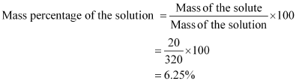
Question 10 ( 3.0 marks)
How can a mixture of powdered rock salt and chalk be separated?
Solution:
The mixture of powdered rock salt and chalk can be separated by first shaking the mixture in water, and then keeping the solution undisturbed for a few minutes.
The salt will dissolve in water, while the chalk powder will remain at the bottom. On filtering the solution, chalk powder will be obtained as residue. The rock salt can then be re-obtained by evaporating the filtered salt solution.
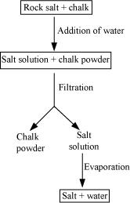

The Fundamental Unit of Life

Question 1 ( 1.0 marks)
Name any three basic structures present in both plant and animal cells.
Solution:
Cell membrane, nucleus and cytoplasm are present in all types of cells.
Question 2 ( 1.0 marks)
Give an example of diffusion from daily life.
Solution:
The scent from an open bottle of perfume diffuses in the room. Its particles diffuse towards the region where it is in low concentration.
Question 3 ( 1.0 marks)
Name the process by which an amoeba acquires its food.
Solution:
Endocytosis
Question 4 ( 2.0 marks)
Differentiate between diffusion and osmosis.
Solution:
- | Diffusion | - | Osmosis
(i) | It is the movement of molecules from a region of higher concentration to a region of lower concentration. | (i) | It is a special case of diffusion wherein the medium is water.
(ii) | It does not require a membrane. | (ii) | It requires a semi permeable membrane.
Question 5 ( 2.0 marks)
Explain how cell wall prevents the bursting of a cell.
Solution:
When a plant cell is placed in a hypotonic (dilute) media, the cell tends to take in water from the media and swell. As the cell swells, pressure is built up against the cell wall. The cell wall exerts an equal pressure against the swollen cell, thereby preventing the cell from bursting.
Question 6 ( 2.0 marks)
What is a prokaryotic cell? Give two examples of prokaryotes.
Solution:
A prokaryotic cell is one which lacks a true nucleus, i.e., the nucleus material is scattered within the cell as the nuclear membrane is absent.
Two examples of prokaryotes: bacteria and blue-green algae
Question 7 ( 3.0 marks)
What are plastids? Classify plastids into various types.
Solution:
Plastids are the cell organelles present exclusively in plants. They are made up of two distinct regions − grana and stroma. Plastids are basically of two types.
(i) Chromoplasts − These are coloured plastids. They contain various pigments. The chromoplast containing the pigment chlorophyll is called chloroplast. Chloroplast is the site for photosynthesis.
(ii) Leucoplasts − These are colourless plastids. In them, materials such as starch, oils and protein granules are stored.
Question 8 ( 3.0 marks)
Differentiate between plant and animal cells.
Solution:
- | Animal cells | - | Plant cells
(i) | Animal cells are generally smaller in size. | (i) | Plant cells are usually larger than animal cells.
(ii) | Cell wall is absent. | (ii) | Cell wall surrounds the plasma membrane.
(iii) | Plastids are not present in animal cells. | (iii) | Plastids are present in plant cells.
(iv) | Vacuoles in animal cells are smaller in size. | (iv) | Vacuoles are larger in size. A large central vacuole is present.
(v) | Animal cells have a single, highly complex Golgi apparatus. | (v) | Plant cells have many units of Golgi apparatus called dictyosomes.
 | 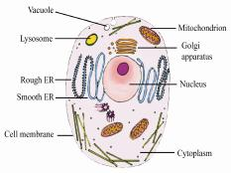 |  | 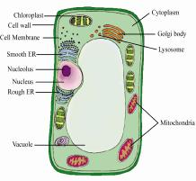
Question 9 ( 5.0 marks)
Explain the structures of the nucleus and its components with the help of a diagram. Write the function of each component.
Solution:
The components of a nucleus are shown in the following diagram.
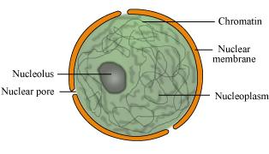
(i) Nuclear membrane − It is a double-layered membrane with pores in it. It separates the contents of the nucleus from the cytoplasm. The nuclear pores allow the movement of specific substances in and out of the nucleus.
(ii) Nucleoplasm − It is a homogenous and dense fluid present inside the nucleus. Chromatin and nucleolus are suspended in the nucleoplasm.
(iii) Chromatin − Chromatin network is an entangled mass of thread-like structures. At the time of cell division, chromatin gets organised into chromosomes. The DNA present on them contains genes, which are the functional units of heredity. DNA is concerned with the transmission of hereditary information.
(iv) Nucleolus − It is rich in proteins and RNA molecules, and is the site of ribosome formation.
Question 10 ( 5.0 marks)
Explain the effects of placing a plant cell in hypertonic, hypotonic and isotonic salt solutions.
Solution:
Cell in a hypertonic solution
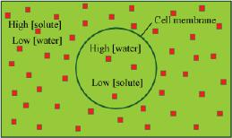
A hypertonic solution is concentrated. It has a higher concentration of solute molecules and lower concentration of water molecules than the plant cell kept in it. The water will tend to move from the region of higher concentration to the region of lower concentration, i.e., from the plant cell to the solution. As a result, the plant cell will lose water and shrink.
Cell in a hypotonic solution
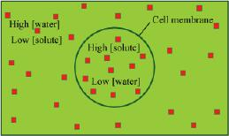
A hypotonic solution is more dilute. It has a higher concentration of water than the plant cell kept in it. So, the water will move from the solution to the plant cell. As a result, the plant cell will gain water and swell.
Cell in an isotonic solution
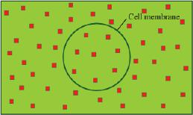
An isotonic solution has exactly the same concentration of water as the plant cell kept in it. So, there will be no net movement of water across the plasma membrane and the cell will neither gain water nor lose water. Hence, its size will remain the same.

Motion
Question 1 ( 1.0 marks)
What does the speedometer of a car measure?
Solution:
The speedometer of a car measures instantaneous speed.
Question 2 ( 1.0 marks)
A body is moving in a circular path. It returns to the position from where it started. What is the displacement of the body?
Solution:
The displacement of the body is the shortest distance between its initial and the final positions. Hence, the displacement of the body is zero.
Question 3 ( 1.0 marks)
The velocity−time graph of a body is as shown in the given figure. What is its acceleration?
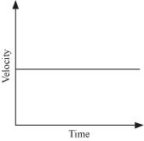
Solution:
The acceleration of the body is zero.
Question 4 ( 2.0 marks)
Can the distance covered by a moving body ever be zero? If yes, then give an example.
Solution:
No. The distance covered by a moving body can never be zero.
Question 5 ( 2.0 marks)
What do you understand by ‘uniform circular motion’?
Solution:
When a body moves in a circular path with uniform speed (constant speed), its motion is called uniform circular motion.
Question 6 ( 2.0 marks)
On pressing the accelerator of a car, its velocity increases from 20 km/h to 60 km/h at a constant rate. What is the average velocity of the car during this interval?
Solution:
Here,
Initial velocity of the car, u = 20 km/h
Final velocity of the car, v = 60 km/h
Average velocity is defined as
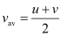
Therefore, average velocity of the car, 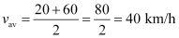
Question 7 ( 3.0 marks)
What is the difference between instantaneous speed and average speed?
Solution:
The average speed of a body is the total distance covered by it divided by the total time taken to cover this distance, whereas the instantaneous speed of a body is its speed at a particular instant of time.
Question 8 ( 3.0 marks)
The given graph shows how the speed of a car changes with time.
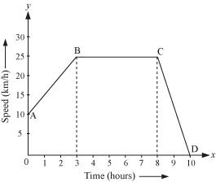
Answer the following questions.
(i) What is the initial speed of the car?
(ii) What is the maximum speed attained by it?
(iii) Which part of the graph shows zero acceleration?
Solution:
(i) The initial speed of the car is 10 km/h.
(ii) The maximum speed attained by it is 25 km/h.
(iii) The part BC of the graph shows zero acceleration.
Question 9 ( 5.0 marks)
A car travelling at a uniform speed of 20 m/s approaches a signal. The driver applies the brake and the car retards uniformly at the rate of 2 m/s². How much time will be taken by the car to come to rest?
Solution:
Here,
Initial speed of the car, u = 20 m/s
Acceleration of the car, a = −2 m/s²
From the 1st equation of motion, we have
v = u + at
0 = 20 − (2) t
Or, 2t = 20
Or, t = 10 s
Therefore, the car will come to rest 10 s after the application of the brake.
Question 10 ( 5.0 marks)
A man takes two steps forward and one step backward in one second. If the length of his step is 0.5 m, then what is the distance covered by him in 10 seconds? Also calculate his displacement at the end of this time period.
Solution:
In one second, the man takes a total of 3 steps.
Therefore, in 10 s, the man takes a total of (3 × 10) steps = 30 steps
Distance covered with one step = 0.5 m
Therefore, in 10 s, the man covers a total distance of (30 × 0.5) m = 45 m
Net displacement in one second = [(2 − 1) × 0.5] m = 1 × 0.5 m
Therefore, net displacement in 10 s = (10 × 0.5) m = 5 m
-------------------------------------!@#$%^&*()_++_)(*&^%$#@!------------------------------ BY,
“RACHIT AGRAWAL”
Website: www.rachitagrawal.weebly.com

