Sample Paper – 2013
Class – XII
Subject – INFORMATICS PRACTICES - PRACTICAL
TIME : 1Hrs. M.M. 30
Q1. (a). Read the following case study and answer the questions that follow :
The Shop n Store has developed the following data entry screen for its operations. The store offers
three different types of membership discount schemes for its regular customers. Platinum members
get a discount of 10% on all their purchases, Gold members get 5% and Silver members get 3%
discount.
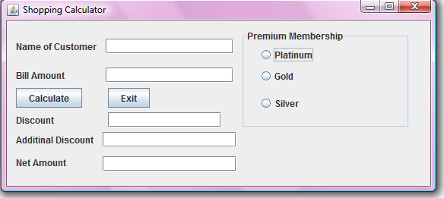
The list of controls for above interface is as follows:
Object Type | Object Name | Description
Text Field | ProducTF  QtyTF  RateTF  AmountTF  DiscountTF  NetTF | To enter name of the product  To enter quantity Sold  To enter rate per unit  To display total amount as quantity *rate  To display the discount amount based on membership type  To display net amount as amount-discount
Radio Buttons | PlatinumRB  GoldRB  SilverRB | To Specify the Member Ship Type
Button | CalcBTN  ExitBTN | To Calculate the amount, discount and net amount  To Close the Application
(i).Write the code to disable the text fields AmountTF, DiscountTF and NetTF. [1.0]
(ii).Write the code for CalcBTN to calculate the amount, discount and net amount as per given [2.5]
descriptions and conditions.
(iii).Write the code for ExitBTN to close the application, but before the application is closed it [1.5]
should check the net amount and if the net amount > 10,000 the membership of the customer
should be upgraded and displayed. For example, if the customer already has Silver membership
it should be upgraded Gold membership (similarly from gold to platinum) and he informed of
the same using a message box.
Q2 Define a class Book with the following specifications :
Data Members of the Book are :
BOOK_NO INTEGER
BOOK_TITLE STRING
NO_OF_BOOKS INTEGER
PROCE FLOAT(PRICE PER COPY)
TOTAL_COST() A function to calculate the total cost for number of
copies. Member methods of the class book are :
(1) [P.T.O]
INPUT() Function to read No of Books, Book_title, price.
The following is the screen used to declare class to calculate total cost :
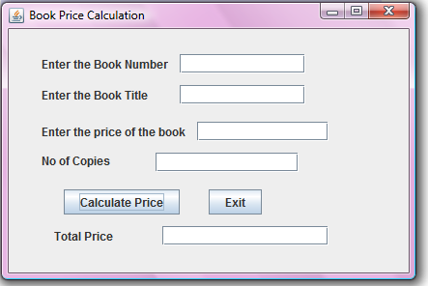
The list of controls for the above form is as follows :
Control Type | Control name | Property Value
JTextField | JTextField1  JTextField2  JTextField3  JTextField4  JTextField5 | txtBNo  txtBName  txtPrice  txtNo  txtTotal
JButton | JButton1  JButton2 | Calculate price  Exit
(i). Define a class Book with required specification. [2.5]
(ii). Write the code for calculate Price buttons click event procedure to operate the class Book’s [2.0]
method.
(iii).Write the code for Exit Button to exit application. [0.5]
Q3. (a). Write SQL Commands for (a) to (e) and write the outputs for (f) on the basis of table :[1x10=10]
Table : FURNITURE
NO | ITEM NAME | TYPE | DATEOFSTOCK | PRICE | DISCOUNT
1 | White Lotus | Double Bed | 2002-02-23 | 3000 | 25
2 | Pink feathers | Baby Cot | 2002-01-29 | 7000 | 20
3 | Dolphin | Baby Cot | 2002-02-19 | 9500 | 20
4 | Decent | Office Table | 2002-02-01 | 25000 | 30
5 | Comfort zone | Double Bed | 2002-02-12 | 25000 | 30
6 | Donald | Baby cot | 2002-02-24 | 6500 | 15
7 | Royal Finish | Office Table | 2002-02-20 | 18000 | 30
8 | Royal tiger | Sofa | 2002-02-22 | 31000 | 30
9 | Econo sitting | Sofa | 2001-12-13 | 9500 | 25
10 | Eating Paradise | Dinning Table | 2002-12-19 | 11500 | 25
- To show all the information about the Baby cots from the furniture table.
- To list the itemname which are priced at more than 15000 from the furniture table.
- To list itemname and type of those items, in which dateofstock is before 2002-02-01 from the furniture table in descending order of itemname.
(2)
- To display itemname and dateofstock of those items, in which the discount percentage is more than 25 from the furniture table.
- To count the number of items, whose TYPE is “Sofa” from the furniture table.
- Give the output of following SQL statement :
(i). select count (distinct type) from furniture;
(ii). Select max(discount) from furniture;
(iii). Select avg(discount) from furniture where type=”Baby Cot”;
(iv). Select sum(price) from furniture where dateofstock < ’2002-02-12’;
(v). Select count (*) from furniture;
Q4. Study the following tables Doctor and Salary and write SQL Commands [1x4=4]
Table : DOCTOR
ID | NAME | DEPT | SEX | EXPERIENCE
101 | John | ENT | M | 12
104 | Smith | ORRHPEDIC | M | 5
107 | George | CARDIOLOGY | M | 10
114 | Lara | SKIN | F | 3
109 | K George | MEDICINE | F | 9
105 | Johnson | ORRHPEDIC | M | 10
117 | Lucy | ENT | F | 3
111 | Bill | MEDICINE | F | 12
130 | Morphy | ORRHPEDIC | M | 15
Table : SALARY
ID | BASIC | ALLOWANCE | CONSULTATION
101 | 12000 | 1000 | 300
104 | 23000 | 2300 | 500
107 | 32000 | 4000 | 500
114 | 12000 | 5200 | 100
109 | 42000 | 1700 | 200
105 | 18900 | 1690 | 300
130 | 21700 | 2600 | 300
(a). Display NAME of all doctors who are in “MEDICINE” having more than 10 years experience and
basic more than 10000.
(b). Display the average of all doctors working in “ENT” department using the DOCTOR and where as
salary=basic + allowance
(c). Display the minimum ALLOWANCE of female doctors.
(d). Display the highest consultation fee among all male doctors.
Q5. Write the resulting output of the following : [0.5 X 6 = 3]
(a). Select SUBSTR(‘NetBeans IDE Programmer’, 10,3);
(b). select INSTR(TRIM(‘ ABS Public School ‘)5);
(c). select 200 + SQRT(144);
(d).select MOD ( ROUND ( 125.60,1) , 5 );
(e). select LEFT(‘RAMESH SHARMA’ , 5);
(f). select ROUND(1045.439 , 2) + MOD (12.12 , 3)

(3) [P.T.O]

Q6). Write the html code to display the following controls : [3]
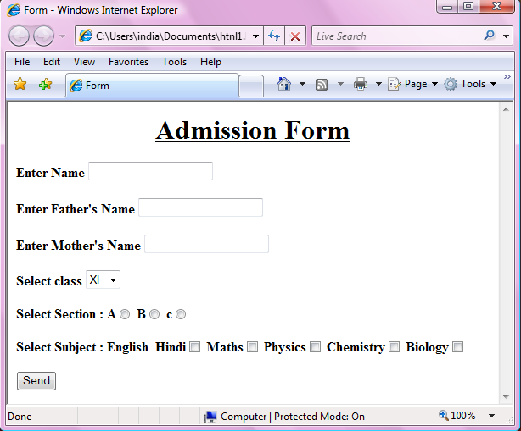
GAGAN KUMAR AGARWAL
PGT[IP]
UDAISHWAR PUBLIC SCHOOL, JWALAPUR, HARDWAR
PHONE NO : 9758777202
EMAIL ID: gagan_agarwal2006@hotmail.com

------------------------------------------------ --------------------------------------------------

