Guess Paper – 2013
Class – X
Subject – Information Technology

- What do you mean by FONT Element?
- Write a HTML code for the following output: -
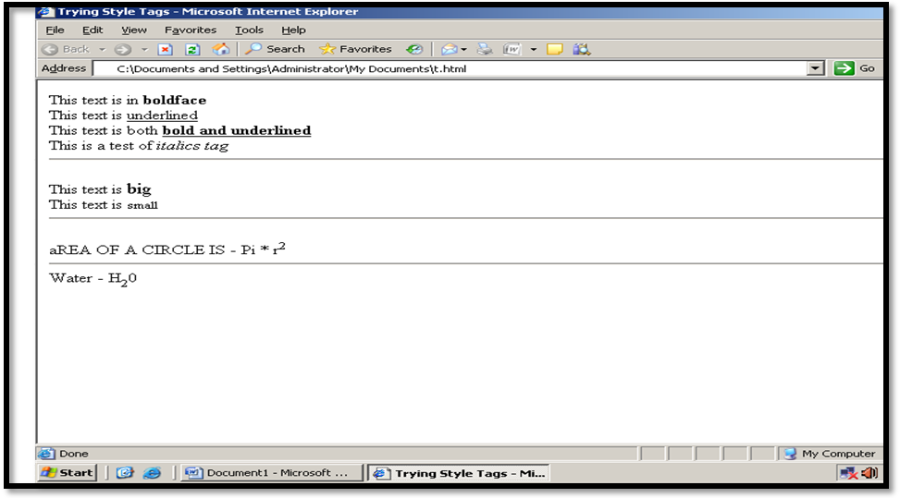

- Title of the web page is trying style tag.
- Horizontal rule size is 5, color is black.
- All fonts should be in “Times New Roman”, Size is 12.
- Alignment of text is Left.
- Essential elements you use as per requirements.
- What are the differences between the BGCOLOR & BACKGROUND attribute in BODY Element?
- Explain all attribute of FONT Element in HTML?
- Find out the error from the following codes: -
- <FONT FACE = “rose.gif”, SIZE = 15>
- <BODY BACKGROUND = “red”>
- <IMG SRC = “ Times New Roman”>
- What do you mean by paragraph tag? Explain with suitable example.
- How many heading level supported by HTML document.
- What are the differences between the <EM> and <STRONG> tag?

Paper Submitted By:
Name Jitender Singh
Email jsinghg21@gmail.com
Phone No. 9713323879

