Guess Paper - 2013
Class – XII
Subject – INFORMATICS PRACTICES
HALF-YEARLY EXAMINATION
TIME : 3Hrs. M.M. 70
Q1. (a). Which Protocol is used for transfer of hypertext documents of the Internet? [1]
(b). Two doctors in the same room have connected their Palm Tops using Bluetooth for working on a [1]
group presentation. Out of the following what kind of network they have formed?
LAN, MAN, PAN, WAN
(c). Arrnge the following communication channels in ascending order of their data transmission rates. [1]
Ethernet Cable, Optical Fibre, Telephone Cable, Co-axial Cable.
(d). Which of the following is not a characteristic of Open Source Software? [1]
- Its source code is available for modification
- Its owned by a company or an individual
- It can be download from Internet
(e). Jai Khanna is confused between the terms Domain Name and URL Explain the difference with [2]
the help of appropriate examples of each.
(f). Define any two threats to Network Security. [2]
(g). Differentiate between Star and Bus Topology of networks. [2]
Q2. (a). Ms. Sunita has developed a Java application through which the students of her school can view their
marks by entering their admission number. The marks are displayed in various text fields. What should
she do so that the students are able to view but not change their marks in text fields? [1]
(b). What is the purpose of default clause in a switch statement? [1]
(c). What is the use of <CENTER> tag in an HTML document? [1]
(d). What is XML? [1]
(e). What will be values of x and y after execution of the following code : [2]
int x, y = 0;
for( x= 1; x<=5; ++x)
y=x++;
--y;
(f). Write a function in Java that takes principal, rate and time as parameter and returns Simple [2]
Interest.
(g). Mention the purpose of each of the following HTML tags : [2]
<B>, <LI>, <HR>, <TABLE>
Q3. (a). Which Command is used in MySQL to make the changes in database permanent? [1]
(b). While Creating a table ‘Customer’ Simrita forget the set of primary key for the table. Give [1]
the statement which she should write now to set the column ‘CustID’ as the primary key of the table?
(c). What is the purpose of the following SQL query : [1]
SELECT MAX ( SALARY) FORM EMP;
(d). Rama is not able to change a value in a column to NULL. What constraint did she specify when [1]
she created the table.
(e). In a student table, out of RollNumber, Name, Address which column can be set as Primary key [2]
and Why?
(f). The Item_No and Cost columns of a table “ITEMS” are given below : [2]
ITEM_NO | COST
101 | 5000
102 | NULL
103 | 4000
104 | 6000
105 | NULL

(g). A table “stock” in a database has 5 columns and constraints 17 records. What is the degree and [2]
cardinality of this table.
Q4. (a). Define Inheritance with reference to Object Oriented Programming. [1]
(b). Read the following case study and answer the questions that follow :
The Shop n Store has developed the following data entry screen for its operations. The store offers
three different types of membership discount schemes for its regular customers. Platinum members
get a discount of 10% on all their purchases, Gold members get 5% and Silver members get 3%
discount.
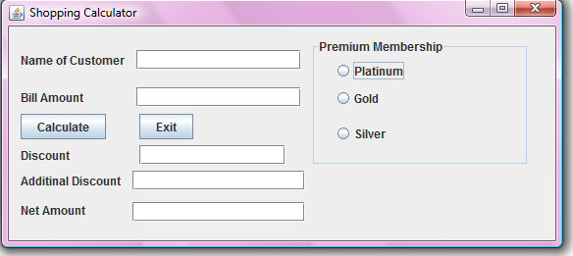
The list of controls for above interface is as follows:
Object Type | Object Name | Description
Text Field | ProducTF  QtyTF  RateTF  AmountTF  DiscountTF  NetTF | To enter name of the product  To enter quantity Sold  To enter rate per unit  To display total amount as quantity *rate  To display the discount amount based on membership type  To display net amount as amount-discount
Radio Buttons | PlatinumRB  GoldRB  SilverRB | To Specify the Member Ship Type
Button | CalcBTN  ExitBTN | To Calculate the amount, discount and net amount  To Close the Application
(i). Write the code to disable the text fields AmountTF, DiscountTF and NetTF. [0.5]
(ii). Write the code for CalcBTN to calculate the amount, discount and net amount as per given [2.0]
descriptions and conditions.
(iii). Write the code for ExitBTN to close the application, but before the application is closed it [1.5]
should check the net amount and if the net amount > 10,000 the membership of the customer
should be upgraded and displayed. For example, if the customer already has Silver membership
it should be upgraded Gold membership (similarly from gold to platinum) and he informed of
the same using a message box.
(c). Define a class Book with the following specifications :
Data Members of the Book are :
BOOK_NO INTEGER
BOOK_TITLE STRING
NO_OF_BOOKS INTEGER
PROCE FLOAT(PRICE PER COPY)
TOTAL_COST() A function to calculate the total cost for number of copies.
Member methods of the class book are :
INPUT() Function to read No of Books, Book_title, price.
The following is the screen used to declare class to calculate total cost :
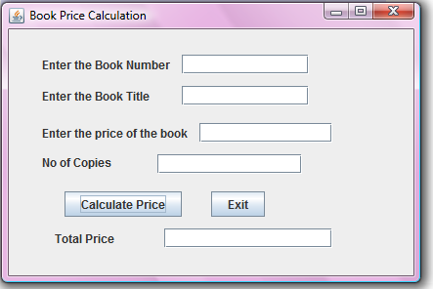
The list of controls for the above form is as follows :
Control Type | Control name | Property Value
JTextField | JTextField1  JTextField2  JTextField3  JTextField4  JTextField5 | txtBNo  txtBName  txtPrice  txtNo  txtTotal
JButton | JButton1  JButton2 | Calculate price  Exit
(i). Define a class Book with required specification. [2.0]
(ii). Write the code for calculate Price buttons click event procedure to operate the class Book’s [1.5]
method.
(iii). Write the code for Exit Button to exit application. [0.5]
(d). Rewrite the following code using a for loop : [1]
int i=1, sum=0;
while (i<10)
{
sum+=i;
i+=2;
}
Q5. (a). Write SQL Commands for (a) to (e) and write the outputs for (f) on the basis of table : [1x10=10]
Table : FURNITURE
NO | ITEM NAME | TYPE | DATEOFSTOCK | PRICE | DISCOUNT
1 | White Lotus | Double Bed | 2002-02-23 | 3000 | 25
2 | Pink feathers | Baby Cot | 2002-01-29 | 7000 | 20
3 | Dolphin | Baby Cot | 2002-02-19 | 9500 | 20
4 | Decent | Office Table | 2002-02-01 | 25000 | 30
5 | Comfort zone | Double Bed | 2002-02-12 | 25000 | 30
6 | Donald | Baby cot | 2002-02-24 | 6500 | 15
7 | Royal Finish | Office Table | 2002-02-20 | 18000 | 30
8 | Royal tiger | Sofa | 2002-02-22 | 31000 | 30
9 | Econo sitting | Sofa | 2001-12-13 | 9500 | 25
10 | Eating Paradise | Dinning Table | 2002-12-19 | 11500 | 25
- To show all the information about the Baby cots from the furniture table.
- To list the itemname which are priced at more than 15000 from the furniture table.
- To list itemname and type of those items, in which dateofstock is before 2002-02-01 from the furniture table in descending order of itemname.
- To display itemname and dateofstock of those items, in which the discount percentage is more than 25 from the furniture table.
- To count the number of items, whose TYPE is “Sofa” from the furniture table.
- Give the output of following SQL statement :
(i). select count (distinct type) from furniture;
(ii). Select max(discount) from furniture;
(iii). Select avg(discount) from furniture where type=”Baby Cot”;
(iv). Select sum(price) from furniture where dateofstock < ’2002-02-12’;
(v). Select count (*) from furniture;
Q6. Study the following tables Doctor and Salary and write SQL Commands [1x4=4]
Table : DOCTOR
ID | NAME | DEPT | SEX | EXPERIENCE
101 | John | ENT | M | 12
104 | Smith | ORRHPEDIC | M | 5
107 | George | CARDIOLOGY | M | 10
114 | Lara | SKIN | F | 3
109 | K George | MEDICINE | F | 9
105 | Johnson | ORRHPEDIC | M | 10
117 | Lucy | ENT | F | 3
111 | Bill | MEDICINE | F | 12
130 | Morphy | ORRHPEDIC | M | 15
Table : SALARY
ID | BASIC | ALLOWANCE | CONSULTATION
101 | 12000 | 1000 | 300
104 | 23000 | 2300 | 500
107 | 32000 | 4000 | 500
114 | 12000 | 5200 | 100
109 | 42000 | 1700 | 200
105 | 18900 | 1690 | 300
130 | 21700 | 2600 | 300
(a). Display NAME of all doctors who are in “MEDICINE” having more than 10 years experience and
basic more than 10000.
(b). Display the average of all doctors working in “ENT” department using the DOCTOR and where as
salary=basic + allowance.
(c). Display the minimum ALLOWANCE of female doctors.
(d). Display the highest consultation fee among all male doctors.
Q7. Write the resulting output of the following : [0.5 X 6 = 3]
(a). Select SUBSTR(‘NetBeans IDE Programmer’, 10,3);
(b). select INSTR(TRIM(‘ ABS Public School ‘)5);
(c). select 200 + SQRT(144);
(d).select MOD ( ROUND ( 125.60,1) , 5 );
(e). select LEFT(‘RAMESH SHARMA’ , 5);
(f). select ROUND(1045.439 , 2) + MOD (12.12 , 3)
Q8. Create table “Employee” as per following table Instance Chart. [2]
Column Name | EmpID | EmpName | EmpAddress | EmpPhone | EmpSal | DeptID
Key Type | Primary |  |  |  |  | Foreign
Nulls/Unique |  | NOT NULL
Fk Table |  |  |  |  |  | Department
Fk Column |  |  |  |  |  | Dept_ID
Data Typa | NUMBER | VARCHAR | VARCHAR | VARCHAR | VARCHAR | VARCHAR
Length | 6 | 20 | 30 | 10 | 9,2 | 2

Q9. a). How is e-learning beneficial to students ? Write one point. [1]
b). How are our society benefited from e-governance ? write two points [2]
c). Prikshit works for a School. She wishes to create controls on a form for the following functions [2]
Choose appropriate controls from Text field, Label, radio Button, Check Box, List box, Combo
Box, Button and write in the third column.
S.No | Control used to | Control
1 | Enter Admission Number
2 | Select Stream
3 | Select Subjects
4 | Clear the Form

Q10. a). Differentiate between Container Tag and Empty Tag. [1]
b). What is the wrong in the following coding ? [1]
<HEAD> <MY WEB PAGE>
<TITLE> Welcome to my web page
</HEAD>
</TITLE>
c). Write HTML Code to display these Text : [2]
CaSO₄
(a+b)²=a²+b²+2ab
d). Write the html code to display the following controls : [2]
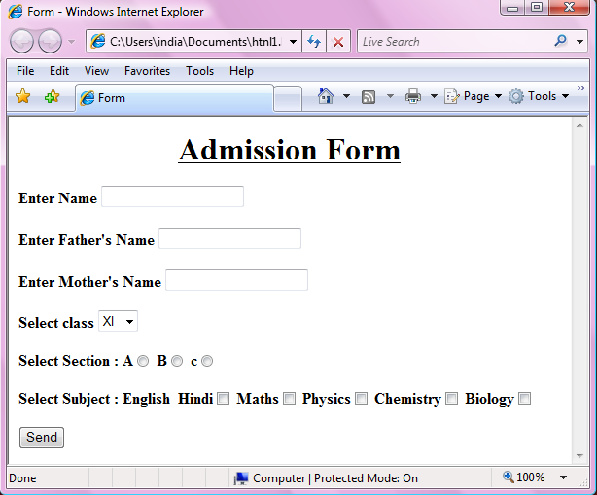

GAGAN KUMAR AGARWAL
PGT[IP]
UDAISHWAR PUBLIC SCHOOL, JWALAPUR, HARDWAR
PHONE NO : 9758777202
EMAIL ID: gagan_agarwal2006@hotmail.com

------------------------------------------------ --------------------------------------------------

