SAMPLE PAPER-2013
CLASS-XII
Subject: Multimedia and Web Technology

M.M. : 70 Time: 3 Hours

- Please check that this question paper contains 5 printed pages.
- Please check that this question paper contains 7 questions.
- Please write down the Serial Number of the question before attempting it.
- 15 minutes time has been allotted to read this question paper and will not write any answer on the answer script during this period.

- Identify the most suitable data type for the following data items : <1>
      - Age of a person
      - An Address
- Explain the terms tuple and cardinality with the help of an example. <2>

- The relation Nations is used to maintain some statistics related to some nations of the world. Study the table and answer the following questions :
Nations
Nat_ID | Nat_Name | Population | Area | Status
A102 | India | 1.21 Billion | 3287 | Developing
E054 | Spain | 0.05 Billion | 504 | Developed
F062 | Nigeria | 0.16 Billion | 923 | Developing
N013 | Canada | 0.04 Billion | 17075 | Developed

- Name the field that can act as a primary key in the table Nations. <1>
- If a separate table Population needs to be created to maintain information about each country’s population, name any two fields from the above table that should be included in the new table. <1>
- Name the type of relation that would exist between the table Nations and newly created table Population. <1>
- Give the full form of MIDI. <1>
- Name any two image formats that are most popularly used while designing web pages. <1>
- What is the difference between using a GIF image and a Flash movie in a web page? <2>
- Answer the following questions based on Macromedia Flash:
  - Explain the use of the Mask Layer. <1>
  - Differentiate between Symbol and Instance. <2>
  - What is a Key Frame? <1>
  - Give one advantage of using layers in Flash. <1>
  - Name any two formats to which a Flash movie can be published. <1>
  - Observe the figure given below and do as directed: <4>

- The Image on the left hand side shows the position and size for frame 1.
- The Image on the right hand side shows the position and size for frame 40.
- The shape on the left is blue in colour while the one on the right side is orange in colour.
Write the procedure and property settings for animating the above scenario.

- Answer the following questions based on HTML:
  - What is the difference between the <FONT> and <BASEFONE> tags? <2>
  - Write the HTML code to generate a Web Page in the format given below : <8>
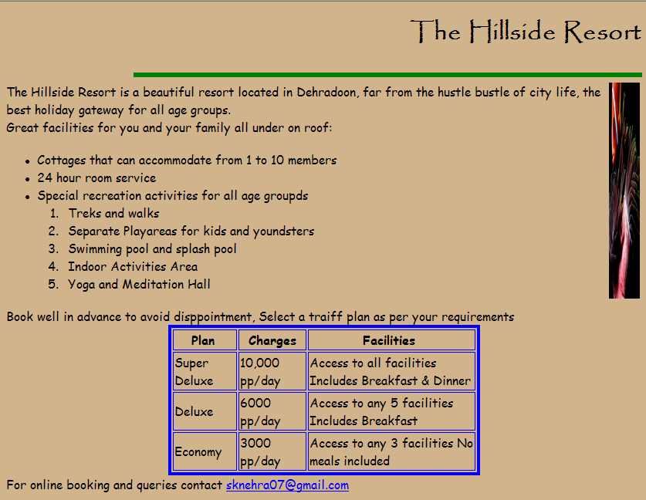
Consider the following points while writing the HTML code:
      - Title of the web page is Hillside Resort.
      - The Background colour of the web page is tan.
      - Text style of main heading is Papyrus and that of the rest of the page is Comic Sans MS.
      - The image used is flower.jpg
      - The line is green in colour and 6 pixels thick.
      - The table has a blue colored border that is 4 pixels thick.
      - Use the concept of nested lists for creating the given list.
      - The link at the bottom is an e-mail link to the address “sknehra07@gmail.com”.

- Answer the following questions based on ASP:
  - Give one reason why server side scripting is essential. <1>
  - Name any two collections of the Request object. <1>
  - Name the object and its method : <3>
    - To clear the buffered HTML output of a response without displaying it
    - To block other clients from modifying the variables of an application
    - To create a new instance of a server component

  - Name the two objects necessary to read from a text file. Also write their main function. <2>

  - Give the output of the following statements: <3>
    - Response.Write(7 * 6 – 12 / (8 MOD 3))
    - Response.Write(MID(“SunilNehra”, 6,3) & SPACE(2) & RIGHT(“Nehra”,2))
    - Response.Write(MONTHNAME(MONTH(“17/06/2011”)+3))

- Answer the following questions based on ASP:
  - What is the difference between the MoveNext and MoveLast methods of the Recordset object? <1>
  - Give the full form of OLE-DB. <1>
  - Predict the output of the following code: <2>
<%
Dim cnt, num
List = ARRAY (30,15,25,10,20,40,12,16)
FOR cnt = 0 to 6 STEP 2
Num = List(cnt) + List(cnt + 1)
RESPONSE.WRITE (num & “<BR>”)
NEXT

%>
  - Rewrite the following code after removing all errors and underline each correction :
<%
Dim a = 30
DO A > 0
SUM = SUM + F1 (A)
RESPONSE.DISPLAY (“SUM =” & SUM)
A = A - 10
LOOP
FUNCTION F1 (NUM)
F1 = NUM MOD 6
END
%>

  - SNEHRA cards uses banner advertisements to fund their web site as shown below : <4>
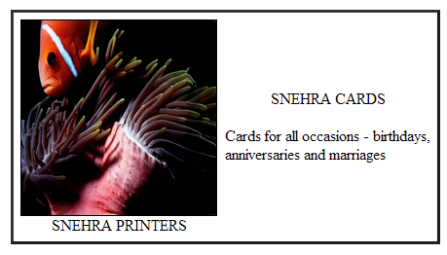
Create an ASP file “Greeting.asp” to display different banner advertisement on the webpage. The ads to be displayed are stored in the file myads.txt.

- Answer the following questions based on VBScript:
  - What is Event Handling? Name the event that occurs when the mouse cursor is brought over an element on a web page. <2>

  - Rewrite the following code using a DO WHILE instead of FOR Loop without affection the output : <2>
<Script Language=”VBScript”>
Dim prod
Prod = 1
For n = 6 to 1 step – 2
prod = prod * 2
document.write (prod & “<br>”)
Next
</Script>

  - Predict the output of the following code : <2>
<Script Language=”VBScript”>
Dim S1, S2, LEN1, LEN2
S1 = “Happy”
S2 = “Anniversary”
LEN1 = LEN (S1)
LEN2 = LEN (S2)

IF LEN2 MOD LEN1 = 0 THEN
DOCUMENT.WRITE (S1 & S2)
ELSE
DOCUMENT.WRITE (S2 & S1)
END IF
</Script>
  - Write the HTML code to generate the following form : <4>
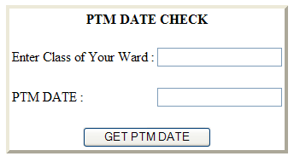

Write the VBScript code to display the PTM date on the click of the GET PTM DATE button as :
- 12/10/2012 if class entered is between 1 to 6 and
- 15/10/2012 if class is between 7 to 12
- If the user enters any class other than the above then an error message should be displayed.

- Answer the following questions based on Communication and Network Concepts:

- What is a Network Topology? <1>
- Name any two modes of wireless transmission media. <1>
- What are the following software used for : <2>
- PHP
- GNU

- What is a firewall? What is its use? <2>

- SNehra Software Company has set up its new centre at Jaipur for its office and web based activities. It has 4 Blocks of buildings as shown : <4>

Building A

Building B

Building C

Building D

Center to centre distances between various blocks
Block A to Block B | 80 m
Block B to Block C | 100 m
Block C to Block D | 40 m
Block A to Block D | 120 m
Block B to Block D | 150 m
Block A to Block C | 130 m
Number of Computers
Block A | 50
Block B | 40
Block C | 250
Block D | 100

- Suggest a cable layout of connections between buildings and name the topology used.
- Suggest the most suitable place (i.e. building) to house the server of this organization with a suitable reason.
- Where the repeaters should be placed?
- The Parent Company of SNehra Software Company is situated in New Delhi. Suggest the most economical method of linking the head office and this office that can provide fast communication.

