SAMPLE PAPERS - 2013
CLASS XI
Multimedia and Web Technology

M.M. : 70 Time: 3.00Hours

- Answer the following questions based on Computer System: (10 Marks)

  - Write Short Notes on Following: (7)

- Printer
- Joystick
- RAM
- CD-ROM
- System Software
- UPS
- Memory Units

  - Write Steps to do Following: (3)
      - Install New Fonts in Windows Operating System.
      - Remove Software in Windows Operating System.
      - Change Date/Time in Windows Operating System.

- Answer the following questions based on Web Page Development: (25 Marks)

  - What is the use of HR TAG? Name all the attributes of HR TAG. <1>
  - Divide the page horizontally into three sections of measurement 40, 40, 20 respectively
and then further divide the last row vertically into two columns each of equal
proportion (50%, 50%). <2>

  - Write Short Notes on Following Tags with a Suitable Example: (4*2=8 Marks)

      - <BODY>
      - <IMG>
      - <TEXTAREA>
      - <FONT>

  - Write differences between : (3*2=6 Marks)
      - Container Tag and Empty Tag
      - <p> and <br> Tag
      - <Frameset> and <Frame> Tag

  - Write the HTML code to generate a Web Page in the format given below : <8>
Consider the following points while writing the HTML code:
      - Title of the page should be “Su-Bodh Public School, Jaipur”.
      - Background color of the page should be “lightyellow”.
      - Text color of main heading should be “green” and font style should be “Arial Bold”.
      - Image used in the page is “multimedia.jpg”.
      - Page linked to are as specified below:
- Graphics Designing as “graphics.html”
- Game Designing as “game.html”
- Web Designing as “web.html”
- Print & Publishing as “print.html”
      - Use the concept of lists to display the given numbering.
      - The table should have a border of size 2 and color green.
      - The bottom message should be of size 2 and the text “Mail to us” is an email link to the e-mail address info@spsjaipur.com.

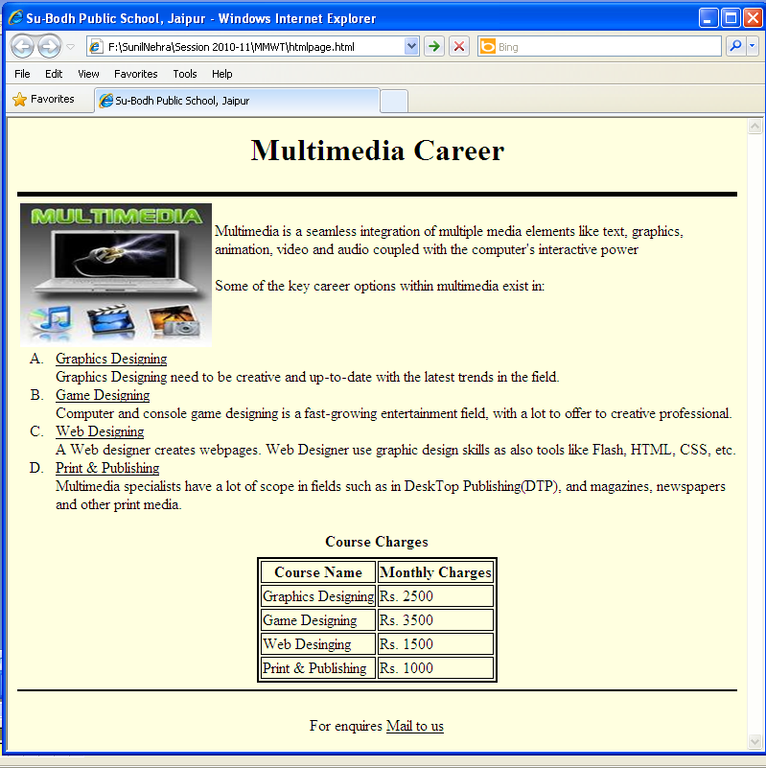

- Answer the following questions based on Web Scripting : (25 Marks)

  - Give the output of the following statements: <7>

      - Document.write(date())
      - Document.write(now())
      - Document.write(Len(“Multimedia and Web Technology”))
      - Document.write(UCase(“Multimedia”))
      - Document.write(strreverse("MULTIMEDIA"))
      - Document.write(mid("Multimedia and Web Technology",20))
      - Document.write(mid(“Technology”,7,3))

  - What is Variable? Write any four naming rules for variable declaration. <2>

  - What is a Comment in a Script? How are Comments added to a Script? <2>

  - Give the output for the following script code : <2>
<script language=”vbcript”>
dim a,b
b=3
a=1
Do while a<=4
document.write("<br>"&a+b)
a=a+1
Loop
</script>

  - Give the output for the following script code : <2>
<script language=”vbcript”>
dim a,b
b=9
a=4
do
document.write("<br>"&a+b)
a=a-1
b=b+a
loop while a>=1
</script>

  - Give the output for the following script code : <2>
<script language=”vbcript”>
dim x,y
y=17
for x=1 to 7 step 2
document.write("<br>"&x+y)

next
</script>

  - Change the following script using Do Loop While without effecting the output : <2>
<script language=”vbcript”>
dim a,b
b=5
a=1
Do while a<=4
document.write("<br>"&a+b)
a=a+1
Loop
document.write("<br>"&a+b)
</script>

  - Rewrite, the following code after removing errors with each correction underlined. <2>
<script Language=”VBScript”>
Var a, b, c
For a = 1 to 5
If a>2 Then
Document.print(“Su-Bodh”)
End
Loop
</script>

  - Write the code to display the below form and add the vbscript to display the results when user click on display button. <4>

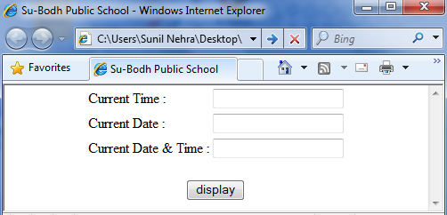

- Question given below are based on Multimedia And Authoring Tools : (10 Marks)

- Write full forms of the followings : (6*1=6)
- PDF
- PSD
- BMP
- SWF
- GIF
- MPEG
- Differentiate between : (2*2=4)

- JPEG and GIF
- FLA and SWF

