SAMPLE PAPER-2013
Class XI
Multimedia and Web Technology

M.M. : 70 Time: 3 Hours
Date: __ / __ / 2012 Roll No.:
S | -

- Please check that this question paper contains 4 printed pages.
- Please check that this question paper contains 4 questions.
- Please write down the Serial Number of the question before attempting it.
- 15 minutes time has been allotted to read this question paper and will not write any answer on the answer script during this period.

- Answer the following questions based on Computer System:

  - Write Short Notes on Following: [6 Marks]

- Printer
- Compiler
- Browsers
- VDU
- Anti Virus
- Memory Units

  - Name any 4 Input Devices and Explain any one of them. [2 Marks]

  - Write differences between :
      - RAM and ROM [2 Marks]
      - Application Software and System Software [2 Marks]

  - Write Steps to do Following: [3 Marks]
      - Install New Fonts in Windows Operating System.
      - Remove Software in Windows Operating System.
      - Change Date/Time in Windows Operating System.

- Answer the following questions based on Web Page Development:
  - What is the use of the ALT attribute of an <IMG> tag? [1 Mark]
  - Write a note on the Different types of Lists available in HTML. [2 Marks]
  - Write the HTML code to create a framed web page in the following format: [2 Marks]
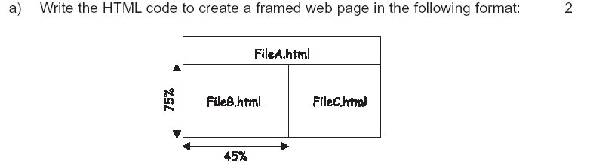

  - Write Short Notes on Following Tags with a Suitable Example: [8 Marks]

      - <P>
      - <A>
      - <TEXTAREA>
      - <IMG>

  - Write differences between :
      - <Font> and <Basefont> Tag [2 Marks]
      - <Frameset> and <Frame> Tag [2 Marks]

  - Write the HTML code to generate a Web Page in the format given below : [8 Marks]
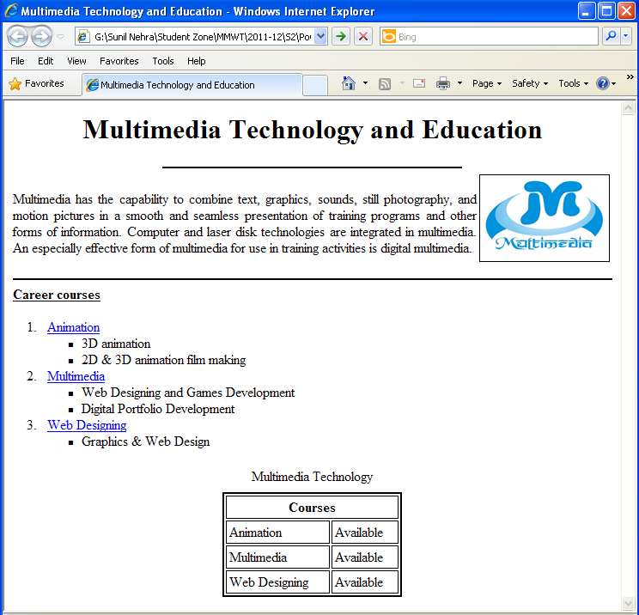
Consider the following points while writing the HTML code:
      - Title of the page should be “Multimedia Technology and Education”.
      - Background color of the page should be “green”.
      - Text color of main heading should be “yellow” and font style should be “Arial Bold”.
      - Image used in the page is “multimedia.jpg”.
      - Page linked to are as specified below:
- Animation as “animation.html”
- Multimedia as “multimedia.html”
- Web Designing as “web.html”
      - Use the concept of lists to display the given numbering.
      - The table should have a border of size 2.

- Answer the following questions based on Web Scripting :

  - What is Variable? Write any Four Naming Rules for variable declaration. [2 Marks]
  - Give the Output of the following statements: [3 Marks]
      - Document.write (mid("Multimedia and Web Technology",6,9))
      - Document.write (right(“Technology”,4))
      - Document.write (len(“Multimedia and Web Technology”))

  - Rewrite the following code after removing errors with each correction underlined:[2 Marks]
<Script Type=”VBScript”>
var no1, no2
no1 = inputbox(“Enter First No :”)
no2 = inputbox(“Enter Second No :”)
if no1>=no2 print
document. write(“No1 is Greater”)
else
document. write(“No2 is Greater”)
end
</Script>

  - Give the Output for the following script code : [2 Marks]
<script language=”VBScript”>
dim a, b
b=5
a=1
Do while a<=4
document.write ("<br>"&a+b)
a=a+1
Loop
</Script>

  - Give the output for the following script code : [2 Marks]
<Script Language=”VBScript”>
dim x,y
y=10
for x=1 to 7 step 2
document.write ("<br>"&x+y)

next
</Script>
Change the following script using Do Loop While without effecting the output :[2 Marks]
<Script Language=”VBScript”>
dim a,b
b=5
a=1
Do while a<=4
document.write("<br>"&a+b)
a=a+1
Loop
</Script>

  - Write a VBScript Program that takes the Number from the user and check it whether
Number is Even or Odd. [3 Marks]

  - Write the HTML Code to display the below Form and add the VBScript to display the results when user click on display button. [4 Marks]

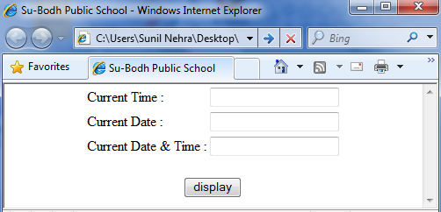

- Question given below are based on Multimedia And Authoring Tools :

- Write Full Forms of the followings : [4 Marks]
- PDF
- PSD
- MPEG
- PNG

- Explain the following tools : [4 Marks]
- Selection Tool
- Crop Tool

- Differentiate between : [2 Marks]
- JPEG and GIF

