SAMPLE PAPER-2013
CLASS-XII
Subject : - MATHEMATICS

TIME: 3 hrs. DATE: __.__.__ MAX. MARKS: 70

INSTRUCTIONS:

- The question paper consists of 3 pages.
- Diagrams/graphs are to be drawn only with a PENCIL; Calculators are NOT allowed.
- The paper consists of 30 questions with following marks distribution:
- Section A consists of 10 questions of 1 mark each.
- Section B includes questions 11 to 22 of 4 marks each.
- Section C includes questions 23 to 29 of 6 marks each.
---------------------------------------------------------------------------------------------------------------------------------------
SECTION A

Q.1: If f: [0,1] [0,1], defined by f(x) = x² and g: [0,1] [0,1], defined by g(x) = 1 – x, then
determine f(g(x)).
Q.2: Show that .
Q.3: If A = 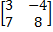 . Find a skew symmetric matrix using A and A^{T}.
Q.4: Find adjoint of the matrix A = 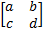.
Q.5: Find the value of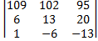.
Q.6: Evaluate .
Q.7: Evaluate .
Q.8: If is a unit vector and () . ( + ) = 8. Find .
Q.9: Find the angle between the planes
.
Q.10: Find the domain of the function f(x) = log x² .

SECTION B

Q.11: Let X = Y = R – {1}. Show that the function f: X Y defined by is one-one and
onto. Find f ⁻¹(x).
Q.12: If F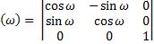 , then show that .
OR
Using properties of determinants, prove that
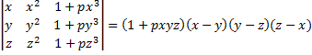.
Q.13: Show that 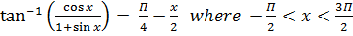 .
Q.14: Find the domain and range of the following function:
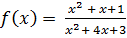 .
Q.15: If , then find at t =.
OR
Let . If U(x) = h(f(g(x))), then prove that
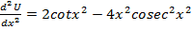.
Q.16: Show that the curves
touch each other.
OR
Find the equation of normal to the curve
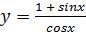 at 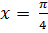.
Q.17: Evaluate 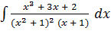.
OR
Evaluate .
Q.18: Solve the differential equation
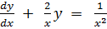 given .
Q.19: Form the differential equation corresponding to the function .
Q.20: Find the value of the constant M such that the scalar product of the vector with the
unit vector parallel to the sum of the vectors and is equal to one.

Q.21: (a) Find the length of the perpendicular from (1 , -1 , 2) to the plane 3x + 5y -4z = 5.
(b) Prove that the angle between the line 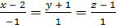 and the plane 3x + 2y – z = 4
is .
Q.22: If the papers of 4 students can be checked by any of the 7 teachers, then show that the
probability that all the 4 papers are checked by exactly 2 teachers is .

SECTION C

Q.23: Use product 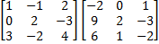 to solve the system of equations
.
OR
Find the inverse of the matrix 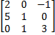 using elementary transformation.
Q.24: A window is in the form of a rectangle surmounted by a semi circle. Total perimeter of the
window is 10 metres. Find the dimensions of the rectangle so as to admit maximum light
through the whole opening.
Q.25: Using the method of integration, find the area of the region bounded by the lines
Q.26: Solve the differential equation
given that when x = 3.
Q.27: Find the equation of the plane passing through the point (-1 , 3 , 2) and perpendicular to each
of the planes .
Q.28: Given three identical boxes A, B and C each containing two coins. In box A, both the coins are
gold coins, in box B both are silver coins and in box C there is one gold and one silver coin. A
person chooses a box at random and takes out a coin. If the coin is of gold, what is the
probability that the other coin in the box is also of gold.
Q.29: A factory makes badminton rackets and cricket bats. A racket takes 90 minutes of machine
time and 3 hours of craft man’s time while the bat takes 3 hours of machine time and 60
minutes of craft man’s time. In factory, machine is not available for more than 42 hours and
that of craft man for 24 hours. If the profit on a racket and a bat is Rs. 20 and Rs. 10
respectively, find the number of rackets and bats that the factory must manufacture to earn
the maximum profit. Make it as an L.P.P. and solve graphically.

