Sample Paper

Class XI

Subject – BIOLOGY

Time – 3Hrs MM – 70

General Instructions
1. The question paper comprises of four sections A, B, C and D. You are to attempt all the sections.

2. All questions are compulsory.

3. There is no overall choice However, internal choice has been provided in one question of two marks, one question of three and all the three questions of five marks category.Only one option in such questions is to be attempted.

4. All questions of section a, B, C and D are to be attempted separately.

5. Questions 1 to 8 in section are very short questions of one mark each. These are to be answered in one word or one sentence each.

6. Questions 9 to 18 in section B are short questions of two marks each. These are to be answered in approximately 20-30 words each.

7. Questions 19 to 27 in section C are questions of three marks each. These are to be answered in approximately 30-50 words each.

8. Questions 28 to 30 in section D are questions of five marks each. These are to be answered in approximately 80-120 words each.

SECTION A

- Write the scientific name of mango.
- Define the terms: plasmogamy and lichens.

- Identify the figure and write its importance.

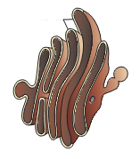

- In which organism’s typhlosole is found. Write its importance.
- Label the diagram and write one function of this sub cellular part.

- What is relation between root pressure and guttation?
- What is erythroblastosis foetalis?
- Expand LMM and HMM.
SECTION B
- Make a neat and labelled diagram to show mechanism of hormone action of a steroid hormone.
- Label the diagram.
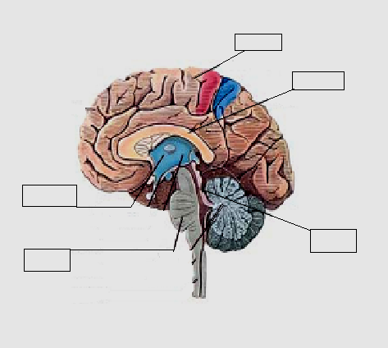

- What are the factors affecting the rate of diffusion, and explain any one factor.
- Explain the role of following nutrients of plants.
- Write any two functions of mesosomes.
- Draw structures of the following bio molecules: glucose and glycine. Identify the following bio molecules.

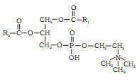
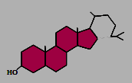

- Label the diagram.

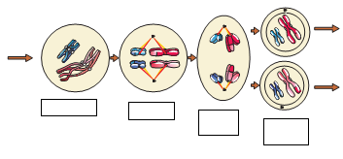

- Name the edible part of mango, apple, banana, and coconut.
- The cross section of a plant material shows the following anatomical features under the microscope :
- The vascular bundles are radially arranged.
- Four xylem strands with exarch condition of the protoxylem.
To which organ should it be assigned?
- Why people give common vernacular names to organisms?
OR
What are characteristic features of euglenoids?

SECTION C
- Diagrammatically indicate the location of various endocrine glands in our body.
- Which of the following statements are true? If false correct them :
- Boron deficiency leads to stout axis.
- Every mineral element that is present in a cell is needed by the cell.
- Nitrogen as a nutrient element is highly immobile in the plants.
- Draw a neat and labelled diagram of plant cell.
- Define enzyme. Explain any three factors affecting enzyme activity.
- What do you mean by modification of root? What type of modifications of root found in
- Sweet potato
- Turnip
- Cuscuta
- Asparagus.
- Explain in detail with diagram alimentary canal of cockroach.
- Explain diffusion, facilitated diffusion and osmosis.
- Enlist any three disorders of each skeletal and muscular system. Explain any three of them.
- Differentiate between smooth, skeletal and cardiac muscles with diagram.
OR
Compare the salient features of Monera and protista.

SECTION D
- Explain in detail the vegetative characters, floral characters and economic importance of Solanaceae family.
OR

Explain in detail the vegetative characters, floral characters and economic importance of Lilaceae family.
- Explain in detail the location , function and hormone produced by the following endocrine glands.(a) pituitary gland (b) pineal gland (c) thyroid (d) parathyroid (e) thymus.
OR
Explain in detail the location, function and hormone produced by the following endocrine glands. (a) adrenal gland (b) pancreas (c) testis (d) ovary.
- Explain in detail the process of root nodule formation with diagram.
OR
Explain in detail Meiosis cell division with diagram and write its significance.

***********************

