Sample Paper 2013
Class - XII

Subject- BIOLOGY

Time Allowed: 3 Hr Maximum Marks: 70

General Instructions:
- All questions are compulsory.
- The question paper consists of four sections A, B, C and D. Section-A contains 8 questions of 1 mark each, Section-B contains 10 questions of 2 marks each, Section-C has 9 questions of 3 marks each and Section-D contains 3 questions of 5 marks each.
- There is no overall choice. However, an internal choice has been provided in one question of 2 marks, one question of 3 marks, and all the three questions of 5 marks weightage. A student has to attempt only one of the alternatives in such questions.
- Wherever necessary, the diagrams drawn should be neat and properly labeled.

SECTION-A

- From the below diagram , find out which regions form the bran
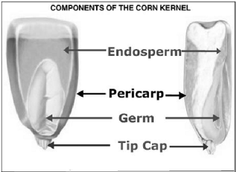

- If a double stranded DNA has 40% guanine calculate the % of adenine in the
DNA.

- What is the difference between these two plasmids?
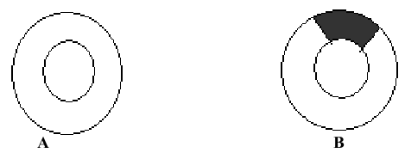

- What does the graph A, B&C represent with reference to organismic response to Homeostasis?

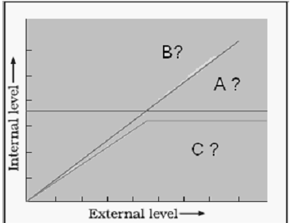

- The accelerated rate of species extinction that the world is facing now is largely due to human activities. Group such activities under four major heads and explain.

- Write the anticodon of the given t-RNA
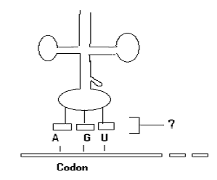

- If a woman is using a copper T, will it protect her from sexually transmitted diseases? Why?
- All human beings have Proto oncogenes. But all of them do not suffer from cancer. Why?

SECTION-B
- Fill in the missing columns:

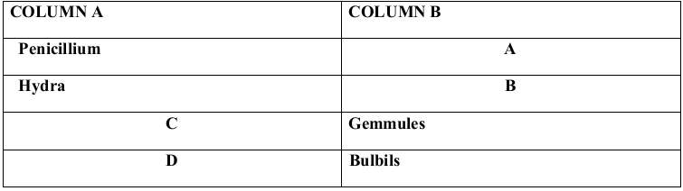

- Expand each one to its full form:
(a) MALT (b) CMI (c) AIDS (d) NACO
- A) Sometimes the doctor injects some medicine into the body of a woman to induce uterine contractions and delivery. What do you think that the doctor has injected?
B) Not all copulations result in pregnancy. Give a reason.
- What do you mean by SNPs and its significance with respect to human genome?
OR

The map distance between A & B genes is 18 units; between B & C is 20
Unit and C & A is 2 units.
(a)What is the order of genes on a linkage group?
(b) Write the unit of map distance.
- If you are selected as the chairman of Delhi municipality what measures would you take to
- Control the increasing number of cases of dengue fever.
- Spread awareness among public about dengue.
- Complete the table.
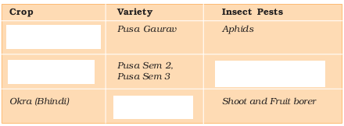

- Water Zooplanktons Small fish Fish eating birds
DDT (0.003ppm) (0.04ppm) (0.5ppm) (5ppm)
Why is the concentration of DDT increasing from the producers to consumers in the above food chain?
- What do you mean by Red Ribbon Express?
Express train launched by Indian Railways recently to create awareness about AIDS. This train was taken all over India and stationed at different Junctions.
- Draw and label a structure of an antibody molecule.
SECTION-C

- Given below is an incomplete flow chart showing influence of hormones on gametogenesis in males. Observe the flow chart carefully and fill in the blanks A, B and C.

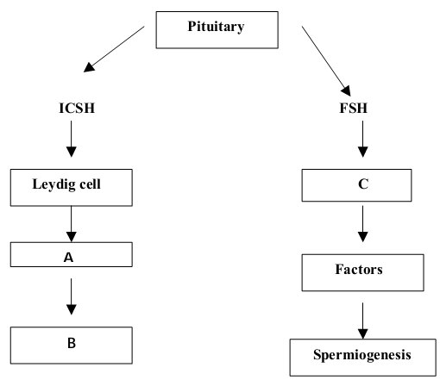

OR

The events of the menstrual cycle are represented below. Answer the questions following the diagram

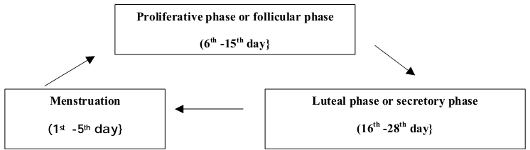

a.) State the levels of FSH, LH and progesterone simply by mentioning high or low around 13th, 14th day and 21st to 23rd day.
b.) In which of the above mentioned phases does the egg travel to the fallopian tube?
- Genomic mutation is the term used for change in chromosomal number, Write
its two types and mention where they are seen?
- The following are the steps in controlled breeding experiments
a. Semen is collected from Male parent

b. Semen stored or immediately used

c. xxxx

d. Desirable mating achieved.

1. Complete the sequence by filling xxxx.
2. Name the process.
3. What is the advantage?

- Explain RDT with a diagram.
- What are Cry proteins? Name an organism that produces it. How has
man exploited this protein to his benefit?
- Write the matching word:--

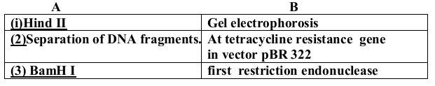

- What do the following changes represent in the given graph?

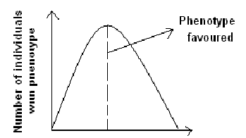

(i) If operation of natural selection makes peak higher and narrower
(ii) if peak shifts to right direction
(iii) If two peaks are formed instead.
- What according to your opinion is the reason for failure of the major programs like Ganga Action plan or Yamuna action plan?
- Explain the importance of cloning vector .Show any two molecular scissor sites on a cloning vector.
- (i)What do you infer from this schematic representation
(ii)Label A, B, C, D & E

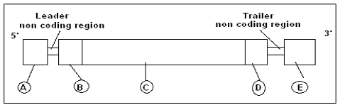

SECTION-D

- a) “Dehydration of seed increases their shelf life” – Explain
b) Cleistogamous flowers are strictly self-pollinating,” Explain. What is the
disadvantage of this phenomenon?
c) Even after killing the generative cell with a laser beam, the pollen grain of a
flowering plant germinates and produces normal pollen tube. How does it happen?

OR

Study the following diagram and answer the following questions:

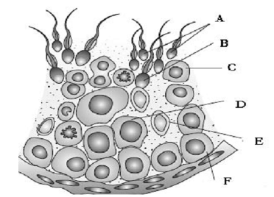

a) Label the parts A, B, C, D, E and F
b) How does D differ from F?
c) What is the function of E?
- Cystic fibrosis is recessive condition that affects about 1 in 2,500 babies.
Calculate the following.
a) Name the principle involved
b) the equation used
c) the frequency of the recessive allele in the population
d) the frequency of the dominant allele in the population
e) the percentage of heterozygous individuals (carriers) in the population

OR

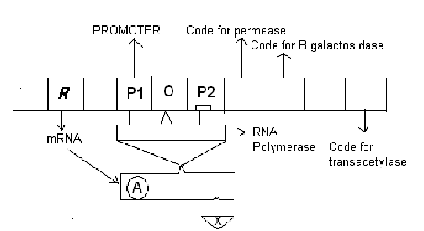

(i) Label R, A, X & O
(ii) Which operon the above figure represents?
- A) What initiatives were taken for reducing vehicular air pollution in Delhi?
Has air quality improved in Delhi?
B) Discuss briefly the following:
(a) Greenhouse gases
(b) Catalytic converter
(c) Ultraviolet B
OR

(a) What are age pyramids? Explain all the types of population pyramids with diagram.
(b) Complete the figure.




