Sample Paper, 2012-13
Subject: Computer Science
Class 12th
Time Allowed : 3 Hr. M.M.: 70
Code: 083

General Instruction

- Please check this question paper contains 10 printed pages.
- Code number given on the right side of question paper should be written on the title page of the answer – book by the candidate
- Please check that this question paper contains 7 questions.
- Please write down serial number of the question before attempting it.
- All questions are compulsory.
- Programming language : C++

Q1.(a) What is the difference between the call by value and call by reference? Give an example in
c++ to illustrate both. 2
(b) Name the header files, to which the following built-in functions belong to: 1
(i) eof ( ) (ii) isalpha

(c) Identify and correct the error(s) in the following program: 2
#include<iostream.h.
Main {
float class = 10.7;
float y;
y = class % 5.0;
cout<<class <<” , “<<y;
}

(d) Give the output of the following Program: 2
#include<iostream.h
int a = 3;

void demo (int &x, int y, int *z)
{
a + = x;
y * = a;
*z = a + y;
cout<<a<<”, “’<<x<< “,”<<y<<”,“<<z<<endl;
}

void main( )
{
int a = 2, b=5;
demo(::a,a,&b);
cout<<::a<<”,”<<a<<”,”<<b;
}

(e) Give the output of the following Program: 3
#include<iostream.h>
void withdef ( int HisNum = 30)
{
for ( int I = 20 ; I<= HisNum; I+= 5)
cout<<I<<”,”;
cout<<endl;
}
void Control( int &MyNum )
{
MyNum + = 10;
withdef(MyNum);
}
void main( )
{
int YourNum = 20;
Control(YourNum );
withdef( );
cout<< “Number=”<<YourNum<<endl;
}

(f) Study the following program and select the possible output from it : 2
#inlude<iostream.h>
#include<conio.h>
#include<stdlib.h>
const int LIMIT = 4;
void main( )
{
randomize( );
int Points;
Points = 100 + random(LIMIT);
for ( int p = Points; p>=100; p--)
cout<<p<<”#”;
cout<<endl;
}

- 103#102#101#100#
- 103#102#101#100
- 101#102#103#104#
- 103#102#101#100#
Q.2 (a) What do you understand by Copy Constructor? Explain with suitable example. 2
(b) Answer the questions (i) and (ii) after going through the following class: 2 class Travel
{
int days;
public:
Travel ( ) // Function 1
{
Days = 50; cout << “ Journey starts now” << endl;
}
void sightseeing( ) // Function 2
{
cout << “ Sightseeing in the journey starts” << endl;
}
Travel (int Duration) // Function 3
{
Days = Duration; cout << “ Journey starts now” << endl;
}
~ Travel ( ) // Function 4
{
cout << “ Happy journey” << endl;
}
};

- In Object Oriented Programming, what is Function 4 referred as and when does it get invoked/ called?
- In Object Oriented Programming, which concept is illustrated by Function 1 and
Function 3 together? Write an example illustrating the calls for these functions.
(c) Define a class Garments in C++ with the following descriptions : 4

Private members :
Gcode of type string
Gtype of type string
Gsize of type integer
Gfabric of type string
Gprice of type float

A function Assign ( ) which calculates and assigns the value of Gprice as follows :
For the value of Gfabric “COTTON” ,
Gtype Gprice( Rs)
TROUSER 1300
SHIRT 1100
For Gfabric other than “COTTON” the above mentioned Gprice gets reduced by 10%
Public members:
A constructor to assign initial values of Gcode, Gtype, and Gfabric with the word “NOT ALLOTTED” and Gsize and Gprice with 0.
A function Input( ) to input the values of the data members Gcode, Gtype, Gsize and Gfabric and invoke the Assign( ) function.
A function to Display( ) which displays the content of all the data members for a Garments.
(d) Answer the questions (i) to (iv) based on the following code: 4
class Car
{
char Model[10];
char Date_of_purchase[10];
char Company[20];
public( );
Car( );
void entercardetail( );
void showcardetail( );
};
class Accessories : public Car
{
protected:
char stereo_tape[30];
char sheet_cover[20];
public:
float Price;
Accessories( );
void enteraccessoriesdetails( );
void showaccessoriesdetails( );
};
class Dealer : public car
{
int No_of_dealers;
char dealers_name[20];
int No_of_products;
public:
Dealer( );
void enterdetails( );
void showdetails( );
};
- (a) How many bytes will be required by an object of class Car and an object of class Dealer?
(b) Which type of inheritance is illustrated in the above c++ code?
- Write names of all the data members which are accessible from the objects of class Dealer.
- Write names of all the members accessible from member functions of class Accessories.
- Write names of all the member functions which are accessible from objects of class Dealer.

Q.3 (a) Write the function SWAPCOL() in C++ to swap (interchange) the first column elements with
the last column elements , for a two dimensional integer array passed as the arguments of the function. 3
Ex. If the two dimensional array contains. After swapping of the content of 1st column and last column it should be
2 | 1 | 4 | 9
1 | 3 | 7 | 7
5 | 8 | 6 | 3
7 | 2 | 1 | 2
9 | 1 | 4 | 2
7 | 3 | 7 | 1
3 | 8 | 6 | 5
2 | 2 | 1 | 7

(b) If an array B[11][8] is stored as column wise and B[2,2] is stored at 1024 and B[3,3] at 1084. Find the addresses of B[5,3] and B[1,1]. 3
(c) Define functions stackpush( ) to insert nodes and stackpop( ) to delete nodes, for a linked list implemented stack having the following structure for each node: 4
struct node
{
char name[20];
int age;
node *LINK;
};
(d) Obtain the postfix notation for the following infix notation of expression showing the contents of the
stack and postfix expression formed after step of conversion: 2
A * B + (C – D / F↑G)* H
(e) Write a user defined function Upper_half() which takes a two dimensional array A, with size N rows and N columns as arguments and point the upper half of the array. eg. 2
2 3 1 5 0 2 3 1 5 0
7 1 5 3 1 1 5 3 1
If A is 2 5 7 8 1 The Output Will be 7 8 1
0 1 5 0 1 0 1
3 4 9 1 5 5

Q4. a) Observe the program segment given below carefully and answer the question that follows: 1
class Team
{
long TId;
char TName[20];
float points;
public:
void Accept( );
void Show( );
void PointChange( );
long R_TId( ) {return TId;}
};
void ReplacePoints(long Id)
{
fstream File;
File.open (”Team.Dat”,ios::binary|ios::in|ios::out);
Team T;
int Record=0, found=0;
while(!found && File.read((char*)&T, sizeof(T)))
{
if (Id==T.R_TId( ))
{
cout<<”Enter New Points”;
T.PointChange ();
_________________ //Statement 1
_________________ // Statement 2
Found=1;
}
Record++;
}
if(Found==1)
cout<<”Record Updated”;
File.close( );
}
Write the statement 1 to position the File Pointer at the beginning of the Record for which the Team’s ID matches with the argument passed, and Statement 2 to write the updated record at the Position.
(b) Write a function in C++ to print the count of the word “Me” and “My” (ignoring the case) as an independent word in a text file STORY.TXT.
If the file “Story.txt” content is as follows:
My first book was me and My
family. It gave me change to be
known to the world.
The output of the function should be Count of Me/My in file: 4 2
(c) Write a function in C++ to search and display details, whose destination is “Delhi” from a binary file “Train.Dat”. Assuming the binary file is containing the objects of the following class: 3
class TRAIN
{
int Tno; // Train Number
char From[20]; // Train Starting Point
char To[20]; // Train Destination
public:
char * GetFrom ( ); { return from; }
char * GetTo( ); { return To; }
void input() { cin>>Tno>>; gets(From); get(To); }
void show( ) { cout<<Tno<< “:”<<From << “:” <<To<<endl; }
};
Q 5. (a) Differentiate between Primary key and Foreign Key in context of RDBMS. Give suitable
example. 2
- Consider the following table DRESS and Material. Write SQL commands for the
statements (i) to (iv) and give outputs for SQL quarries (v) to (viii). 6
Table: DRESS

Dcode | description | price | mcode | launchdate
10001 | Formal Shirt | 1250 | M001 | 12-JAN-08
10020 | FROCK | 750 | M004 | 09-SEP-07
10012 | INFORMAL SHIRT | 1450 | M002 | 06-JUN-08
10019 | EVENING GOWN | 850 | M003 | 06-JUN-08
10090 | TULIP SKIRT | 850 | M002 | 31-MAR-07
10090 | PENCIL, SKIRT | 1250 | M003 | 19-DEC-08
10023 | SLACKS | 850 | M003 | 20-OCT-08
10089 | FORMAL PANT | 1450 | M001 | 09-MAR-08
10009 | INFORMAL PANT | 1400 | M002 | 20-OCT-08
10024 | BABY TOP | 650 | M003 | 07-APR-07

TABLE: MATERIAL
mCODE | TYPE
M001 | TERELENE
M002 | COTTON
M004 | POLYESTER
M003 | SILK

- To display DCODE and DESCRIPTION of each dress in ascending order of DCODE.
- To display the details of all the dresses which have LAUNCHDATE in between 05-DEC-07 and 20-JUN-08 (inclusive of both the dates)
- To display the average PRICE of all the dresses which are made up of material with MCODE as M003.
- To display material wise highest and lowest price of dresses from DRESS table.
(Display MCODE of each dress along with highest and lowest price) .
- SELECT SUM( PRICE) FROM DRESS WHERE MCODE= ‘M001’;
- SELECT DESCRIPTION , TYPE FROM DRESS MATERIAL WHERE DRESS.DCODE>=1250;
- SELECT MAX(MCODE) FROM MATERIAL ;
- SELECT COUNT(DISTINCT PRICE) FROM DRESS.
Q6. (a) State and verify Absorption’s Law and Demorgan’s Law using truth table and
algebraically. 2
(b) Write the equivalent Boolean Expression for the following Logic Circuit 1
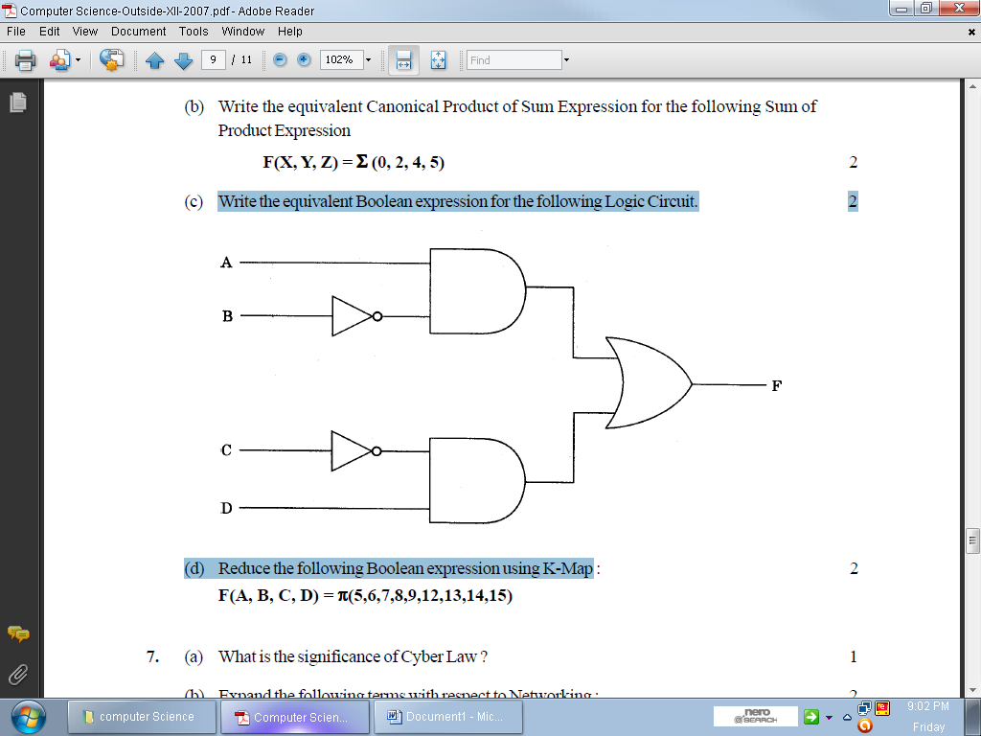
(c) Write the SOP form of a Boolean function G, which is represented in a truth table as follows: 1
U | V | W | G
0 | 0 | 0 | 1
0 | 0 | 1 | 1
0 | 1 | 0 | 0
0 | 1 | 1 | 0
1 | 0 | 0 | 1
1 | 0 | 1 | 1
1 | 1 | 0 | 0
1 | 1 | 1 | 1

(d) Reduce the following Boolean Expression using K-Map: 3
F(U,V,W,Z)= ∑(0,1,4,5,6,7,11,12,13,14,15)
(e) Give the dual of (A+BC+AB) 1
Q.7 (a) What is the difference between Packet switching and message switching technique? 1
(b) Expand the following terminologies: 1
(i) TDMA
(ii) WLL
(c) What is the utility of Cyber law? 1
(d) What do you understand by cookies 1
(e) The Reliance Info Sys has set up its Branch at Srinagar for its office and web based activities. It has 4 Zone of buildings as shown in the diagram:
Zone Z
Zone Y

Zone X
Zone U

Center to center distances various blocks

Zone X to Zone Z | 40 m
Zone Z to Zone Y | 60 m
Zone Y to Zone X | 135 m
Zone Y to Zone U | 70 m
Zone X to Zone U | 165 m
Zone Z to Zone U | 80 m

Number of Computers

Zone X | 50
Zone Z | 130
Zone Y | 40
Zone U | 15

(e1) Suggest a most suitable cable layout of connections between the Zones and topology. 1
(e2) Suggest the most suitable place (i.e., Zone) to house the server of this organization with a suitable reason, with justification. 1
(e3) Suggest the placement of the following devices with justification: 1
- Repeater (2) Hub / Switch
(e4) The organization id planning to link its head office situated in Mumbai at the offices at Srinager. Suggest an economic way to connect it; the company is ready to compromise on the speed of connectivity. Justify your answer. 1
(f) What is the difference between the LAN and MAN? 2

Mr. Sachin Kumar Mishra
HOD of Computer Science
R.E.D School Jhajjar.
Haryana

