Sample Paper - 2013

Subject - Informatics Practices

Class - XII

MM:70 Time-3hrs

____________________________________________________________________________________________

Q1 | (a) | Write two advantages and two disadvantages of following :  (i)Optical fibre (ii) Coaxial (iii) Bluetooth |  |  | 2
 | (b) | Mr Chandra a Network administrator of Deepa Electricals want to connect his registered  office located in Mumbai with head office in Delhi. Suggest an economic way to connect it with reasonable high speed? |  |  | 1
 | (c) | How Mac address is different from IP address? Give suitable example. |  |  | 1
 | (d) | What is difference between Star, Ring and Bus Topology? |  |  | 2
 | (e) | Define Freeware software and Shareware software. |  |  | 1
 | (f) | What is an abbreviation of ASCII, PHP, OGG and PNG ? |  |  | 2
 | (g) | Define the common threats to network security ? |  |  | 1
Q2 | (a) | What is the difference between exit controlled and entry controlled loop? |  |  | 1
 | (b) | Find out the value of variable b.  - int b=0 ;  for(int a=0;a<=30;a++)  {  if( a % 2==0)  {  b= b+a;  else  {  b=b;  }}  System.out.println(“”+b); |  |  | 1
 | (c) | Which method is used to close an application and disable a radio button? |  |  | 1
 | (d) | Differentiate between method overloading and method overriding? Give example |  |  | 1
 | (e) | What is an use of break, continue and final keyword? |  |  | 2
 | (f) | Write HTML code to create hyperlink to a page marks.doc stored in c drive? |  |  | 1
 | (g) | State and define the different methods of Resultset class? |  |  | 1
 | (h) | Which methods are used to register a Driver and create a Connection object? |  |  | 1
 | (i) | Differentiate between XML and HTML? |  |  | 2
3 | (a) | Which commands in MySql is used to make any Database current Database and see the list of table in that data base? |  |  | 1
 | (b) | What do you mean by table level constraint and column level constraints? Give example for that. |  |  | 1
 | (c) | How primary key in a table is different from unique key constraint? |  |  | 1
 | (d) | What is the purpose of following query statements. Write output.  Select round(4325.7869,2);  Select truncate(4325.7869,2); |  |  | 1
 | (e) | What is the difference between Group by and Order by clause? |  |  | 1
 | (f) | A table Alpha contains 4 records and table Beta contains 7 records what will be total number of records in their Cartesian product? |  |  | 1
 | (g) | Write SQL statement to add a column regno of data type varchar in a table candidate which is primary key? |  |  | 2
 | (h) | Mrs Hetal a database administrator created a table Voters in which she has used nationality as column name and by mistake she has entered nationality as Gujarat. Now she wants to change all the values from Gujarati to Indians using single statement. Help her to do the following by writing statement. |  |  | 1
 | (i) | What will be the query output for the following statement. Write in words/sentence. |  |  | 1
- (a) SELECT * from SCHOOL where sname like “_ _ _ SURAT”;

- (b) SELECT * from SCHOOL where sname like “DC%”;
Q4 | (a) | Write HTML code to create web page whose title is “Computer Parts” and contains following list:  - RAM  - ROM  - OPTICAL MOUSE |  |  | 2
 | (b) | Rewrite the following code using switch case:  int num1=310;  int num2=20;  int choice=Integer.parseInt(jTextField1.getText());  if(choice= =1)  System.out.println(“ “+(num1+num2));  else if(choice= =2)  System.out.println(“ “+(num1- num2));  if(choice= =3)  System.out.println(“ “+(num1* num2));  if(choice= =4)  System.out.println(“ “+(num1/ num2));  else  System.out.println(“ Invalid choice “); |  |  | 2
 | (c) | How many times does the following do .... while loop get executed ?  int x = 5;  do  {  x + = 2 ;  System.out.println(“”+x);  }while(x<10); |  |  | 1
 | (d) | Write sample code to display image orange.jpg on a label “limage” which is stored in D drive? |  |  | 1
 | (e) | Given below is the form. Write sample code for “Add” button to add the text into Textarea “ta” depending upon selection made by user. Also write code for reset button.  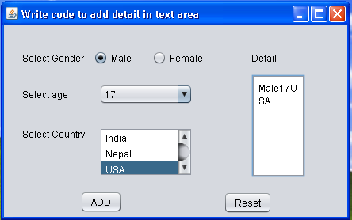 |  |  | 3
 | (f) | Which method in java is used to find length of string “INTERNATIONAL”? |  |  | 1
5 | (a) | Write java code that takes value for two numbers num1and num2 from jTextField1 and jTextField2 and swaps the two number? |  |  | 2
 | (b) | Write the sample code to check whether password is STUDENT or not if not display proper message “Password is wrong” ?  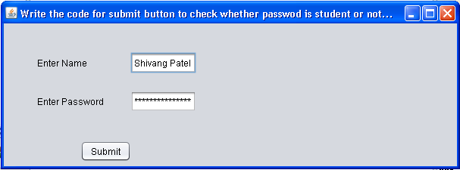 |  |  | 2
 | (d) | A table Registration contains 5 rows and 7 columns. What is the degree and cardinality of the table? |  |  | 2
 | (e) | Depending upon the table given below write sql queries for the following:  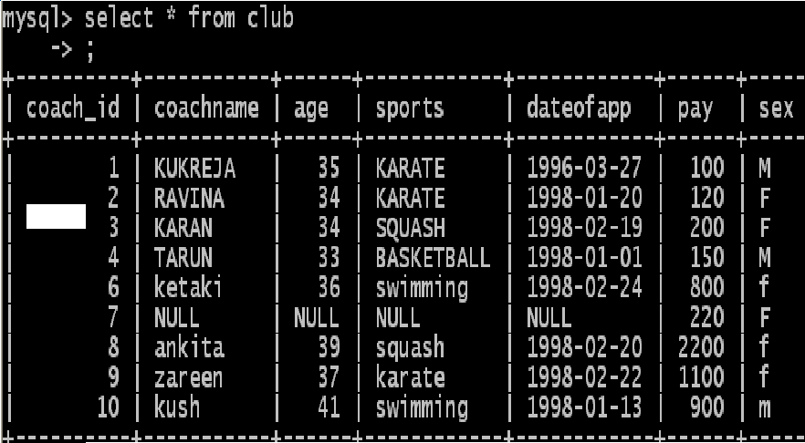  - Those coaches whose date of appointment is greater than 17-1-1998.  - Those coaches whose pay is between 100 and 500.  - All coaches in ascending order of pay.  - Display sum of pay for each sports separately. |  |  | 4
Q6 | (a) | What is the difference between drop and delete table command? |  |  | 1
 | (b) | What are different commands used in Transaction in mysql? |  |  | 2
 | (c) | Consider the tables DOCTORS and PATIENTS given below:  DOCTORS  PATIENTS
  DOCID | DOCNAME | DEPARTMENT | OPD_DAYS
  101 | M.Panday | ENT | TTS
  102 | G.P.Gupta | Paed | MWF
  201 | C.K.Sharma | Ortho | MWF
  PATNO | PATNAME | DEPARTMENT | DOCID
  1 | Neeraj | ENT | 101
  2 | Mohit | Ortho | 201
  3 | Ragni | ENT | 101
  4 | Mohit | Paed | 102
  5 | Nandani | Ortho | 201
With reference to these tables, write commands in SQL for(i) and (ii) and output for (iii) below:
- Display the Patno, PatName and corresponding DocName for each Patient. 1
- Display the list of all patients whose OPD_Days are MWF. 1
- Select OPD_DAYS, count(*) from DOCTORS,PATIENTS 2
Where Patients.Department=Doctors.Department
Group by OPD_DAYS;
 | (d) | Write SQL statement to create the table Film given below as per specification |  |  | 4
  Column Name | Code | Name | Price | City
  Data type | Varchar | Varchar | Number | Varchar
  Size | 6 | 30 |  | 30
  Constraint | Primary key |  |  | Default Delhi
 | (c) | (i) Write SQL statement to add a column Director of data type Varchar(20) in the above table.  (ii) Write SQL statement to change size of the column City from 40 to 80 |  |  | 1  1
 |  | (iii) Write SQL statement to display structure of the table. |  |  | 1
Q7 | (a) | Write short notes on e-Governance, e-Learning and e-Business? |  |  | 3
 | (b) | What components are used for creating Front-end of any Software? Give details about any four components. |  |  | 2
--------

