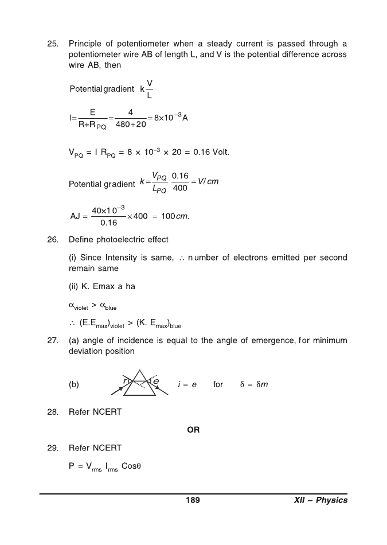
Mr.ANEESH
(Academic co-ordinator & Senior Physics Teacher)
TDIS,Indonesia.

