SAMPLE PAPER-2013
SUBJECT- PHYSICS (Theory)
Class-XII

- Please check that this question paper contains 5 printed pages.
Code number given on the right hand side of the question paper should be written on the title page of the answer-book by the candidate.
- Please check that this question paper contains 30 questions.
- Please write down the serial number of the question before attempting it.

Time allowed: 3 hours Maximum Marks: 70

General Instructions:
- All questions are compulsory.
- There are 30 questions in total. Questions 1 to 8 carry one mark each, questions 9 to 18 carry two marks each, questions 19 to 27 carry three marks each and questions 28 to 30 carry five marks each.
- There is no overall choice. However, an internal choice has been provided in one question of 2 marks, one question of 3 marks and all the three questions of 5 marks. You have to attempt one of the choices in such questions.
- Use of calculators is not permitted.
- You may use the following values of physical constants wherever necessary:

c = 3 x 10⁸ ms^{–1}

h = 6.626 x 10^{–34} Js

e = 1.602 x 10^{–19} C

μ₀ = 4 π x 10^{–7} T m A^{–1}

$\frac{1}{4{\text{πε}}_{0}} = 9 x {\text{10}}^{9} N m^{2} C^{−2}$

Mass of neutron m_{n} ≅ 1.675 x 10^{–27} kg

Boltzmann’s constant k = 1.381 x 10^{–23} J K^{–1}

Avogadro’s number N_{A} = 6.022 x 10²³ mol ^{–1}

- A glass of refractive index 1.45 disappears when immersed in a liquid. What is the value of the refractive index of the liquid?
- What is the ratio of radii of the orbits corresponding to first excited state and ground state in a hydrogen atom?
- When a light travels from a rarer medium to denser medium, the speed decreases. Does this decrease in speed imply a decrease in the energy carried by the light wave? Justify your answer.
- An α-particle and a proton are accelerated from rest by the same potential. Find the ratio of their de-Broglie wave length.
- For a given single slit, the diffraction pattern is obtained on a fixed screen, first by using red light then by using blue light. In which case, will the central maximum, in the observed diffraction pattern, have a larger angular width?
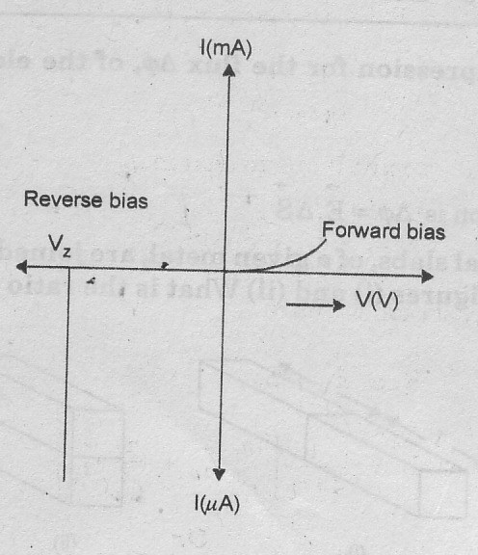
- Figure shows the I-V characteristics of a given diode. Name the diode and write where it is used?

- Write the expression for Bohr’s radius in hydrogen atom.
- What do the terms ‘depletion region’ and ‘barrier potential’ mean for a p-n junction?
- Draw the circuit diagram of an illuminated photodiode in reverse biase. How is photo diode used to measure light intensity?
- A heavy nucleus X of mass number 240 and BE/nucleon 7.6MeV is splits in to two fragments Y and Z of mass numbers 110 and 130. The binding energy of nucleons in Y and Z is 8.5 MeV per nucleon. Calculate the energy Q released per fission in MeV.
- A biconvex lens has a focal length 2/3 times the radius of curvature of either surface. Calculate the refractive index of the material.
- Write two factors justifying the need of modulating signal. A career wave of peak voltage 12V is used to transmit a message signal. What should be the peak voltage of the modulating signal in order to have modulation index of 75%.
OR
What is meant by ‘detection of a modulated carrier wave? Describe briefly the essential steps for detection.
- Draw a plot of potential energy of a pair of nucleons as a function of their separation. Write two important conclusions which you can draw regarding the nuclear forces.
- (a) What is unpolarised light?
(b) An unpolarised beam of light, of intensity I_{o}, is incident on a combination of two polaroids. Find the total intensity of the light, transmitted by the combination, when the ‘pass axis’, of the two polaroids are inclined to each other at an angle of 60º.
- Name any two types of transmission media that are commonly used for transmission of signals. Write the range of frequencies of signals for which these transmission media are used.
- Draw suitable graphs to show the variation of photo electric current with collector plate potential for (i) a fixed frequency but different intensities I₁ > I₂> I₃ of radiation (ii) a fixed intensity but different frequencies ν₁ > ν₂ > ν₃ of radiation.
- How is the resolving power of microscope affected when (i) the wavelength of the illuminated radiation is decreased? And (ii) the diameter of the objective lens is decreased? Justify your answer.
- By how much would the stopping potential for a given photo sensitive surface go up if the frequency of the incident radiations were to be increased from 4 x 10¹⁵ Hz to 8 x 10¹⁵Hz?
- Draw the general shape of the transfer characteristics of a transistor in its CE configuration. Which region of this characteristics of transistor, are used when I works (a) as a switch, and (b) as an amplifier? Why is the output voltage of the CE amplifier opposite in phase with the input voltage?
- A person with normal near point (25 cm) using a compound microscope with objective of focal length 8mm and eyepiece of focal length 2.5 cm can bring an object placed at 9mm from the objective in sharp focus. What is the separation between the two lenses? Calculate the magnifying power of the microscope.
OR
A prism is made of glass of unknown refractive index. A parallel beam of light is incident on a face of the prism. The angle of minimum deviation is measured to be 40⁰. What is the refractive index of the material of the prism? The refracting angle of the prism is 60⁰. If the prism is placed in water (µ = 1.33), predict the angle of minimum deviation of a parallel beam of light.
- (i)Define ‘activity’ of a radioactive material and write its S.I unit.
(ii) plot a graph showing variation of activity of a given radioactive sample with time.
(iii) the sequence of step wise decay of radioactive nucleus is :
D ^{α} D₁ ^{β} D₂

If the atomic number and the mass number of D₂ are 71 and 176 respectively, what are their corresponding values for D?
- (i) Draw a neat labeled diagram of an astronomical telescope in normal adjustment. Explain briefly its working.
(ii) An astronomical telescope uses two lenses of power 10 D and 1 D. what is its magnifying power in its normal adjustment?
- In young’s double slit experiment, the two slits0.15 mm apart are illuminated by monochromatic light of wave length 450 nm. The screen is 1 m away from the slits.
- Find the distance of the second bright fringe and second dark fringe from the central maximum.
- How will the fringe pattern change if the screen is moved away from the slits?
- (i) Write an expression for the maximum line of sight distance d_{m} between the two antenna having heights H₁ and H₂ above the earth’s surface.
(ii) a carrier wave , c(t) = A_{c} sinω_{c}t, is amplitude modulated by a modulating signal,
m(t) = A_{m}sinω_{m}t. The maximum and minimum amplitudes, of resulting AM wave, are found to be 16V and 4 V respectively. Calculate the modulation index.
- What is the basic mechanism for the emission for the emission of β⁻ or β⁺ particles in a nuclide? Give an example by writing explicitly for decay process for β⁻ and β⁺ emission.
Is (i) the energy of the emitted β⁻ particle continuous or discrete? (ii) the daughter nucleus obtained through β⁻ decay, an isotope or an isobar of the parent nucleus?
- A beam of unpolarised light is incident on the boundary between two transparent media.
- If the reflected light is completely plane polarized, how is its direction of the corresponding refracted light?
- Define Brewster’s angle. Obtain the relation between this angle and the refractive index of the given pair of media.
- What is the maximum possible number of spectral lines observed when the hydrogen atom is in its second exited state? Justify your answer. Calculate the ratio of the maximum and minimum wavelengths of the radiations emitted in this process.
- (a) A student has to study the input and output characteristics of an n-p-n silicon transistor in the CE configuration. What kind of circuit arrangement should she/he use for this purpose?
(b) Draw the typical shape of input characteristics likely to be obtained by her/him. What do we understand by the cut-off state, active state and saturation state of the transistor?
OR
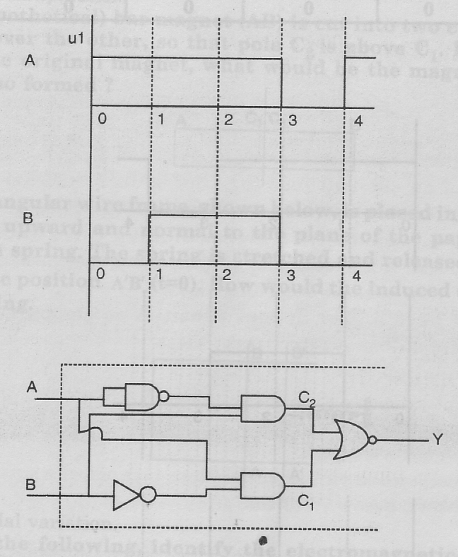
Input signals A and B are applied to the input terminals of the ‘dotted box’ set shown below.

Let Y be the final output signal from the box. Draw the wave forms of the signals labeled as C₁ and C ₂ within the box, giving (in brief) the reasons for getting these wave forms. Hence draw the wave form of the final output signal Y. Give reason for your choice. What can we state
(in words) as the relation between the final output signal Y and the input signals A and B?
- (a) Draw a plot of the binding energy per nucleon as function of mass number for a large number of
nuclei, 2 ≤ A ≥ 240. How do you explain the constancy of binding energy per nucleon in the range 30 < A < 170 using the property that nuclear force is short ranged?
(b) Using the relevant Bohr’s postulates, derive the expression for the (a) speed of the electron in the n^{th} orbit, (b) radius of the n^{th} orbit of the electron, in hydrogen atom.
OR
- Derive the mirror equation using the ray diagram for the formation of a real image by a concave mirror.
- Define the resolving power of a telescope. Write any two advantages of a reflecting telescope over refracting telescope.
- (a) What are coherent sources? Why are they necessary for observing a sustained interference
pattern? How are the two coherent sources obtained in the Young’s double slit experiment?
- Show that the super position of the wave originating from the two coherent sources S₁ and S₂ having displacement Y₁ = a cos ωt and Y₂ = a cos (ωt + φ) at a point produce a resultant intensity I = 4a² cos² (φ/2). Hence, write the conditions for the appearance of dark and bright fringes.
OR
- In a single narrow slit (illuminated by a monochromatic source) diffraction experiment, deduce the conditions for the central maximum and secondary maxima and minima observed in the diffraction pattern. Also explain why the secondary maxima go on becoming weaker in intensity as the order increases?
(b)How does the width of the slit affect the size of the central diffraction band?

