Sample Paper- 2013
Subject: INFORMATICS PRACTICES
Class XIIth

MM.: 70
Q1. Answer the following questions:
- Mr. Abhinav wants to implements a network using less cable length and data should be transmitted in one direction only. Name the topology and direction of data transmission.1
- What are Denial of Services Attacks? 1
- Given the following MAC address, can you identify its parts? Also specify who defines/specifies these parts number? 1
00:A3:O3:51:OE:AC
- What is a domain name? How is it alternatively known? 1
- Which of the following is not a characteristic of open source software? 1
- Its source code is available for modification
- It is owned by a company or an individual
- It can be downloaded by Internet
- What is open source based software? 1
- Which of the following softwares are open source: 2
Mozilla ,PostgreSQL, PHP, MySql
- Expand the following terms: 2
- FSF ii) FLOSS
Q2. Answer the following questions:
a) Sugandha has developed a login form in java. Which method will she use to obtain the password
from a password field. 1
b) Name any two types of inheritance supported by Java ? 1
- Which is the largest heading tag in HTML? 1
- What is wrong with the following code: 1
<OL type=”a” start=”d”>
- Differentiate between IF and Switch statement. 1
- What is the client server computing? Give example of a real life situation that uses 1 client server computing?
- Write a function in java that accepts two numbers as parameters and returns their product. 2
- Write two differences between HTML tags and XML tags. 2
3. Answer the following questions:
- If a database “Library” exists, which MySql command helps you to start working in that database.? 1
- A table ‘EMP’ has one of its column named Salary. Give the command in MySql to increase the salary of all the employees by 5%. 1
- Rajiv wants to remove all the rows from the table “Flight” but does not want to remove the structure of the table. Which command he should use? 1
- Which function in MYSQL returns the total number of characters from a character expression? 1
- A table Lab in a database has 7 columns and no rows in it. What is its cardinality? What will be its cardinality if 12 rows are added in the student table? 2
- The student names and marks column of a table “Student” are given below:
Name | Marks
Robin | 86
Prachi | 65
Nisha | 92
Geetansh | NULL
Based on the above information, find the output of the following queries: 2
- Select AVG(marks) from Student;
- Select marks+5 from student where marks>90;
- Can a table have multiple primary keys? Can it have multiple foreign keys? Also define foreign
key constraint. 2
4. Answer the following questions:
- What will be the contents of jTextField1 after executing the following statement : 1
int n=20;
n=n-6;
if(n<10)
jTextField1.setText(Integer.toString(n));
else
jTextField1.setText(Integer.toString(n-2));
- The following code has some error(s). Rewrite the correct code underlining all the corrections made: 2
Int n1,n2=10;
n1=n2-5;
if(n1=n2)
jTextField1.setText(“n1 and n2 are equal”);
else
jTextField1.setText(“n1 and n2 are not equal”);
- The Admission No. of a student is stored in a variable strAdmno. Sugandha wants to store this admission no. in an Integer type variable intAdmno. What java statement should she write to do this? 1
- Regal Theater has computerized its ticketing system. The programmer has developed a GUI application in Netbeans as shown below:
At ticket counter, three types of tickets(Box, balcony and General) at the rate of 200, 150 and 100 respectively are available. If the movie is tax free , then the total amount should be deducted by Rs. 25 per ticket.

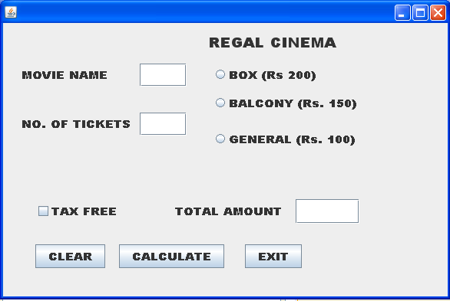
- What should be done so that only one of the radio button (Box, Balcony and general) can be selected at a time. 1
- Write code to do the followings :
- Calculate and display the Total amount in the corresponding text field when calculate button is pressed. 3
- Clear all the text fields. 1
- Close the application when Exit button is clicked. 1
Note : (You can assume any suitable names for various controls on the form)

- Rewrite the following program using a if statement. 2
int c=jComboBox1.getSelectedIndex();
switch(c)
{ Case 0: FinalAmt= billAmt; break;
Case 1: FinalAmt= 0.9*billAmt; break;
Case2: FinalAmt=0.8* billAmt; break;
default: FinalAmt= billAmt; break;
}

- How many times the following while loop get executed? 2
int p=5;
int q=36;
while(p<=q)
{ P+=6;
}
- Given a string object named Salary having value as “55000” stored in it. Obtain the output of the following. 1
JOptionPane.showMessageDialog(null,””+Salary.length()+Integer.parseInt(Salary)));
5. Answer the following questions:
a) What is the purpose of GROUP BY clause in MYSQL How is it different from ORDER BY clause? 1
b) Give difference between COMMIT and ROLLBACK commands used in MYSQL 1
c) Write SQL Commands for (a) to (d) and write the outputs for (e) on the basis of the following table : [1x8=8]
Table : FURNITURE
NO | ITEM NAME | TYPE | DATEOFSTOCK | PRICE | DISCOUNT
1 | White Lotus | Double Bed | 2002-02-23 | 3000 | 25
2 | Pink feathers | Baby Cot | 2002-01-29 | 7000 | 20
3 | Dolphin | Baby Cot | 2002-02-19 | 9500 | 20
4 | Decent | Office Table | 2002-02-01 | 25000 | 30
5 | Comfort zone | Double Bed | 2002-02-12 | 25000 | 30
6 | Donald | Baby cot | 2002-02-24 | 6500 | 15
7 | Royal Finish | Office Table | 2002-02-20 | 18000 | 30
8 | Royal tiger | Sofa | 2002-02-22 | 31000 | 30
9 | Econo sitting | Sofa | 2001-12-13 | 9500 | 25
10 | Eating Paradise | Dinning Table | 2002-12-19 | 11500 | 25
- To list the itemname which are priced at more than 15000 from the furniture table.
- To list itemname and type of those items, in which dateofstock is before 2002-02-01 from the furniture table in descending order of itemname.
- To display itemname and dateofstock of those items, in which the discount percentage is more than 25 from the furniture table.
- To count the number of items, whose TYPE is “Sofa” from the furniture table.
- Give the output of following SQL statement :
(i). select count (distinct type) from furniture;
(ii). Select max(discount) from furniture;
(iii). Select avg(discount) from furniture where type=”Baby Cot”;
(iv). Select sum(price) from furniture where dateofstock < ’2002-02-12’;
Q6. a) Write a SQL command to create a table LIBRARY with following structure: 2
Field | Type | Constraint
Book_no | Integer(4) | Primary key
Title | Varchar(40) | Not Null
Author | Varchar(30)
Publisher | Varchar(30)
Pages | Integer(4)
Date_of_pub | Date

b) In a database there are two tables ‘Employee’ and ‘Dept’ as shown below:
BRAND
ICODE | BRAND
101 | SONY
202 | HP
303 | LG
404 | IFB
ITEM
CODE | INAME | PRICE
101 | TELEVISION | 75000
202 | COMPUTER | 42000
303 | REFRIGERATOR | 90000
404 | WASHING MACHINE | 27000
Write MYSQL queries for the following:
- To display ICode, IName and corresponding Brand of those items, whose price is between 20000 and 45000(both values inclusive) 2
- To display ICode, Price and BName of the item which has IName as “Television” 2
- To increase the Price of all items by Rs. 15%. 2
c) Given below is a Table: Customer
C_ID | Cust_Name | City | Item_No
01 | Dreams Disney | New Delhi | P002
05 | Life time inc. | Mumbai | P005
12 | Happy Travels | New Delhi | P001
15 | Apeksha Pvt. Ltd. | Madras | P003

- Identify Primary key in the table given above. 1
- Write MySql query to add a column Price with data type Integer and size 6 in the table customer. 1
Q 7(a) What social impact does e-Governance has on society? 1
(b) Define e-business? Give URL of one of the commonly used e–Business portals. 2
(d) Mr. Anurag Das is creating a form for his practical file. Help him to choose most appropriate controls from List Box, Combo Box, Text Field, Text Area, Radio Button, Check Box, Label and Command Button for the following entries from user: - 2
- A message “Enter your Name” in front of a Text Field.
- An input to choose more than one subjects from a set of given choices.
- An input for entering comments of user.
- An input for accepting Gender out of Male & Female.

ALL THE BEST

TIPS
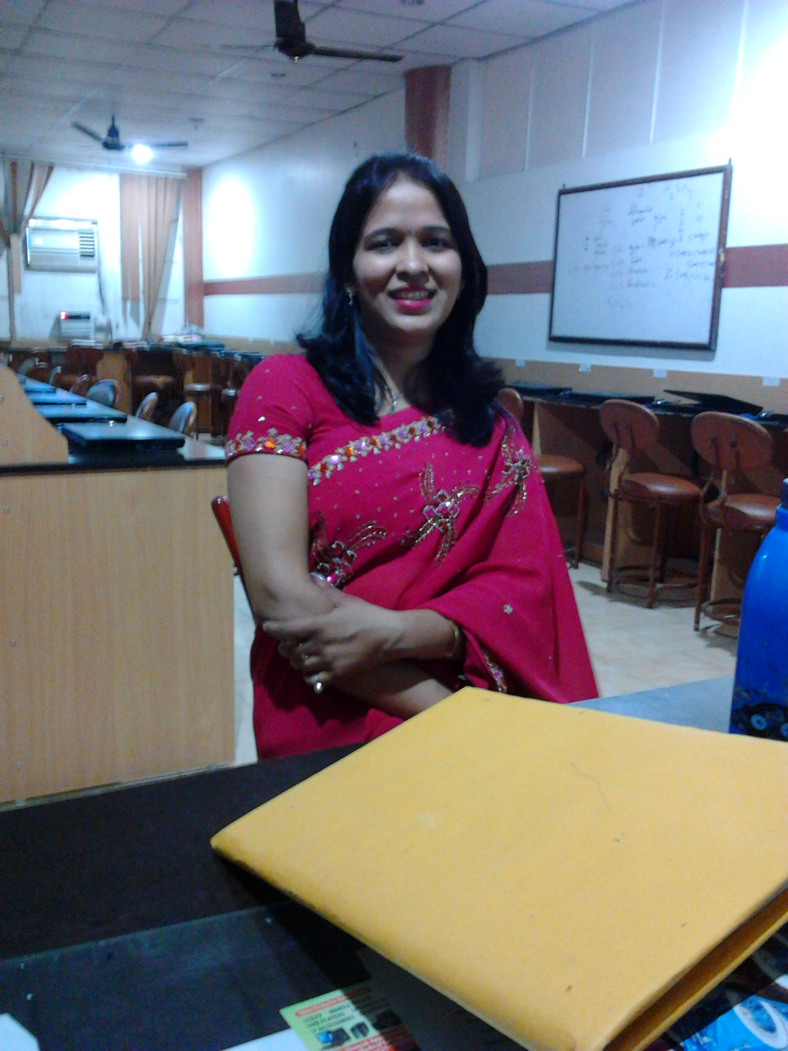
  - Read the question paper carefully.
  - It is a Board based sample paper. It is not compulsory that
questions will come from this paper.
  - After completing the paper, again go through the questions
and their solutions.
  - Answer all the questions.
MANI JAIN
CITY VOCATIONAL PUBLIC SCHOOL

