MATHEMATICS 2007
SAMPLE QUESTION
Class: X
Time : 3 1/4 hrs Marks :80
General Instructions
1. All questions are compulsory
2. The question paper consists of 25 questions divided in to three sections A, B and C .Section A contains 7 questions of 2 marks each .Section B is of 12 Questions of 3 marks each and section C of 6 Questions of 5 marks each
3. There is no overall choice .However ,internal choice has been provided in two questions of two marks each, two questions of three marks each, two questions of five marks each
4. In question on construction ,drawing should be neat exactly as per the given measurements.
5. Use of calculators is not permitted.
SECTION-A
- On a New Year eve 5 cats decided to have a party. They went to some restaurant but unfortunately they get only 3 rats. What is the probability that a cat will remain hungry if we assume that one cat eat not more than one rat.
- If the sum of first 10 terms of an A.P is zero and the sum of next 10 terms are 100. Find an AP.
OR
Find the sum of all three digit numbers which leave remainder 2 when divided by 5.
- In Akbar court once the Birbal was asked for reward. He says” my Lord take a chess board. Put one coin in first box and put the double of coin which you had put before in the second box and so on. Is this AP? If yes find total number of coins.
- solve for u and v
2u + 15v + 17uv, 5u + 5v + 36uv
OR
If x+3 is a factor of
- For what value of k, the g.c.d. of x² + x - (2k + 2) and 2x² + kx - 12 is x + 4?
- The diagonals AC and BD of a quadrilateral ABCD intersect each other at O such that
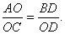
Prove that the quadrilateral ABCD is trapezium.
OR
In the following figure, O is the centre of the circle and ∆ AOB is an equilateral triangle. Find angle ACB

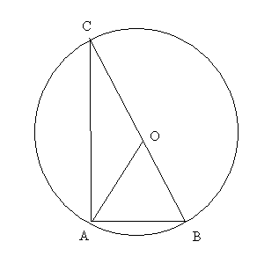
- A refrigerator is listed at Rs.8000 it is available for Rs. 5000 cash down payment and Rs. 3250 to be paid back after six months. Find the rate of interest charged under the installment plan.
SECTION-B
- The line joining the points (2,1) and (5,-8) is trisected at points P and Q. if the
Point P lies on the line 2x-y+k=0.
OR
Show that the points A (3,-1), B (5,-1) and C (3,-3) are the vertices of right angled
Triangle.
- Plot the points P (-4, 0), Q (3, 0) and R (3, 7) in a rectangular coordinate system.
Find the coordinates of the fourth point S such that PQRS is a square.
- If the roots of the equation (p - q) x² + (q - r) x + (r - p) = 0 are equal, prove that 2p = q + r. Find the value of p for which the following equations has real roots:
- A PUDA society charges for a flat Rs. 26, 00,000 or Rs. 15, 45,999 cash down payment and four equal half yearly installments. If the society charged 18% p.a. compounded half yearly, calculate the value of each installment and the total interest charged.
- Solve the following system of linear equations graphically and then find the points where the lines meet y- axis:- 3x + y - = 0, 2x - y - 5 = 0
- if the following figure angle B is 90 and the side BC of a ∆ ABC is trisected at the points D and E. prove that
8AE² = 3 AC² + 5 AD²

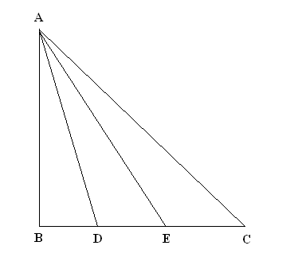

- The LCM and GCD of two polynomials, P(x) and Q(x) are 56(x⁴ + x) and 4(x² - x + 1) respectively. If P(x) = 28(x³ + 1), find Q(x).
- simplify
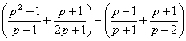
- The radii of the faces of a frustum of a cone are 3cm and 4cm and its height is 5 cm. Find its volume.
OR
The radii of two cylinders is in ratio 2 : 3 and their height are in the ratio of 5 : 3. Calculate the ratio of their volumes.
- if
OR
Without using the trigonometric tables, evaluate the following
- OSHO GEARS LTD One of the leading gear company has the following major vendors. The sales of the company to major company are represented in following chart.
- If the supply to Star motors is 20,000 gears what is its supply to others.
- What is the ratio of their supply to Sonalika Motors to Swaraj Tractors?
- Draw a circle of radius 5 cm. take a point p on it. Construct a tangent at the point P without using the centre of circle. Write thae steps of construction also.
SECTION-C
- Mrs. Ambika, who is a senior citizen has an annual in come of, is Rs 4, 75,000. She donates Rs 20,000 to Prime Minister’s Relief Fund ( 100% exemption ), Rs 5000 to an orphanage ( 100% exemption ) and Rs 15,000 to a Charitable Society ( 70% exemption). She contributes Rs 1, 00,000 towards PPF and pays quarter-yearly premium of Rs 6,000 towards Life Insurance. She also purchases NSC for Rs 30,000. She pays Rs 1,000 per month towards income tax for 11 months. What is her tax liability for the last month of the financial year?
- Prove that the sum of either pair of opposite angles of quadrilateral is 180°. Using the above theorem find the value of x and y.
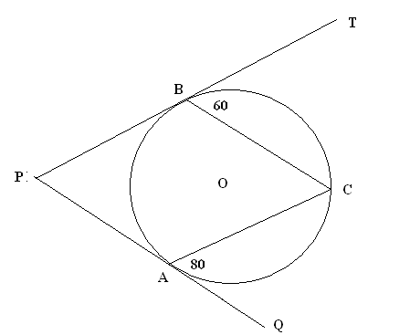
OR
In the following figure AD and BE are respectively perpendiculars to BC and AC. Show that
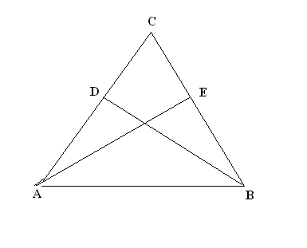
- a) Two circles with a radii a and b touch each other externally. Let c be the radius of a circle which touches these two circles as well as a common tangent to the circles. prove that
b) If PA and PB are two tangents drawn from a point P to a circle with centre O
Touching it at A and B, prove that OP is perpendicular bisector of AB.
- The angle of depression of the top and the bottom of a building 60 m height as observed from the top of the tower are 45 and 60 respectively. Find the height of the tower and the horizontal distance between the building and the tower.
OR
The angles of elevation of the top of a tower, as seen from two points A and B situated in the same line and at distances u and v respectively from the foot of the tower, are complementary. Prove that the height of the tower is
- Find the mean age of the females in the survey done in a community from the following data:

Marks | Number of students
Below 10 | 14
Below 20 | 10
Below 30 | 33
Below 40 | 43
Below 50 | 30
Below 60 | 40

Give your feedback
VIKRANT AGGARWAL –ludhiana
09915089502 , vikrant0805@gmail.com

