Sample Paper 2013
Subject-Informatics Practices
Class XII

Time- 3hrs Max^{m} Marks- 70

Read the Questions carefully
Mention Question number and its options properly

Answer all the questions:-

Q1 | (a) | Write short notes on the following :  (i)LAN (ii) MAN (iii) WAN (iv) PAN |  |  | 2
 | (b) | Write the name of software/Hardware used to prevent unauthorized access of Local Area Network? |  |  | 1
 | (c) | What are the main features of networking? |  |  | 1
 | (d) | (i) Name the two Indian scripts included in Unicode?  (ii) Define the following:  (a) Router (b) Repeater |  |  | 2
 | (e) | The process of preventing legitimate users of the system from accessing or using the resources, information, or capabilities of the system is known as what? |  |  | 1
 | (f) | (a)Expand the term (i) FLOSS (ii) SDLC |  |  | 2
 |  | (b)What are the following software used for (a) PHP (b) Tomcat
 | (g) | Define the following with reference to threats to network security?  (i) Worm  (ii) Trojan Horse |  |  | 1
Q2 | (a) | What will be an output of the following code if value of a is  (i) 2 (ii) 4 (iii) none  switch(a)  {  case 0 : System.out.println(“ C”);  case 1 : System.out.println(“ C++”);  case 2 : System.out.println(“ VB”);  case 3 : System.out.println(“ Java”); break;  case 4 : System.out.println(“ PHP”);  default : System.out.println(“ ASP”); break;  } |  |  | 1
 | (b) | Find the output of the following program:  int c = 0, i = 2;  while(i<10) {  c = ++i – i*2;  }  System.out.println(“c = “ +c + “i = “+i); |  |  | 1
 | (c) | What are these methods used for ?  (i) isEditable() (ii) setEditable() (iii) setEchoChar() ( iv) getSelected Index() |  |  | 2
 | (d) | Find out Errors if any :  m = 1;  n = 0;  for( ; m+n <10 ; ++n)  system.out.print(“ Hello \n”);  m = m +10; |  |  | 1
 | (e) | What is the difference between if construct and while loop? |  |  | 1
 | (f) | Write the name of HTML tag used to include  (a) Bulleted list  (b) Numbered list in a HTML Web page. |  |  | 1
 | (g) | XML is case sensitive. Write true/false? |  |  | 1
 | (h) | What is the difference between executeQuery() and executeUpdate() Methods? |  |  | 1
 | (i) | (a) Differentiate between bgcolor and background attribute of body tag?  (b) What is an use of the following tags <HR> <br> and <TR> |  |  | 2
3 | (a) | Which function in MySql is used to show current date and time? |  |  | 1
 | (b) | Mrs Smita created the following table Doctor and forgets to declare primary key on docid. Help her to do the same by writing proper command? |  |  | 1
  DocId | DocName | DateofJoinning
 | (c) | How Alternate key in a table is different from Candidate key? |  |  | 1
 | (d) | Write the command using function to display the digits after decimal place up to 2 digits only.  4325.7869 |  |  | 1
 | (e) | What is the difference between having and where clause? |  |  | 1
 | (f) | Write query to join two tables empl and dept on the basis of field deptno? |  |  | 1
 | (g) | Write SQL statement to drop a column regno from table candidate which is primary key? |  |  | 1
 | (h) | What is the difference between Alter and update command in MySql? |  |  | 1
 | (i) | Write the command in MySql for the following:  (a) To display name of students from student table whose name ends with “an”?  (b) To display the detail of students from student table whose total_marks is less than 450 and grater than 250. Total_marks is the column in Student table. |  |  | 2
4 | (a) | (i) What is Meta language? Write the name any one Meta language?  (ii) In XML tags are system defined . Write true/false? |  |  | 2
 | (b) | Write code for Add and Remove button to add and remove items in the list during run time?  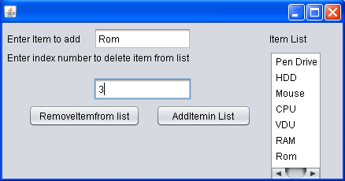 |  |  | 2
 | (c) | How many times does the following while loop get executed ?  int x = 3;  while(x<10)  {  x + = 2 ;  System.out.println(“”+x);  } |  |  | 1
 | (d) | Write sample code to display a message box containing message “WELCOME TO DCS” ? |  |  | 1
 | (e) | Given below is the form. Write sample code for “Calculate discount” button and Calculate net amount button as per the following scheme to calculate discount and net amount:  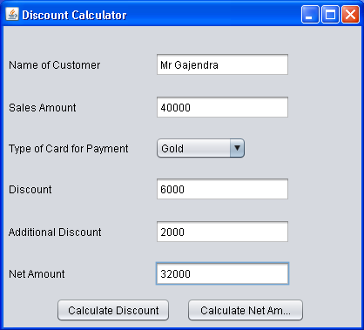  Calculate additional discount 5% of Sales amount if sales amount is more than 30000. |  |  | 3
  Type of Card | Offer
  Gold | 15%
  Platinum | 25%
  Silver | 10%
5 | (a) | Write java code that take any number from user in jTextField1 and display its factorial in jTextField2? Calculate factorial using while loop? |  |  | 2
 | (b) | Write the sample code for two buttons given in the form to add rows and display number of rows in the table in the dialog box like given below? Use suitable control names.  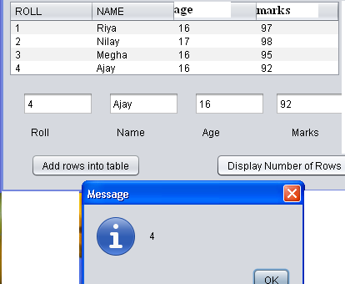 |  |  | 3
 | (d) | (i) What do you mean by Degree and Cardinality of a table created in MySql? |  |  | 2
 |  | (ii) What do you mean by implicit and explicit transaction?
 | (e) | Depending upon the table STORE given below write sql queries for the following:  - To display details of all items in store table in increasing order of MFG_Date.  - To display ItemNo and ItemName of those items from store table whose rate is less than 35.  - To display sum of qty and maximum of rate from Store table of an ITEM.  - To display ItemNo and ItemName of those items from store table whose qty is greater than 20 and rate is greater than 10. |  |  | 4
  ITEMNO | ITEMNAME | SCODE | QTY | RATE(in hundred) | MFG_DATE
  1003 | PENDRIVE | 12 | 40 | 4 | 2012-07-09
  1006 | CPU | 32 | 70 | 50 | 2011-08-10
  1005 | RAM | 13 | 80 | 12 | 2010-09-19
  1009 | MOUSE | 22 | 70 | 1 | 2013-01-10
  1008 | KEYBOARD | 33 | 30 | 2 | 2013-01-20
  1004 | PRINTER | 44 | 32 | 45 | 2013-01-06
  1007 | HARD DISK | 15 | 20 | 35 | 2012-04-07
Q6 | (a) | What is the difference between round and truncate function in mysql? |  |  | 1
 | (b) | What will be an output of the following sql commands?  (i) Select mid(“Divine Child School”,3,length(“Rama”));  (ii) Select Mod(14*9,90/3); |  |  | 2
 | (c) | Consider the tables Item and Customer given below:  Items  CUSTOMER
  Item_Id | Item_Name | Price
  PC01 | Personal Computer | 25000
  LC05 | Laptop | 45000
  PC03 | Personal Computer | 22000
  PC06 | Personal Computer | 18000
  C_Id | CName | City | I_Id
  101 | B.Patel | Rajkot | LC03
  106 | R.Chaudhary | Mehsana | PC03
  112 | A.Shah | Ahmedabad | PC06
  115 | S.Gupta | Jamnagar | LC03
With reference to these tables, write commands in SQL for(i) and (ii) and output for (iii) given below:
- Display the CName,City from Customer and Itemname and Price from table Item, with their corresponding matching I_Id. 1
- Display the CName,itemname from the table customer and item having price more than 15000. 1
- Select CName,ItemName from Item,Customer 2
Where Item.I_Id=Customer.I_Id;

 | (d) | Write SQL statement to create the table Student given below as per specification |  |  | 4
  Column Name | Roll | Name | Marks | City
  Data type | Varchar | Varchar | Number | Varchar
  Size | 6 | 30 |  | 30
  Constraint | Primary key |  |  | Default Delhi
  Insert at least one record
 | (c) | (i) Write SQL statement to add a column School_Name of data type Varchar(20) in the above table.  (ii) Write SQL statement to change name of the column City to State. |  |  | 1  1
 |  | (iii) Write SQL statement to delete all the rows of the table. |  |  | 1
Q7 | (a) | Write any two advantages of the following e-Governance, e-Learning and e-Business? |  |  | 3
 | (b) | What components are used for creating Front-end for the following: |  |  | 2
  a. | To select any one option from multiple options.
  b. | An input to choose more than one subjects from a set of given choice
  c. | To enter description of an item
  d. | To enter encrypted text
--------

