GUESS PAPER – 2013
CLASS - XII
SUBJECT – (INFORMATICS PRACTICES)
Time Allowed : 3 Hours | Maximum Marks : 70
General Instructions :
- All questions are compulsory.
- Question Paper is divided in to 3 Sections(A,B and C)
- Section –“A” consist of 30 Marks
- Section-“B” consist of 25 Marks
- Section –“C “ consist of 15 Marks.
- Attempt all the parts of section together

SECTION -A

Q1.(a) In which Topology,each node is connected to other all nodes directly? 1
(b) Define IP address. 1
(c) Which symbol is used to separate the MAC address? 1
(d) Which of the communication media, will you suggest to be procured by the company for connecting their local offices in Mumbai for very effective and fast communication. 1
(i)Optical Fiber (ii)Ethernet Cable (iii)Telephone Cable
(e) What is the difference between star and Ring topology 2
(f) Identify the wired and wireless technologies from the followings: 2
Blue Tooth, Optical Fiber, Co-axial, Infrared
(g)Expand the following terms: 2
(i) FLOSS (ii) OSS
Q2.(a) By default a combo box does not offer editing features. How would you make a combo box editable? 1
(b)Which Tag is used to create ordered list in HTML 1
(c) Why is it necessary to put break statement after every case in a switch statement? 1
(d)Which is the largest heading tag? 1
(e) What will be the values of x and y after execution of the following code. 2
int x, y = 0;
for (x=1; x<=5; ++x)
y = x++
-y;
(f)Write a function in java that accepts two numbers as parameters and returns their product. 2
(g)Name any four control types supported by HTML forms. 2
Q3. (a) Which Command is used in MySql to make the changes permanent? 1
(b) What is Join? 1
(c) What is the significance of NOT NULL constraint? 1
(d)Pooja has created a table in MySql.Later on she found that the width of name column is not sufficient for entering some log names. She wants to increase the width of the name column .Which command she should give to do this? 1
(e) Define PRIMARY KEY constraint. How will you add a Primary Key constraint later in a table? 2
(f) A table supplier in a database contains 4 rows and 5 columns what is the degree and cardinality of the table? 2
(g)The COACH_NAME column of a table “club” is given below:
COACH_NAME
Ramesh
Sunil
Amit
Rohan
Lucky
Based on this information, find the output of the following queries: 2
- SELECT Coach_name FROM club where Coach_name like ‘_u%’;
- SELECT Coach_name FROM club where Coach_name like ‘%a%’;

SECTION –B
Q4. (a) Define Base class and Derived class. 1
(b) What is meant by case sensitive? Is java case sensitive? 1
(c)What will be the contents of sum after executing the following code: 1
int i=2, j=5, sum =0;
while (i <j)
{
sum+ =i;
i++;
}
(d) Rewrite the following fragment using switch 2
Char ch = “N”;
If (ch = =’E’)
eastern++;
elseif (ch = =’W’)
western++;
elseif (ch = =’N’)
northern++;
elseif (ch = =’S’)
southern++;
(e) What will be the contents of jtextField1 and jtextField2 after executing the following code: 2
JtextField1.setText(Math.pow(3,4)+ “’’);
JtextField2.setText(Math.round(23.172)+ “’’);
(f) The following code has some error(s). Rewrite the correct code underlining all the corrections made: 2
Int i=2, j=5;
While j>i
{
jtextField1.getText(“j is greater”);
j--; ++I;}
joptionpane.showMessageDialog(“Hello”);
(g) ABC is bank wants to calculate the compound interest of his clients. He ask software programmer to design an interest calculator. Rate of Interest will be calculate according to following criteria:
Time Rate of Interest
2 Years 8%
3 Years 9%
5 Years 10%
and to calculate the interest amount is P*(1+R/100) ☹T
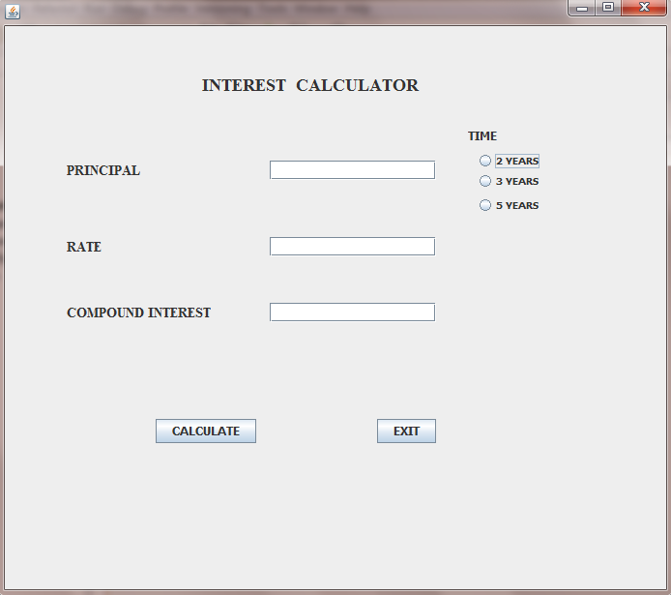
(a)Write the code to make the textFields for rate and compound interest uneditable 2
(b) Write the code to do the following:
(i)When calculate button is clicked the rate of interest and interest amount should be calculated as per above criteria and displayed in the respective text fields. 3
(ii) Close the application when Exit Button is clicked. 1
Q5. (a) What is the difference between Drop table and Delete commands used in Mysql? 2
(b)Write the output of the following SQL queries: 2
- SELECT INSTR(‘MAHATMA GANDHI’,4,2);
- SELECT LCASE(‘informatics Practices’);
- SELECT MONTH(‘2008-04-12’);
- SELECT SUBSTR(‘TITANIC’2,3);

(c) ) Consider the table CRICKET given below .Write the commands in SQL for (i) to (iv) and output for (v) to (viii). 6
TABLE CRICKET
S.NO | PLAYER | AGE | CITY | RUNS | WICKETS
1 | Sachin Tendulkar | 39 | Mumbai | 15216 | 105
2 | Virender Sehwag | 37 | Delhi | 6244 | 82
3 | M.S.Dhoni | 32 | Rachi | 5219
4 | Rahul Dravid | 37 | Banglore | 9325 | 11
5 | Yuvraj Singh | 32 | Mumbai | 8244 | 126
- To display all the information about the players who lived in Mumbai city
- To display Players name, age and runs who have scored more then 8000 runs
- To display Player name and city of those players who have not taken any wickets
- To count the numbers of players of each city
- Select Min(age) from Cricket;
- Select Max(runs )from cricket;
- Select Count( Distinct (city)) from cricket;
- Select Avg(Wickets) from cricket;

SECTION –C

Q6(a) Write the SQL command to create a table Sports with the following structure: 2
Table: Sports
FIELD | TYPE | CONTRAINT
Sno | Integer(3) | Primary Key
Name | Varchar(20) | Not Null
Age | Integer(2)
Address | Varchar(30)
City | Varchar(20)
(b) In a database, there are two tables “Employee” and “Dept” as shown below: 2
DEPT
DEPT_CODE | DEPT_NAME
MKTG | MARKETING
PERS | PERSONAL
ACCT | ACCOUNTS
EMPLOYEE
EMP_NO | EMP_NAME | SEX | DEPT_CODE
1 | Nidhi | F | ACCT
2 | Rajesh | M | MKTG
3 | Pankaj | M | PERS
4 | Puneet | M | ACCT
5 | Amita | F | MKTG
- identify the foreign key column in the table employee.
- How many rows and columns will be there in the Cartesian product of these two tables.
(c) Consider the tables Student and House given below: 6
HOUSE
H_CODE | HOUSE_NAME
H1 | VIRJANAND
H2 | SHARDHANANAD
H3 | DAYANAND
STUDENT
ADM_NO | NAME | CLASS | H_CODE
1001 | ANKITA | VII | H2
1002 | RAHUL | IX | H1
1003 | SAHIL | VII | H1
1004 | ANUJ | X | H3
1005 | DEEPTI | IX | H2
With reference to these tables, write commands in SQL for (i) and (ii) and output for (iii) given below
- Display the Adm_No, Student Name and House name of the students of class VII.
- Count the numbers of student of SHARDHANANAD house
- Select House_Name, Count(*) from student,house where student.H_code=house.H_Code group by H_Code;

Q7.(a) Write two benefits of database connectivity. 1
(b) Write two positive social impact of E-Governance. 2
(c)What controls will you suggest for the following inputs: 2
S.NO | CONTROL USED TO | CONTROL
1 | Enter Employee Name
2 | Gender
3 | Select Post applied for
4 | Submit the Form

PAPER SUBMITTED BY :
GAURAV BHATIA
MOB: 09719025585
E-mail:gauravbhatia1@rediffmail.com

