Guess Paper – 2013
Class – XII
Subject – BIOLOGY

Time Allowed: 3 Hrs Maximum Marks: 70

General Instructions:
- All questions are compulsory.
- The question paper consists of four sections A, B, C and D. Section-A contains 8 questions of 1 mark each, Section-B contains 10 questions of 2 marks each, Section-C has 9 questions of 3 marks each and Section-D contains 3 questions of 5 marks each.
- There is no overall choice. However, an internal choice has been provided in one question of 2 marks, one question of 3 marks, and all the three questions of 5 marks weightage. A student has to attempt only one of the alternatives in such questions.
- Wherever necessary, the diagrams drawn should be neat and properly labeled.

SECTION-A

- Identify the type of carpel with the help of diagrams given below:

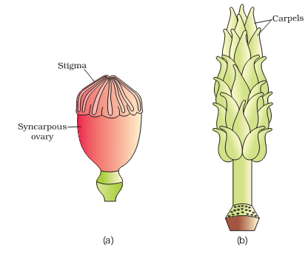

If the sequence of nitrogen bases of the coding strand of DNA in a transcription unit is:
5' - A T G A A T G - 3',
What would be the sequence of bases in its RNA transcript .
- A bacterial cell was transformed with a recombinant DNA that was generated using a human gene. However, the transformed cells did not produce the desired protein. Explain the reason.
- Name an industry which can cause air pollution, thermal pollution and
eutrophication.
- Why is genetic variation important in the plant Rauwolfia vomitoria?
- In 1953 S. L. Miller created primitive earth conditions in the laboratory and gave experimental evidence for origin of first form of life from pre-existing non-living organic molecules. What were the primitive earth conditions created by them.
- During reproduction, the chromosome number (2n) reduces to half (n) in the gametes and again resume the original number (2n) in the offspring, what are the processes through which these events take place?
- Name a microbe used for statin production. How do statins lower blood cholesterol level?
SECTION-B
- Is pollination and fertilisation necessary in apomixis? Give reasons.
- What would happen to immune system, if thymus gland is removed from the body of a person?
- Males in whom testes fail to descent to the scrotum are generally infertile. Why?
- In a certain population, the frequency of three genotypes is as follows:
Genotypes: BB Bb bb
frequency: 22% 62% 16%
What is the likely frequency of B and b alleles?
OR
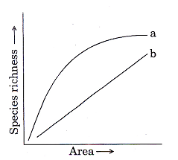

The above graph shows Species-Area relationship. Write the equation of the curve ‘a’ and explain.
- If a regular dose of drugs or alcohol is not provided to an addicted person, he shows some withdrawl symptoms. List any four such withdrawal symptoms.
- Differentiate between benign and malignant tumours.
- Identify the type of the given ecological pyramid and give one example each of
pyramid of number and pyramid of biomass in such cases.
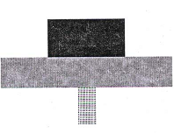

- What is meant by ‘hidden hunger’?
- Many microbial pathogens enter the gut of humans along with food. What are the preventive barriers to protect the body from such pathogens? What type of immunity do you observe in this case?

SECTION-C
- Briefly explain IVF and ET. What are the conditions in which these methods are advised?
OR
Draw a labeled diagram of the reproductive system in a human female.
- In a Mendelian monohybrid cross the F2 generation shows identical genotypic and phenotypic ratios. What does it tell us about the nature of alleles involved? Justify your answer.
- What is the basic principle of vaccination? How do vaccines prevent microbial infections? Name the organism from which hepatitis B vaccine is produced.
- Identify and explain steps ‘A’, ‘B’ and ‘C’ in the PCR diagram given below.

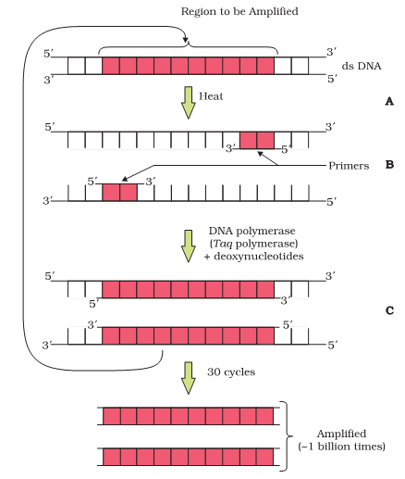

- Comment on the utility of variability in number of tandem repeats during DNA finger printing.
- Fill in the blanks

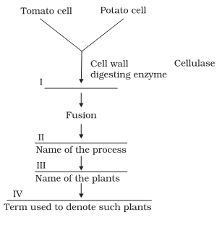

- (a) Sickle celled anaemia in humans is a result of point mutation. Explain.
(b) Write the genotypes of both the parents who have produced a sickle celled
anaemic offspring.
- (i) State the consequence if the electrostatic precipitator of a thermal plant fails to function.
(ii) M ention any four methods by which the vehicular air pollution can be controlled.

- A wine maker and a molecular biologist who has developed a recombinant vaccine, both claim themselves to be biotechnologist. Who in your opinion
is right?
- You are repeating the Hershey-Chase experiment and are provided with two isotopes: 32 P and 15 N (in place of 35 S in the original experiment). How do you expect your results to be different?

SECTION-D

- Rose plants produce large, attractive bisexual flowers but they seldom
produce fruits. On the other hand Lady’s finger produces plenty of fruits.
Analyse the reasons for failure of fruit formation in rose.
OR
What role does pituitary gonadotrophins play during follicular and ovulatory phases of menstrual cycle and also explain the shift in
steroidal secretions.
- Define an operon. giving an example, explain an Inducible operon.
OR
A normal visioned woman, whose father is colour blind, marries a normal visioned man. What would be the probability of her (a) sons (b) daughters
to the colour blind? Explain with the help of pedigree chart.
- (a) Explain primary productivity and the factors that influence it.
(b) Describe how oxygen and chemical composition of detritus control
decomposition.
OR
(a) What is El Nino effect? Explain how it accounts for biodiversity loss.
(b) Explain any three measures that you as an individual would take, to reduce environmental pollution.

Paper Submitted By:jagnnath dhere
Mobile:8698892689
Email:jagnnath10@gmail.com

