Guess Paper-2013
CLASS-XII
Sub: Computer Science
Time allowed : 3 hours

General Instruction
- Please check that this question paper contains 7 questions.
- Please write down serial number of the question before answering it.
- All questions are compulsory.
- Programming language : C++

Q1.(a) What is the difference between Class and Object? Give an example in c++ to illustrate both. (2
(b) Name the header files, to which the following built-in functions belong to: (1
        - getc ( ) (ii) exit()

(c) Identify and correct the error(s) in the following program: (2
#include <iostream.h>
#include <conio.h>
void main()
{ float class = 10.7;
float y;
y = class % 5.45;
cout<<class <<", "<<y;
getch();
}

(d) Give the output of the following Program: (2
#include<iostream.h
CONST int CONST 3.14159
int a = 3;
void func (int &x, int y, int *z)
{ cout<< CONST << endl;
a + = x;
y * = a;
*z = a + y;
cout<<a<<”, “’<<x<< “,”<<y<<”,“<<z<<endl;
}
void main( )
{ int a = 2, b=5;
func(::a,a,&b);
cout<<::a<<”,”<<a<<”,”<<b;
}
(e) Give the output of the following Program: (3
#include<iostream.h>
void withdef ( int HisNum = 30)
{
for ( int I = 20 ; I<= HisNum; I+= 5)
cout<<I<<”,”;
cout<<endl;
}
void Control( int &MyNum )
{ MyNum + = 10;
withdef(MyNum);
}
void main( )
{ int YourNum = 20;
Control(YourNum );
withdef( );
cout<< “Number=”<<YourNum<<endl;
}
(f) Study the following program and select the possible output from it : (2
#inlude<iostream.h>
#include<conio.h>
#include<stdlib.h>
const int LIMIT = 5;
void main( )
{ randomize( );
int Points;
Points = 100 + random(LIMIT);
for ( int p = Points; p>=100; p--)
cout<<p<<”#”;
cout<<endl;
}
- 104#103#102#101#100#
- 104#103#102#101#100
- 101#102#103#104#105#
- 014#103#102#101#100#
Q.2 (a) What do you understand by Copy Constructor? Explain it with a suitable example. (2
(b) Answer the questions (i) and (ii) after going through the following class: (2 class Dance
{ int days;
public:
Dance ( ) // Function 1
{
days = 50; cout << “ Dance starts now” << endl;
}
void danceschedule( ) // Function 2
{ cout << “ The schedule of the dance starts here” << endl;
}
Dance (int Duration) // Function 3
{ days = Duration; cout << “ Dance journey starts now” << endl;
}
~ Dance ( ) // Function 4
{ cout << “ Dance, life cycle ends here” << endl;
}
};
- In Object Oriented Programming, what is Function 4 referred as and when does it get invoked/ called?
- In Object Oriented Programming, which concept is illustrated by Function 1 and
Function 3 together? Write an example illustrating the calls for these functions.
(c) Define a class Mobile in C++ with the following descriptions : (4

Private members :
mcode of type string
mtype of type string
mosname of type string
mscreensize of type integer
mrppvalue of type float
mdiscount of type float
mactsaleprice of type float
A function AdjustPrice ( ) which calculates and assigns the value of mactsaleprice as follows :
mosname mactsaleprice
Android mrppvalue-10% on mrpvalue
iOS mrppvalue-9 % on mrpvalue
Others mrppvalue-15 % on mrpvalue
Public members:
A constructor to assign initial values of mcode with “MCODE01”, mtype with “Tablet” , mosname with “Android”, msscreensiz, mrppvalue, mdiscount and mactsaleprice with 0.
A function GetData( ) to input the values of the data all members variables. and invoke the AdjustPrice( ) function.
A destructor to print “object is being destroyed”.
A function to Display( ) which displays the content of all the data members for a Mobile.

(d) Answer the questions (i) to (iv) based on the following code: (4
class Car
{ char Model[10];
char Date_of_purchase[10];
char Company[20];
public( );
Car( );
void entercardetail( );
void showcardetail( );
};
class Accessories : public Car
{
protected:
char stereo_tape[30];
char sheet_cover[20];
public:
float Price;
Accessories( );
void enteraccessoriesdetails( );
void showaccessoriesdetails( );
};
class Dealer : public car
{ int No_of_dealers;
char dealers_name[20];
int No_of_products;
public:
Dealer( );
void enterdetails( );
void showdetails( );
};
- (a) How many bytes will be required by an object of class Car and an object of class Dealer?
(b) Which type of inheritance is illustrated in the above c++ code?
- Write names of all the data members which are accessible from the objects of class Dealer.
- Write names of all the members accessible from member functions of class Accessories.
- Write names of all the member functions which are accessible from objects of class Dealer.

Q.3 (a) Write the function AddArray() in C++ to club the values( ascending order) of two arrays. (3
(b) Write enumeration in C++ to store the names of days. (3
(c) Define functions pushnode( ) to insert nodes and popnode( ) to delete nodes, for a Linked List implemented Stack having the following structure for each node: (4
struct node
{
char student[20];
int age;
node *node;
};
- What are the difference between Linked List And Dense List? (2
(e) Write a user defined function Upper_half() which takes a two dimensional array A, with size N rows and N columns as arguments and point the upper half(diagonally) of the array. eg. (2
2 3 1 5 0 2 3 1 5 0
7 1 5 3 1 1 5 3 1
If A is 2 5 7 8 1 The Output Will be 7 8 1
0 1 5 0 1 0 1
3 4 9 1 5 5

Q4. a) Observe the program segment given below carefully and answer the question that follows: 1
class Student
{
long rollNumber;
char student[20];
float marks;
public:
void GetData( );
void ShowData( );
void PointChange( );
long getRollNumber( ) {return rollNumber;}
};
void ReplaceUpdateMarks(long Id)
{
fstream file;
file.open (”Team.Dat”,ios::binary|ios::in|ios::out);
Student T;
int Record=0, found=0;
while(!found && file.read((char*)&T, sizeof(T)))
{
if (Id==T.getRollNumber( ))
{
cout<<”Enter New Marks”;
T.PointChange ();
_________________ //Statement 1
_________________ // Statement 2
Found=1;
}
Record++;
}
if(Found==1)
cout<<”Record Updated”;
file.close( );
}
Write the statement 1 to position the File Pointer at the beginning of the Record for which the Student's Roll Number matches with the argument passed, and Statement 2 to write the updated record at the Position.
(b) Write a function in C++ to print the count of the word “Technology” and “India” (ignoring the case) as an independent word in a text file education.TXT.
If the file “education.txt” content is as follows:
Technology brings innovation in education.
Misuse of technology destroys the system.
Indian education is becoming tech-savvy.
(2
(c) Write a function in C++ to search and display details, whose destination is “Chandigargh” from a binary file “Flight.Data”. Assuming the binary file is containing the objects of the following class: (3
class FLIGHT
{ int Fno; // Flight Number
char From[20]; // Flight Starting Point
char To[20]; // Flight Destination
public:
char * GetFrom ( ); { return from; }
char * GetTo( ); { return To; }
void input() { cin>>Fno>>; gets(From); get(To); }
void show( ) { cout<<Fno<< “:”<<From << “:” <<To<<endl; }
};

Q 5. (a) Differentiate between Primary key and Foreign Key in context of RDBMS. Give suitable
example. (2
(b) Write SQL commands for the statements (a) to (i) and give outputs of the SQL Queries (i) to (vi) on the basis of CUSTOMER_DETAILS (1*6=6

Table: CUSTOMER_DETAILS
CUST_ID | CUT_NAME | ACCT_TYPE | ACCULT_AMT | DOJ | GENDER
CNR_101 | Manoj | Saving | 1025000 | 1999-02-19 | M
CNR_102 | Rahul | Current | 1326000 | 1998-01-11 | M
CNR_103 | John | Saving | 1425000 | 1999-02-04 | M
CNR_104 | Steve | Salary Saving | 1825000 | 1998-02-21 | M
CNR_105 | Manpreet | Current | 1125000 | 1998-05-12 | F
CNR_106 | Catherine | Saving | 1026000 | 1999-01-13 | F
CNR_107 | Ramesh | Saving | 2025000 | 1998-04-22 | M

- To select all the customer of Saving and Current account type.
- To list the names of customer with their date of joining in descending order.
- To list the customers who have joined after 1998 May 31.
- To display female customers with accumulated amount greater than 1025000..
- To list the customer having 15 letters name.
- To list the all account types.

Q6. (a) State and verify Distributive Law and Demorgan’s Law using truth table and algebraically. (2
(b) Write the equivalent Boolean Expression for the following Logic Circuit (1
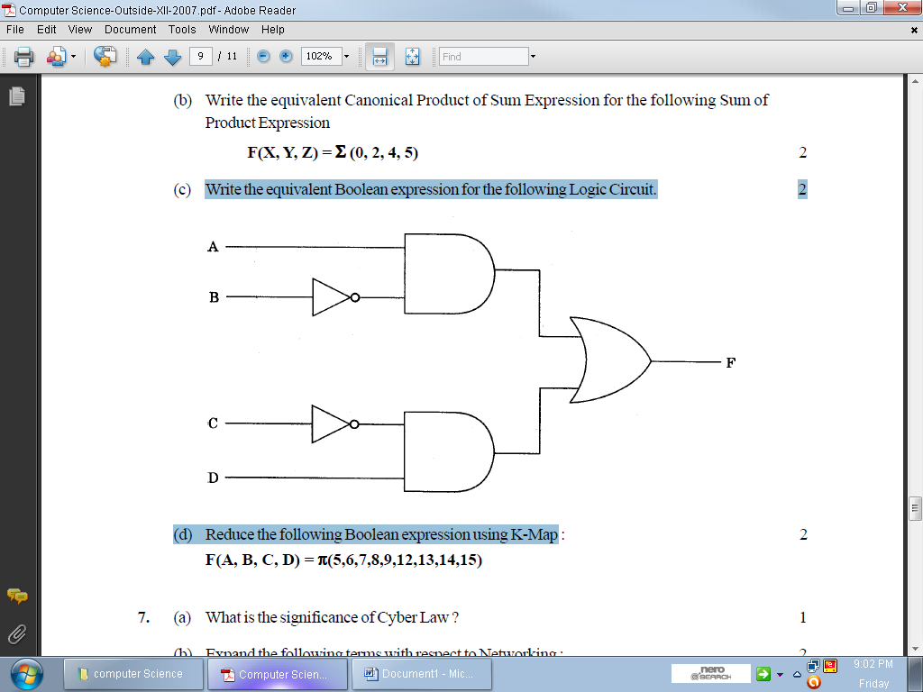
(c) Write the equivalent POS expression of following SOP form : (1
F (x,y,z)= ∑ (0,2,4,6)
(d) Reduce the following Boolean Expression using K-Map: (3
F(U,V,W,Z)= ∑(0,1,4,5,6,7,11,12,13,14,15)
(e) Give the dual of (A+BC+AB) (1

Q.7 (a) What is the difference between Hub and message Router ? (1
(b) Differentiate the following : (1
(i) GSM and CDMA
(ii) FOSS and OSS.
(c) What is Virus? Give two examples. (1
(d) Define and explain Cyber Law. (1
(e) The Sony has set up its Branch at Srinagar for its office and web based activities. It has 4 Zone of buildings as shown in the diagram:
Zone Z
Zone Y

Zone X
Zone U

Branch to branch distances are :
Zone X to Zone Z | 40 Mtr
Zone Z to Zone Y | 60 Mtr
Zone Y to Zone X | 135 Mtr
Zone Y to Zone U | 70 Mtr
Zone X to Zone U | 165 Mtr
Zone Z to Zone U | 80 Mtr

Number of Computers:
Zone X | 50
Zone Z | 130
Zone Y | 40
Zone U | 15

(e1) Suggest a most suitable cable layout or Networking Toplogy of connections between the
Zones. (1
(e2) Suggest the most suitable place (i.e., Zone) to house the ERP and BI Server of this organization with a suitable reason, with justification. (1
(e3) Suggest the placement of the following devices with justifications: (1
- Repeater (2) Hub / Switch
(e4) Which is the most economic type of cable for the selected topology? (1
(f) Differentiate the following pairs: (2
1. Internet and ARPANET.
2. Coaxial Wire and Optical Fiber.
Created by Amrit Chhetri for CBSE-CPP XII 2013; Copyright(C): Amrit Chhetri,2013

