INTERNAL PHASE TEST
Class - XII
MATHEMATICS

Maximum Marks: 60 Time allowed: 2 hours

General Instructions:
- All questions are compulsory.
- Do the paper in a very neat and clearly readable handwriting.
- This paper consists of three sections. The individual section weight age is as follows:
Section A Q. No. 1 – 8 2 marks for each question
Section B Q. No. 9 – 16 4 Marks for each question
Section C Q No. 17 – 18 6 marks for each question
- Do all rough work in the fair copy itself. Please don’t ask for a separate sheet for calculations or any other rough work.

SECTION – (A)
Each question carries 2 marks
- If A = , B = and , find a and b.

- If p, q, r three statements, then examine the validity of the argument (S₁, S₂, S₃; S) for the following:

- Prove that if A and B be symmetric matrices of the same order then, AB – BA is a skew symmetric matrix and AB + BA is a symmetric matrix.

- Show that the function f defined by is an even function.

- Use determinants to prove that if the points (a₁. b₁), (a₂, b₂) and (a₁ + a₂, b₁ + b₂) are collinear, then a₁b₂ = a₂b₁.

- For the following circuit diagram of logic gates, construct an input output table:
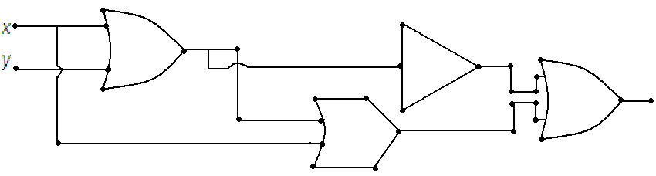

- Using cramer’s rule, solve the following system of linear equations:

- Evaluate:

SECTION – (B)
Each question carries 4 marks

- Let D₆ = {1, 2, 3, 6}. Define ‘+’, ‘.’ and ‘ ‘ ’ in D₆ by
Show that (D₆‘+’, ‘.’, ‘ ‘ ’) is a Boolean algebra.

- Simplify the switching circuit given below:
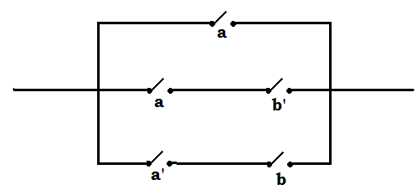

- Using properties of determinants prove that.
- If , find the values of a and b.

- If , prove that. Hence find.

- Given that. Show that.

- If a, b and c are in A.P., then using properties of determinants, prove that

.

- Determine the values of k for which the function f(x) defined by
is continuous.

SECTION – (C)
Each question carries 6 marks

- Using matrix method solve the given system of linear equations:

- Evaluate the following limits:
(a)
(b)

Aapka Tutorials (P) Ltd. B - 6 Neelkanth Apartments Rakesh Marg Nehru Nagar Ghaziabad 201001 Ph. No. 9810064141, 0120 – 4104837

* * * *

