SAMPLE PAPER-2013
CLASS-XI
MULTIMEDIA AND WEB TECHNOLOGY

Time allowed : 3 hours Maximum Marks: 70

Candidates must write the Code on the title page of the answer-book.
- Code number given on the right hand side of the question paper should be written on the title page of the answer-book by the candidate.
- Please write down the serial number of the question before answering it.
1. Answer the following questions based on Computer System: (10 Marks)
(a) What are two advantages and disadvantages of Computers? (2
(b) What are Input Devices? Give the name of two Input Devices other than Mouse. (1
(c) Give the full form of the following terms:-
- VDU (1
- DVD (1
- ALU (1

(d) What is an Operating System? Give the names of two Operating System. (2
(e) What is Android? Give two usages. (2

2. Answer the following questions based on Web Page Development: (25 Marks)
(a) What is the use of Select tag in HTML? (1
(b) What are COLSPAN and ROWSPAN? (1
(c) Write Short Notes on following Tags with a suitable example: (4*2=8)
      - <TBALE>
      - <IMG>
      - <TEXTAREA>
      - <DIV>

(d) What is the use of HR tag in HTML? Give one example . (1
(e) Write the difference between(At least two for each pair). (3*2=6)
- Container Tag and Empty Tag
- <TR> and <TH> Tag
- <Frameset> and <Frame> Tag
- <A> and <TARGET> Tag

(f) Write the HTML code to generate a Web Page in the format given below : (8
Consider the following while writing the HTML code
1. Background color of the page should be “LightGray”, text color should be “Magenta” .
2. Title of the page is “Darjeeling-Queen Of Hills”.
3. Text color of main heading on the page should be “Blue”.
4. Font face of text in the page should be “Verdana”.
5. Picture used in the page is the file “darjeeling.jpg”.
6. Use the concept of select list to display the given drop-box.
7. Pages linked to :
* None

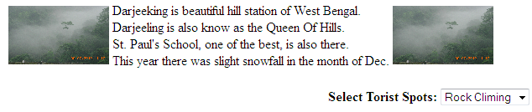
3. Answer the following questions based on Web Scripting : (25 Marks)
(a) What are Procedure and Function? Differentiate between the Procedure and Function? How
we call procedure from main program using <Script> tag. (2
(b) Name the event to be used in the following situations: (2
(1) To perform an action when a button is clicked.
(2) To perform an action as soon as a text field gains a cursor or focus.

(c) Give the output of the following code segment: (2
<Script Language = “text/VBScript”>
Name = "CES 2013"
startword = 1
For i = 1 to Len (Name)
if (startword <>0 ) Then
document.Write (right (Name, i) )
if (Mid (Name, i, 1)) = "" Then
startword = 0
else
startWord = 5
End if
End If
Next
</Script>

(d) Write the HTML code for creating the form given below and also write the embedded VBScript code for checking text-input at You Name field. When the user clicks on 'Submit' button it displays the name typed in the message box. (4
(e) Give the output of the following statements: (1x7=7
- document.write(date())
- document.write(Ucase(“International CES 2013”))
- document.write(Mid(“International CES 2013”),20)
- document.write(Ucase(“International CES 2013”)
- document.write(Cdbl(“45”)
- document.write(Abs(-1*20+2*3))
- document.write(Len(“”))

(f) What is an event? How are lines commented on VBScript? (2
(g) Give the output of the following statements: (2
<script language=”VBScript”>
dim a,b
b=3
a=1
Do while a<=5
document.write("<br>"& a+b)
a+=1
Loop
</script>

(f) Write the code to display the below form and add the vbscript using eval() to display the
result when a user clicks on “Calc” button. (4
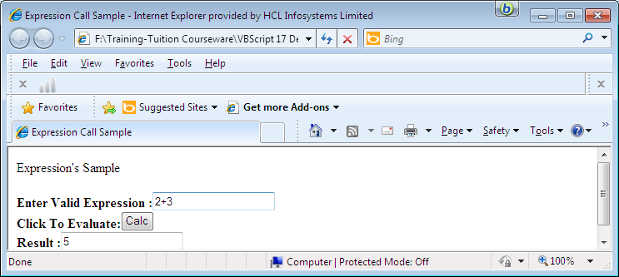

- Question given below are based on Multimedia And Authoring Tools : (10 Marks)
(a) Write full forms of the following : (6*1=6)
- MPEG
- JPEG
- SWF
- BMP
- VOIP
- MMS

(b) Differentiate between the following: (2*2=4)
- FLA and SWF
- MPEG & AVI
Created by Amrit Chhetri for CBSE-MWT XII 2013 ; Copyright(C): Amrit Chhetri; Student of 2 Good Coaching Centre

