Sample Paper- 2013
Subject: PHYSICS
Class 12th

M.M 70 TIME: 3 Hours
General Instructions:
(i) All questions are compulsory
(ii) There are 30 questions in total. Questions 1 to 8 carry one mark each, questions 9 to 18
Carry two marks each, questions 19 to 27 carry three marks each and questions 28 to 30
Carry five marks each.
(iii) There is no overall choice. However, an internal choice has been provided in one question
of two marks one question of three marks and all three question of five marks each.
You have to attempt only one of the choices of the choices in such questions.

Q1:-What do you mean by the statement that susceptibility of Fe is more than that of cu?
Q2:- Why should not current be passed through ammeter bridge wire for a long time?
Q3:- If h_{t} is the height of transmitting antenna & h_{r} is the height of receving antenna then write the expression for its range in LOS mode.
Q4:- What is the meaning of negative energy of orbiting electron in hydrogen spectrum?
Q5:-If the length of a conductor is doubled keeping the p.d. across it unchanged, what will be the effect on the drift velocity of free electrons?
Q6:- Why do we fail to observe the diffraction pattern from a wide slit illuminated by a monochromatic
Light?
Q7:- Give the ratio of velocities of light rays of wavelengths 4000Å and 8000 Å in vacuum.
Q8:-Draw the variation between intensity of light used and photoelectric current in photoelectric effect.
Q9:- The plates of a charged capacitor are connected to a voltmeter. If the plates of the capacitor are separated further, what will be the effect on the potential difference?
Q10:- The variation of potential difference and current for two metals X and Y is shown in the fig. Which is at higher temperature and why?
Q11:- The maximum peak-to-peak voltage of an AM wave is 16 mV and the minimum
Peak-to-peak voltage is 4 mV. Calculate the modulation factor.
Q12:- Give the two basic conditions of TIR.
Q13:- Name the constituent radiation of electromagnetic spectrum which
(i) Is similar to the radiations emitted during decay of radioactive nuclei?
(ii) has its wavelength range between 390 nm and 770 nm.
(iii) is used in satellite communication.
(iv) is absorbed from sunlight by the ozone layer.
Q14:- An electron beam is moving horizontally south to north in a television tube. The vertical component Of earth’s magnetic field is directed downward. In which direction will the beam be deflected?
Q15:- Obtain the truth table for the circuit shown in Fig.
Q16:- A bar magnet is placed in a uniform magnetic field with its magnetic moment making an angle θ with the field. (i) Write an expression for the torque acting on the magnet and hence define its magnetic moment. (ii) Write an expression for the potential energy of the magnet in this orientation. Hence obtain the orientation for which this energy becomes minimum
Q17:-. Why the high frequency carrier waves are are used for transmission?
OR
What is the meaning of term communication? Draw the block diagram of communication system.
Q18:- Complete the following disintegration equations:
Q19:- Derive an expression for electric field intensity at a point
Due to a uniformly charged spherical shell when point lies (i) outside the shell, (ii) on the shell and (iii) inside the shell.
Q2:-. Derive the expression for the energy stored in a parallel plate capacitor.
Q21:- Show that nuclear density is independent to mass no. of nucleus or its size.
Q22:- A proton from rest is accelerated through a potential difference of 1000 V. Determine its de Broglie Wavelength. Mass of proton = 1.67 × 10–27 kg.
Q23:- In young Double Slit experiment , how the interference pattern vary (a) When blue light is used at the place of red light (b) When the distance between the slits is increased (c) When the distance between the screen and slits is increased.
Q24:- Define the coefficient of self induction? On what factors self inductance of a solenoid depends explain briefly.
Q25:- A simple potentiometer circuit is shown in Fig. 7.40 using a uniform wire AB 1m long,
Which has a resistance of 2.0 Ω.? The resistance of 4V battery is negligible. If the variable resistor R were
Given a value of 2.4Ω, what would be the length AC for zero galvanometer deflection?
Q26:-. Derive the expression for the force between two parallel straight conductors caring current in same direction and define ampere.
OR
Draw the labeled diagram of cyclotron & find the expression for its frequency.
Q27:- A spherical surface of radius of curvature R separates air (refractive index 1.0) from glass (Refractive index 1.5). The centre of curvature is in the glass. A point object P placed in air is found to Have a real image Q in the glass. The line PQ cuts the Surface at point O and PO = OQ. Find the distance of the object from the spherical surface.
Q28:- Derive the expression for impedance of series LCR cct.
(a) What is its value at resonance? (b) What is Q factor at resonance?
(c) What are wattles current?
OR
(a)Distinguish between impedance and reactance
(b) Explain that ideal capacitor block D.C.
(c) How transformation ratio helps in deciding the nature of Transformer.
Q29:- Explain the working of transistor as an amplifier in CE arrangement and explain the phase relation between input and output
- Draw the output characteristics for npn transistor.
OR
What is a semiconductor diode? Explain the working of centre-tap full-wave rectifier. Draw V-I characteristics for forward and reverse biased p-n junction diode.

Q30:- Derive an expression for the magnifying power of a compound microscope when the image is formed at the near point.
(a) A ray of light is incident in glass on a glass-water boundary. The angle of incidence is 50°.
Calculate the angle of refraction. Refractive index of glass = 1.50; refractive index of water = 1.33.
OR

Derive an expression for the refractive index of prism material in terms of angle of the prism and the
angle of minimum deviation.
(a)The refractive index of the material of a prism of 60° angle for yellow light is (2)^{1/2} .
Determine the angle of minimum deviation

SOLUTIONS
Ans1:- It means Fe can be magnetized more easily than Cu.
Ans2:- If current is passed through a potentiometer wire for a long time, it gets heated and its resistance increases. This will change the potential gradient along the wire.
Ans3:- d = (2h_{t}R)^{1/2} + (2h_{r}R)^{1/2}
Ans4:- The negative total energy means that it is bound to the nucleus. If it acquires enough energy from some external source (a collision, for example) to make its total energy zero, the electron is no longer bound, it is free.
Ans5:- We know that v_{d} = eEτ/m
V_{d} = eVτ/mL
When L is doubled then v_{d} becomes half
Ans6:- When size of the slit is large, the angular width (= 2θ) of the central maximum is small and the variation in the intensity of other maxima and minima are so small that they cannot be
Distinguished. For this reason, we cannot observe the diffraction pattern.
Ans7:-The ratio is 1:1
Ans8:-

Ans9:- We know that C = ε₀A/d
V = q/C = qd/ε₀A
As d increases the potential difference also increases

Ans10:- X is at higher temperature
Because slope of X is higher than slope of Y,which means resistance of X is higher than Y.
Ans11:- V_{max}=16/2=8mV
V_{min}=4/2=2mv
m_{a}=( V_{max}-V_{min})/ (V_{max}+V_{min})
m_{a}=(8-2)/(8+2) = 6/10 = 0.6
Ans12:-
(1)When light passes from the denser medium to the rarer medium.
(2) The angle of incidence exceeds the critical angle C.

Ans13:- (1) γ-rays (2) Visible Rays (3) Micro Waves (4) UV Rays
Ans14:-Towards west as per the Fleming’s Left Hand Rule.
Ans15:-

Ans16(a):-
Consider a magnetic dipole is placed in an uniform magnetic field of intensity B having length 2l as shown in the fig.
In uniform magnetic field two equal and antiparallel forces acting on the dipole which will try to rotate the dipole in clockwise direction. Hence a torque will developed in it which is given by
Torque = moment of the couple
τ = either force× perpendicular distance
τ = mB×NA
τ = mB × 2lsinθ
τ = m(2l)Bsinθ
τ = MBsinθ

τ = M × B

(b) U = -MBcosθ = -M.B
Potential energy of dipole is minimum when θ=0⁰and hence it is in stable equilibrium.

Ans17:- The energy of a wave is directly proportional to its frequency. This permits modulated waves to carry the signals to long distances.
OR

COMMUNICATION:- The process of sending information from one place to another is known as communication
Ans18:-

Ans19:-
Consider a spherical shell of radius R and centre O. Let +q be the uniform charge on the surface of the sphere. We are to find electric field intensity at a point P at a distance r from the centre of the sphere.
(i) When point P lies outside the shell: With centre O, draw a sphere of radius r through point P
as shown in Fig. Then this sphere (dotted) is the Gaussian surface. The electric flux passing through the spherical shell will be the same as that through the Gaussian surface. The magnitude of electric field (E) is same at all point on the Gaussian surface. Further, at every point on the Gaussian surface, angle between E and area element vector dS is zero.

Therefore, electric flux passing through the Gaussian surface is

(ii) When point P lies on the surface of shell: In that case r = R so that;

If σ is the surface charge density of the spherical shell, then, q = 4π R²σ.

(iii) When point P lies inside the shell: Draw a sphere of radius r (r < R) with O as the centre as shown in Fig.2 Then this sphere (dotted) is the Gaussian surface. The charge enclosed by the Gaussian surface is zero.

Thus electric field intensity inside a charged spherical shell is zero. This is again a very important conclusion. Fig. shows the variation of electric field intensity with distance from the centre O for a uniformly charged spherical shell. Note that E = 0 for r varying from zero to r. In other words, inside the shell, E = 0. The magnitude of E is maximum at the surface of the shell (i.e., at r = R). However, outside the shell, E ∝ 1/r2 so that field intensity-distance curve is a parabola.
Q20:- Charging a capacitor means transferring electrons from one plate of the capacitor to the other. Therefore, work will have to be done (by battery) because electrons are to be moved against the opposing forces. This work done is stored in the form of electric potential energy in the electric field between the plates. You can recover this energy by discharging the capacitor in a circuit, just as you can recover the potential energy stored in a stretched bow by releasing the bow string to send an arrow flying. Consider a capacitor of capacitance C being charged from a d.c. source of V volts as shown in Fig, Suppose at any stage of charging, the charge on the
capacitor is q′ and p.d. between the plates is v. Then,

If a small charge dq is further transferred, then small amount of work done is

The total work done in raising the potential of uncharged capacitor to V is

This work done is stored as electric potential energy in the electric field between the plates of the
capacitor. ∴ Energy stored in the capacitor,

Note that q is the final charge on the capacitor. Further, energy stored will be in joules if q, C and V are taken in coulomb, farad and volts respectively.
As for parallel plate capacitor

Energy is given as: U = ε₀AV²/2d
Q21:- Consider a nucleus having atomic no. is =Z (_{z}X^{A})
Mass no.is =A
Let the mass of each nucleon = m
Total mass = mA
Now the density of the nucleus is given as:
ρ =Toatl mass/Volume of nucleus
ρ = 3mA/4πR³
As we know that R = R₀A^{1/3} (R₀ = 1.2×10⁻¹⁵m)
Thus Density of nucleus, ρ = 3mA/4πR₀³A
ρ = 3m/4πR₀³ = Constt.
It means density of nucleus is independent of mass no. or hence independent of size of the nucleus.
Q22:- Since the electron is accelerated through a potential difference of 1000 V, its kinetic energy is given by ;
E = 1000 eV = 1000 × 1.6 × ¹⁰⁻¹⁹J = 1.6 × 10⁻¹⁶ J
∴ λ=h/(2mE)^{1/2}
λ = 6.63×10⁻³⁴/(2×9.1×10⁻³¹×1.6×10⁻¹⁶)
= 0.388 × 10⁻¹⁰ m = 0.388 Å
Q23:-As we know that fring width in young double slit experiment is given by
β = λd/D
- As the wavelength of Blue light is shorter than the Red colour so the width of the fring decreases
- As d increases the fring width increases
- As D increases fring width decreases
Q24:- It is equal to magnetic flux linked with the coil when unit current passes throuh it.
Self inductance of solenoid is
It means it depends upon
- Medium enclosed inside the solenoid,
- No. of turns of solenoid
- Area of cross-section of solenoid
- Length of solenoid
Q25:-

Q26:- When two parallel current carrying conductors are close together, they exert forces on each other. It is because one current carrying conductor is placed in the magnetic field of the other. If currents are in the same direction, the conductors attract each other; if currents are in opposite directions, the conductors repel each other. Thus: like currents attract; unlike currents repel.
Expression for force: Consider two infinitely long parallel conductors X and Y carrying currents I₁ and I₂ respectively in the same direction as shown in Fig. Suppose the conductors are separated by a distance r in the plane of the paper. The magnitude of magnetic field at any point P on the conductor Y due to current I₁ in conductor X is
According to right-hand grip rule, the direction of magnetic field is perpendicular to the plane of the paper and is directed inwards. [See Fig. (i)].
Now conductor Y carrying current I₂ is placed in the magnetic field B_{x} produced by conductor X. Therefore, per unit length of conductor Y will experience a force F_{y} given by ;
Putting the value of BX from eq. (i), we have,
According to right-hand rule for cross product, the force F_{y} is in the plane of the paper and is directed towards the conductor X as shown in Fig. (i). similarly, the force on conductor X per unit length is
Again by right-hand rule for cross product, this force is in the plane of the paper and is directed towards conductor Y can be drawn in Fig. (ii). clearly, the forces are such that conductors attract each other; the force of attraction per unit length being;
The unit of electric current the ampere is defined on the basis of the force between the currents in parallel conductors. Force between two current carrying parallel conductors/unit length is
Hence one ampere is defined as that current flowing in each of the two infinitely long parallel
conductors 1 m apart, which results in a force of exactly 2 × 10 ⁻⁷N per meter length of each conductor.
OR
In a cyclotron, the ions move faster and in ever larger circle but with the same time period. Suppose at any time, the radius of the circular path is r and the speed of the ion is v. Let us further assume that mass of the ion in m and the magnitude of the magnetic field is B.
(i) Radius of path:-
(ii) Frequency (f) :-

Q27:- Fig. shows the conditions of the problem. It is a case of refraction at convex spherical refracting surface from rarer to denser medium.

Q28:- This is a general series a.c. circuit. Fig. shows R, L and C connected in series across a supply voltage E_{v} (r.m.s.). The resulting circuit current is Iv (r.m.s.).
∴ Voltage across R, V_{R} = Iv R ...... V_{R} is in phase with Iv
Voltage across L, V_{L}= Iv X_{L} ...... V_{L} leads Iv by 90°
Voltage across C, V_{C} = Iv X_{C} ...... V_{C} lags Iv by 90°
As before, the phasor diagram is drawn taking current as the reference phasor. In the phasor diagram [See Fig.], OA represents V_{R}, AB represents V_{L} and AC represents V_{C}. It may be seen that V_{L} is in phase opposition to V_{C}. It follows that the circuit can be effectively inductive or capacitive depending which voltage drop (V_{L} or V_{C}) is predominant. For the case considered, V_{L}> V_{C} so that net voltage drop across L – C combination is V_{L} – V_{C} and is represented by AD.

(a) At resonance Z=R. Because X_{L}= X_{C}
(b)

(c) In pure Inductor or capacitor the phase difference between Current and emf is 90⁰ and current does not consume any power so these are known as wattles current.
OR
(a) Reactance:- The opposition offered by inductor or capacitor to the flow of current is known as reactance. It is of two types
Inductive reactance:- The opposition offered by the inductance to current flow is ωL. This quantity ωL is called the inductive reactance X_{L} of the inductor. It has the same dimensions as resistance and is, therefore, measured in ohms (Ω). ∴ Inductive reactance, XL = ω L = 2π f L
Capacitive reactance:- The opposition offered by capacitance to current flow is 1/ωC. The quantity 1/ωC is called the capacitive reactance X_{C} of the capacitor. It has the same dimensions as resistance and is, therefore, measured in ohms (Ω).

Impedance(Z):- The quantity that offers opposition to the current flow in series LCR circuit and is called impedance Z of the circuit. Sometime it is also called the effective resistance of LCR circuit.
(b)

Thus capacitor provides infinite resistance to d.c. so it block d.c.
(c) For a transformer transformation ratio is given as

If K > 1, then E_{s} > E_{p} it means step-up transformer.
If K < 1, then E_{s} < E_{p} it means step-down transformer.
Q29:- npn transistor as CE amplifier:-
In this circuit arrangement, input is applied between base and emitter and output is taken from the collector and emitter. Here, emitter of the transistor is common to both input and output circuits and hence the name common emitter connection. Fig. (i) Shows common emitter npn transistor circuit
PHASE REVERSAL IN CE CIRCUIT:-
In common emitter connection, when the input signal voltage increases in the positive sense, the output voltage increases in the negative direction and vice-versa. In other words, there is a phase difference of 180° between the input and output voltage in CE connection. This is called phase reversal.*
The phase difference of 180° between the signal voltage and output voltage in a common emitter
Amplifier is known as phase reversal.
Consider a common emitter amplifier circuit shown in Fig. The signal is fed at the input terminals (i.e. between base and emitter) and output is taken from collector and emitter end of supply. The total instantaneous output voltage V_{cE} is given by;

When the signal voltage increases in the positive half-cycle, the base current also increases. The result is that collector current and hence voltage drop I_{c}R_{c} increases. As V_{cc} is constant, therefore, output voltage v_{cE} decreases. In other words, as the signal voltage is increasing in the positive half-cycle, the output voltage is increasing in the negative sense i.e. output is 180° out of phase with the input. It follows, therefore, that in a common emitter amplifier, the positive half-cycle of the signal appears as amplified negative half-cycle in the output and vice-versa. It may be noted that amplification is not affected by this phase reversal.
(a)Output characteristics: It is the curve between collector current I_{c} and collector-emitter voltage V_{cE} at constant base current I_{B}.

OR
pn JUNCTION:-
When a semiconductor crystal (germanium or silicon) is so prepared that one half is p-type and the other n-type, the contact surface dividing the two halves is called a pn junction.
CENTRE-TAP FULL-WAVE RECTIFIER:-
The circuit employs two diodes D1 and D2 as shown in Fig. A centre tapped secondary winding AB is used with two diodes connected so that each uses one half-cycle of input a.c. voltage. In other words, diode D1 utilizes the a.c. voltage appearing across the upper half (OA) of secondary winding for rectification while diode D2 uses the lower half winding OB.
Operation: During the positive half-cycle of secondary voltage, the end A of the secondary winding becomes positive and end B negative. This makes the diode D1 forward biased and diode D2 reverse biased. Therefore, diode D1 conducts while diode D2 does not. The conventional current flow is through diode Dl, load resistor R_{L} and the upper half of secondary winding as shown by the dotted arrows. During the negative half-cycle, end A of the secondary winding becomes negative and end B positive. Therefore, diode D2 conducts while diode D1 does not. The conventional current flow is through diode D2, load R_{L} and lower half winding as shown by solid arrows. Referring to Fig. it may be seen that current in the load R_{L} is in
the same direction for both half-cycles of input a.c. voltage. Therefore, d.c. is obtained across the load R_{L}.Also, the polarities of the d.c. output across the load should be noted.

Ans30:- When image is formed at near point:- The object AB is placed between F₀ and 2F₀ where F₀ is the focus of the objective lens. The objective forms a real, inverted w.r.t. object and enlarged image A'B' of the object AB. The image A'B' becomes the object for the eyepiece. The lenses are so arranged that the image A'B' is inside the focal point Fe of the eyepiece (See Fig.). Hence the magnified image A'B' is further magnified by the eyepiece acting as a magnifying glass. The adjustments are so made that the final image A''B'' is formed at the near point i.e. at
the least distance of distinct vision from the eye. Note that each lens produces magnification so that overall magnification is more than is possible by using only a single lens. Note that f₀ is taken smaller than fe so that field of view may be increased.

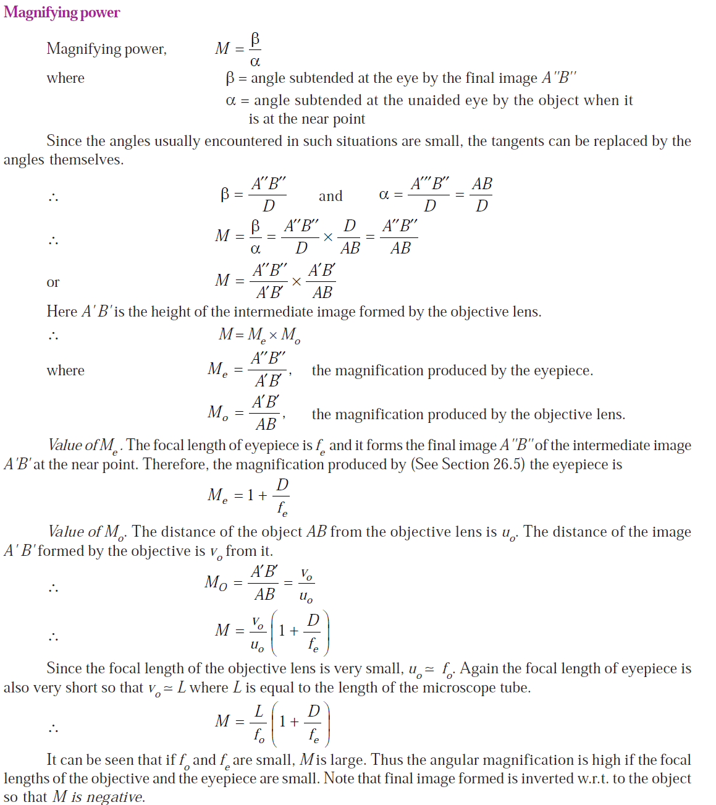
(a)

OR

REFRACTIVE INDEX OF PRISM MATERIAL:-
We can find the refractive index of prism material if we
know the angle of prism (i.e. angle A) and the angle of
minimum deviation (i.e. angle δm).
Let A = angle of the prism (See Fig. )
δm = angle of minimum deviation
μ = refractive index of prism material w.r.t. surrounding medium (air)
We know that
A + δ = i₁ + i₂ and A = r₁ + r₂
But in the position of minimum deviation,
I₁ = i₂ = i (say) and r₁ = r₂ = r (say)

(a)

