Sample Paper- 2013
Subject: Biology
Class XIth

Time – 3Hrs. MM – 70

General Instructions
1. The question paper comprises of four sections A, B, C and D. You are to attempt all the sections.
2. All questions are compulsory.
3. There is no overall choice however, internal choice has been provided in one question of two marks, one question of three and all the three questions of five marks category. Only one option in such questions is to be attempted.
4. All questions of section A, B, C and D are to be attempted separately.
5. Questions 1 to 8 in section A are very short questions of one mark each. These are to be answered in one word or one sentence each.
6. Questions 9 to 18 in section B are short questions of two marks each. These are to be answered in approximately 20-30 words each.
7. Questions 19 to 27 in section C are questions of three marks each. These are to be answered in approximately 30-50 words each.
8. Questions 28 to 30 in section D are questions of five marks each. These are to be answered in approximately 80-120 words each.

SECTION-A

- What is photolysis of water. Give the equation for it
- Bile juice contains no digestive enzymes, yet it is important for digestion. Why?
- Why are bryophytes called the amphibians of the plant kingdom?
- A homopolymer has only one type of building block called monomer
repeated ‘n’ number of times. A heteropolymer has more than one type
of monomer. Proteins are heteropolymers made of aminoacids. While a
nucleic acid like DNA or RNA is made of only 4 types of nucleotide
monomers, proteins are made of how many monomers.
- Name the cells that are living and show angular wall thickning. They also
provide mechanical support.
- Explain plasticity with example.
- How are prosthetic groups different from co-factors?
- What is the difference between differentiation and dedifferentiation.
SECTION B

- Differentiate between light and dark reactions.
- State the role of pancreatic juice in digestion of proteins.
- Enzymes are proteins are long chains of aminoacids linked to
each other by peptide bonds. Aminoacids have many functional groups
in their structure. These functional groups are, many of them at least,
ionisable. As they are weak acids and bases in chemical nature, this
ionization is influenced by pH of the solution. For many enzymes, activity
is influenced by surrounding pH. This is depicted in the curve below,
explain briefly.
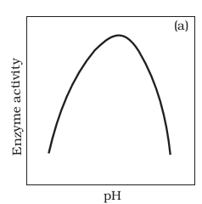

- A transverse section of the trunk of a tree shows concentric rings which
are known as growth rings. How are these rings formed? What is the
significance of these rings?
- The following events occur during the various phases of the cell cycle,
Name the phase against each of the events.
a. Disintegration of nuclear membrane _________________________
b. Appearance of nucleolus _________________________
c. Division of centromere _________________________
d. Replication of DNA _________________________
- Explain graphically the action spectrum of photosynthesis.-
- What is the difference between lenticels and stomata?
- Define a cardiac cycle and the cardiac output.
- Mango and coconut are ‘drupe’ type of fruits. In mango fleshy mesocarp
is edible. What is the edible part of coconut? What does milk of tender
coconut represent?
OR
Rhizome of ginger is like the roots of other plants that grows
underground. Despite this fact ginger is a stem and not a root. Justify.
- An elderly woman slipped in the bathroom and had severe pain in her
lower back. After X-ray examination doctors told her it is due to a slipped
disc. What does that mean? How does it affect our health?
SECTION C

- Complete the following table.

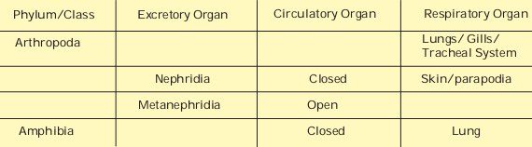

- Explain any three factors affecting photosynthesis.
- Distinguish between
(a) IRV and ERV
(b) Inspiratory capacity and Expiratory capacity
(c) Vital capacity and Total lung capacity.
- Write briefly the significance of mitosis and meiosis in multicellular
organism.
- Explain why sexual reproduction in angiosperms is said to take place
through double fertilization and triple fusion. Also draw a labelled
diagram of embryo sac to explain the phenomena.
- Explain the role of any three growth regulators and one growth inhibitor in plants life.
OR
Explain the process of nodule formation with diagram.
- Structural organisation in animals attains different levels as cell - organ
- organ system. What is missing in this chain? Mention the significance
of such an organization.
- Write down the common features of the connective tissue. On the basis
of structure and function, differentiate between bones and cartilages.
- List the hormones secreted by the following:-
(a) Hypothalamus (b) Pituitary (c) Thyroid (d) Parathyroid(e) Adrenal (f) Pancreas.
SECTION D

- Write the functions of the following
a. Centromere
b. Cell wall
c. Smooth ER
d. Golgi Apparatus
e. Centrioles
OR

What are the various stages of meiotic prophase-I? Enumerate the
chromosomal events during each stage?
- Explain Hatch and Slack pathway with diagram
OR
In the figure given below, the black line (upper) indicates action spectrum for photosynthesis and the lighter line (lower) indicates the absorption spectrum of chlorophyll a, answer the followings:

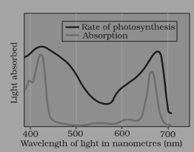

a. What does the action spectrum indicate? How can we plot an action spectrum? Explain with an example.
b. How can we derive an absorption spectrum for any substance?
c. If chlorophyll a is responsible for light reaction of photosynthesis,
Why do the action spectrum and absorption spectrum not overlap?
- Draw a labelled diagram showing reabsorption and secretion of major
substances at different parts of the nephron.
OR
Explain the structure of middle and internal ear with the help of diagram.

*****************

