FINAL EXAMINATION 2006
Informatics Practices
CLASS XII

Time allowed: 3 hours Maximum Marks: 70
NOTE:
(i) All questions are compulsory. (ii) Section A consists of 30 marks.
(iii) Section B and Section C are of 20 marks each. (iv) Answer the questions after carefully reading the text.
Section – A
- Answer the following Questions :
  - Explain any two application areas of database. 2
  - What is meant by Relationship? Explain any two relations with diagram. 2
  - Explain the term Data mining using suitable examples. 2
  - What do you understand by the term SDLC? Name its essential components. 2
  - Explain Open Source Software. Name any two open source software 2

2. Answer the following questions:
  - What do you understand by the term IDE? Why is Visual Basic called an IDE 2
  - Explain List Box control. What are the common methods of List box Control? 2
  - What are Sub procedures? Explain with suitable example. 2
  - What do you understand by the term Record Source of an ADO Data Control? 2
  - Explain adOpenDynamic and adOpenForwardOnly CursorTypes of Open method. 2

3. Answer the following questions :
  - What are DCL commands? Name any two DCL commands 2
  - State the difference between SQL and PL/SQL 2
  - What is a cursor? What types of cursors are supported in PL/SQL? 2
  - What are the different types of triggers? Explain with an example. 2
  - Give difference between IN and OUT procedure. 2

Section – B
4. Read the following case study and answer the questions that follow:
Mr. Vidyarthi works in Blossoms Public School as a programmer. He is required to develop a student record. The school offers two different streams, medical and non-medical, with different grading criteria. The school also offers incentive to the NCC cadets in the form of a 3% increment in percentage for all the NCC cadets. The grading criteria for the two streams are given below:
Stream | Percentage | Grade
Medical | >=80  60-80  <60 | A  B  C
Non Medical | >=75  50-75  <50 | A  B  C
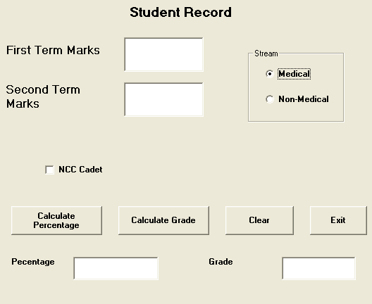
Object Type | Object Name | Description
Form | FrmStudRec | The Main Form object
Text  Box | TxtFirstTerm  TxtSecondTerm  TxtPercentage  TxtGrade | To enter first term marks  To enter second term marks  To display the percentage of the student  To display the grade of the student
Check Box | ChkCadet | To be Checked if student is an NCC Cadet
Option  Button | OptMedical  OptNonmedical | To provide Stream  Information
Command  Button | CmdCalcPer  CmdCalcGrade  CmdClear  CmdExit | To calculate the percentage  To calculate the grade  To clear the entered values  To close the application

(a) Write the commands to disable the textboxes txtPercentage and txtGrade. 1
(b) Write the code for cmdClear Command Button to clear all the textboxes and the checkbox. 1
(c) Write the code for cmdCalcPer to calculate the percentage after finding the total marks of first term and second term (assuming that both marks are out of 100). Also ensure that NCC cadets get an increment of 3% in their percentages. 4
(d) Write the code for cmdCalcGrade to calculate the grade depending on the stream selected according to the criteria given above. 4

5.Answer the following questions:
(a) Find the errors from the following code segment and rewrite, the corrected code underlining the correction made:
Private Sub Command1_Click() 2
Dim p = 1 As Integer, i As Integer
For i = 1 UpTo 50
p = p + 1
If p = 5 Then
p = 1
Display "P is equal to 5"
Else
Display "P is not equal to 5"
Loop i
End Sub
(b) Find the Output of the following code segment: 2
Public Sub cmdClickMe_Click()
Dim N1, N2, Counter as Integer
Counter=1
N1=0
N2=0
Do While Counter <=4
Print N1
Print N2
N1 = N1+ N2
N2 = N2 +N1
Counter = Counter +2
Loop
End Sub
(c) Change the following code using Do...While without effecting the Output: 2
Dim Squar As Integer, Num As Integer
Num =1
Squar = Num * Num
Do
Print Squar
Num= Num +1
Squar = Num * Num
Loop Until Squar >=50
(d)Write a Visual Basic procedure which takes a number as argument and displays the reverse of the number. For example if the argument is passed is 1234 it should display 4321 4

Section - C
6. Read the questions given below and answer accordingly:
(a) Write the output produced by the following part of code in PL/SQL: 2
DECLARE
Y NUMBER;
X NUMBER;
BEGIN
Y :=5;
FOR X IN 1..4
LOOP
Y := X+4;
DBMS_OUTPUT.PUT_LINE (Y);
END LOOP;
END;

(b) Find the errors from the following PL/SQL code and rewrite the corrected code underlining the correction made. 2
DECLARE
V_empno NUMBER[4];
v_empname varchar2(20);
BEGIN;
SELECT empno,ename,salary
INTO v_empno,V-ename
FROM emp
FOR empno=1234;
END;
(c) Explain the usage of the %TYPE attributes in variable declaration in a PL/SQL block with the help of an example. 2
(d)
i) Create a Stored procedure that displays the first name and last name of the student whose student id is passed as parameter.
ii) Invoke the above procedure. 4
Q. 7. Answer the questions base on the table CLUB given below:
Table : CLUB
Column Name | Data Type | Size | Constraint | Description
Member_No | NUMBER | 4 | PRIMARY KEY | Member Number
Member_name | VARCHAR2 | 30 | NOT NULL | Name of the member
Address | VARCHAR2 | 30 |  | Address of the member
Age | NUMBER | 3 | > = 18 | Age of the member
Type | VARCHAR2 | 10 |  | Type of membership
Fees | NUMBER | 6,2 |  | Membership fees
- Write the SQL command to create the table Club including the constraints. 2
- Write the SQL command to display the details of the all the members whose type is “Permanent” and
- fees is more than Rs. 1000. 2
- Write a Pl/SQL code to increase the fees by 5% for a member number accepted from the use if the type of the
- membership is “Temporary”. 3
- Write Pl/SQL code using and explicit cursor to display the details of all the “permanent” members whose age is greater than 50. The code should also display the average membership fees of all such members. 3

