Guess Paper 2013
Class- XII
Subject – PHYSICS

ROLLNO

Time allowed: 3 hours (+2 Pre Board 2013) Maximum Marks: 70
General Instructions:
(i) All questions are compulsory..
(iii) Q.No. 1 to 8 are very short answer type questions, carrying one mark each.
(iv) Q.No numbers 9 to 16 are short answer type questions, carrying two marks each.
(v) Q.No. 17 to 25 are also short answer type questions, carrying three marks each.
vi) Q. No.26 is value based question, carry four marks.
(vi) Q.No. 27 to 29 are long answer type questions, carrying five marks each.
(viii) You may use the following values of physical constants wherever necessary
c=3x10⁸ m/s h=6.6 x 10⁻³⁴ Js e=1.6 x 10⁻¹⁹ C N_{A} = 6.023 x 10²³ /mole m_{n} = 1.67 x 10⁻²⁷ kg µ₀ =4π x 10⁻⁷ T-m/A me = 9 x 10⁻³¹ kg

- Name the experiment for which the following graph, showing the variation of intensity of scattered electrons with the angle of scattering, was obtained.
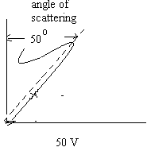
- What is modulation index? Write its expression.
- The vertical component of earth’s magnetic field at a place is √3 times the horizontal component. What is the value of angle of dip at the place?
- Define electrical susceptibility. How it is related to dielectric constant
- In which biasing does the junction resistance of p-n junction increase?
- A carbon resistor is marked with yellow violet and red color strips. What is its resistance?
- How is the myopia defect of an eye corrected?
- Why neutrino cannot be detected in beta decay?
- Draw diagram of reflecting type of telescope. Write its any one advantage over refracting type telescope.
- State laws which are used for calculating equivalent resistance of unbalanced wheat stone bridge.
OR
Calculate the equivalent resistance of the following circuit.
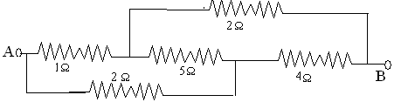

- A plane EM wave of frequency 25 Hz travels in free space along X direction. At a particular point in space and time the electric vector is E = 6.3j V/m. Calculate B at this point.
- Define the terms transducer, signal, noise and attenuation in respect of an electronic communication system.
- A point source is placed midway between two concave mirrors having equal focal length (f) as shown in fig. find the values of d for which only one image is formed.

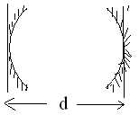

- Why sky wave propagation of electromagnetic waves cannot be used for TV transmission? Suggest two methods by which range of TV transmission can be increased.
- X -ray of wavelength λ falls on photosensitive surface emitting electron. Assuming that the work function of the surface can be neglected, prove that de-Broglie wavelength of electron emitted will be h/[2mK]^{1/2}.
- A conductor of length L is connected to a dc source of emf V. if the length of the conductor is tripled by stretching it, keeping V constant, explain how do the following factors vary in the conductor:
(1) Drift speed of electron (2) Resistivity.
- Show that capacitance of a spherical conductor is proportional to its radius. Hence justify that farad is large unit of capacitance.
- Write the principle of potentiometer. Explain how you will compare the emfs of two cells with the help of circuit diagram.
OR
Write formula to determine the value of unknown resistance when wheat stone bridge is balanced. Assuming the bridge is not balanced, how will find the value of resistance? State these laws.
- State Biot-savart law. An electron is moving at 10⁶ m/s in a direction parallel to a current of 5 A flowing through an infinitely long wire at a perpendicular distance of 10 cm in air. Calculate the magnitude of force experienced by an electron.
- Deduce an expression for torque experienced by a circular coil of radius ‘r’ carrying current “ I ” is placed in presence of uniform magnetic field of strength ‘B’. Using this expression show that the deflection in galvanometer is directly proportional to the current flowing through it.
- Draw a labeled diagram of A.C. generator. Write the principle of A.C. generator. Deduce expression for the induced emf.
- In a series L-R circuit X_{L} = R, power factor is P₁. When a capacitor having capacitance such that X_{C} = X_{L} connected in series, power factor become P₂. Find the ratio P₁/P_{2.}
- Draw a neat labeled ray diagram for the astronomical telescope. Obtain expression for its magnifying power when image is formed at least distance of distinct vision.
- The energy levels in an atom of an element are shown in the following diagram.
Which one of the level transition will result in the emission of photon of wavelength 620nm? Support your answer with mathematical calculation.
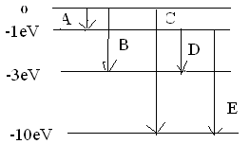
- State the law of radioactive disintegration. Using this law, show that the radioactive decay is exponential in nature.
- One day transformer of a village caught fire due to short circuit and turned down into ash. Department replaced the transformer next day but defect remained permanently resulting the light to be dim. After few days delegation of village representatives met with Chief Engineer about persistence of problem. Imagine you are on the chair of Chief Engineer, how will respond to villagers about the reasons of problem? How it is occurring even with transformer in working condition? And what could be the solution for it?
State four important uses of transformer.
- Explain the effect of introducing a dielectric slab between the plates of a parallel plate capacitor on its capacitance. Derive an expression for its capacitance with the dielectric slab, what is the effective capacitance across XY of the capacitor of capacitance if the capacitor with air/vacuum between the plates of area A each and distance d apart was C_{o}.
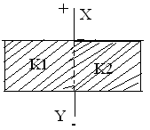
OR
State gauss theorem in electrostatics. Derive an expression for the electric field strength near an infinite plane sheet of charge. A point charge of +10μC is at a distance 5cm directly above the centre of a square of side 10cm as shown in the figure. What is the magnitude of electric flux through the square?

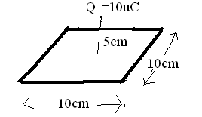

28. Explain with the help of a circuit diagram the principle and use of a transistor (npn) as an oscillator. If the LC circuit produces electromagnetic waves of frequencies 100Hz at resonance with a capacitor of capacitance (20/π²)μF. What should be the self inductance of the inductor?
OR
Discuss how i) AND gate ii) NOT gate are realized in practice. Two signals A and B shown in the figure are used as two inputs of NAND gate. Obtain the output waveforms for the two.

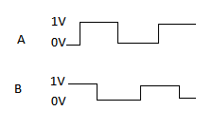

29. Write two differences between diffraction and interference pattern. A beam of light consisting of two wavelengths, 650 nm and 520 nm, is used to obtain interference fringes in a Young’s double-slit experiment. (a) Find the distance of the fourth dark fringe on the screen from the central maximum for wavelength 650nm. (b) What is the least distance from the central maximum where the bright fringes due to both the wavelengths coincide? Given d=2mm and D=120cm.

OR
What is polarization of light? State Brewster’s law for polarization and hence deduce an expression for polarizing angle. A polarizer and an analyzer are oriented so that maximum light is transmitted. What fraction of maximum light is transmitted if analyzer is rotated at 30º and 60º. Write two applications of polarizers.

