SST SAMPLE PAPER 1
2007
Questions 1 to 14 carry 2 marks.
Questions 15 to 21 carry 4 marks each.
Questions 22 to 25 carry 6 marks each.

SECTION - A 2 MARKS EACH

- What do you mean by an economy?
- Explain two policy initiatives of Globalization.
- What is consumer awareness?
- What are prices? Give two consequences of price rise.
- What are known as resources? How does technology influence development of resources?
- What do you mean by water resources? What is its importance?
- How can we plan our water resources?
- What is the economic importance of resources?
- Describe the development of telecommunication in India.
- Name the many groups of people who came to India and settled here from about 1500 B.C. to AD. 1800.
- Give names of two newspapers which started publication in the 19th century and are being published even today.
- Explain Domestic System and Ryotwari System
- Explain the role of UN Disaster administration Team (India) in managing the disaster.
- Who were the moderates and what were their aims?

SECTION - B 4 MARKS EACH

- Describe the principles of Panchsheel.
- What institutional reforms were brought in Indian agriculture after independence? What is meant by landholding ceiling?
- How is land the most important resource what is known as humus? What is its importance? What is the importance of climate in soil formation?
- What is known as shifting agriculture? Where and how is it practiced in India? State two features of Indian Intensive Agricultural Programme.
- Point out any four significant features of the Mughal Architecture in the reign of Akbar.
- What were the demands of the Indian National Conference formed under Govind Ranade In 1887?
- Study the map given below and answer the questions that follows
- Name the two states having very high percentage of net sown area under irrigation.
- Why do these States have largest area under irrigation? Give any one reason.
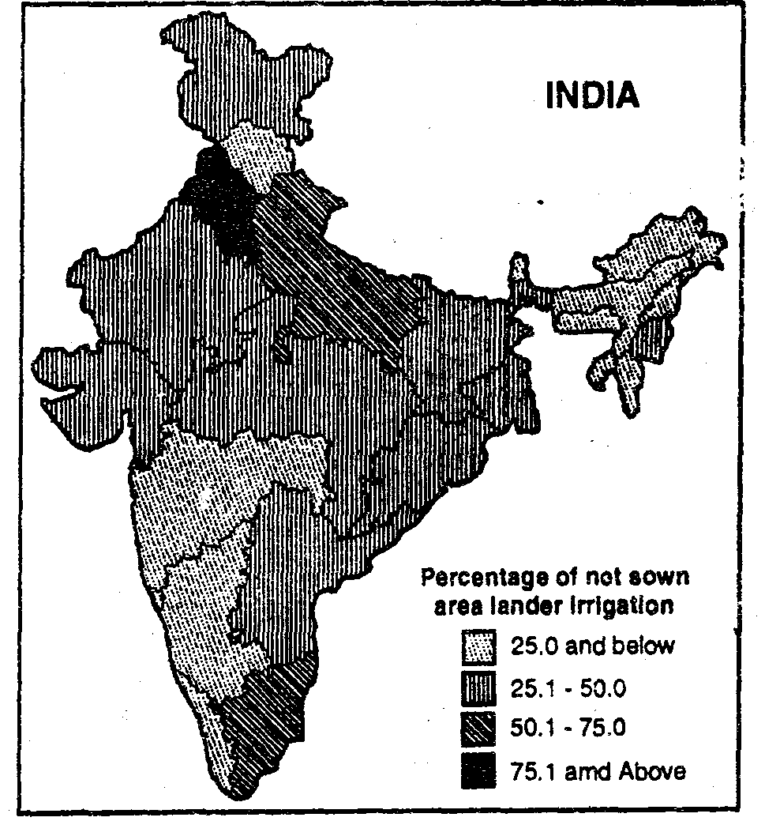

SECTION C 6 MARKS EACH
- Discuss the importance of Legal Literacy. Describe any five Civil Rights.
- What do you mean by corruption? How this practice has spread in India? Give some suggestions to remove corruption in the government services.
- What do you mean by Communalism? What is the nature of Communalism steps should be taken to end the evil of Communalism? How caste system developed in India?
- Explain the meaning of each of the following terms: Anglicists, Orientalists, Sati, Permanent Settlement,

