Guess Paper – 2013

Class – XII

Subject – Maths

Topic: Matrices & Determinants,vectors,line &plane, L.p, area b/w two curves, inverse funct., derivative &diff.equation.

Find x , if 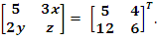
- For what x, the matrix 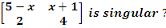
- Find the value of λ if îλ + 3ĵ +2 k̂ and 3î – ĵ +4 k̂ are parallel .
- If =3,=4 and 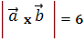 , find the angle between and
- Express the following matrix as the sum of a symmetric and skew symmetric matrix,
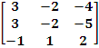

- 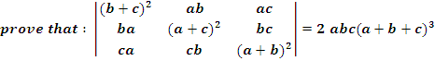
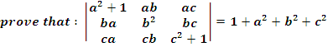
- Find the inverse of matrix , using elementary operations:
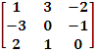
Or
if A = 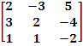 , find A⁻¹ . using A⁻¹ solve the system of equations:
2x-3y+5z =11 ; 3x+2y-4z = -5; x+ y -2z = -3 .

8.

9. If vectors , and are such |++ | =0, and | | = 6, | | = 8 and | | = 10.
Find (.+.+.)
10. Let = – , = 2+ + and = – Find a vector which is perpendicular to both , and = 1.
11. Express the vector - 2ĵ + 5 k̂ as a sum of two vectors such that one vector is parallel to the vector + k̂ and other is perpendicular to
12. If y= , then prove that : (1-x²)- x - a²y = 0
13. If (cos x)^{y} = (sin y )^{x} , find .
14. tan⁻¹ 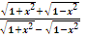= + .
Or
2 tan⁻¹ + tan⁻¹ = tan⁻¹ .
15. Solve for x: tan⁻¹ + tan⁻¹ = .
16. Find the area enclosed between the circles: x² + y² = 4 , (x-2)² + y² = 4 .
Or
Find the area enclosed between the parabolas: x² = 4x , y² = 4x .
17.Solve the differential equation: ( 1+ x²) + y =
18. Solve the differential equation: 2xy dx + ( x² + 2 y²)dy = 0.
19. Find the angle between the line and the plane 2x +y – 3z = 4.
Or
Find the equation of line which passes through the point (1, -1, 2) and parallel to
20. Find the shortest distance between the lines, whose equations are 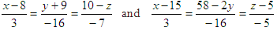
or
Find the coordinate of the foot of perpendicular drawn from the point(1,2,1) to the line
.
21. Find the equation of the plane which is perpendicular to the plane 5x + 3y + 6z + 8 = 0 and which contains the line of intersection of the planes x + 2y + 3z – 4 = 0 & 2x + y – z + 5 = 0.
Or
Find the equation of the plane passing through the point (1,1,1) and containing the line
= -3î +ĵ +5 k̂ + λ(3î - ĵ + 5 k̂).
Submitted by : Satvinder Singh mob 09729064004
Email: sspawar.singh00@gmail.com, mathhelp.ss@gmail.com ***************************************************

Test XII Mathematics  Topic: Matrices & Determinants,vectors,line &plane, L.p, area b/w two curves, inverse funct., derivative &diff.equation. | Sspawar mentors for maths
***

