Guess Paper – 2014
Class – XI
Subject – MULTIMEDIA AND WEB-TECNOLOGY
Time allowed:- 3 hrs. M.M:- 70

Q1. Questions given below are based on Computer System:-

- What are the function of computer? (1)
- What is the difference between volatile and non-volatile memory?(2)
- Compare and contrast the laser and dot matrix printer. (2)
- What is MICR? Where is it used? (1)
- What is disk defragmenter? (1)
- Explain the types of software? (2)
- What is address bus. (1)
- What are the characteristic of secondary storage? (2)
- Write a short note on Assembler. (1)
- Difference between Graphics Tablets and Smart card. (2)

Q2. Questions given below are based on HTML:-

- What is URL? Explain different part of URL? (2)
- Differentiate between HEAD and TITLE tag. (1)
- What is Web-Publishing? (1)
- What is the difference between <Sub> and <Sup> tags? (2)
- Explain the implicit HTML tags. (2)
- Explain the two types of list. (2)
- What is NAME attributes? (1)
- What is BASE tag? (1)
- What is purpose of using TYPE and START attributes used in list? (2)
- What is difference between rowspan and colspan? (1)
- Difference between Cellpadding and Cellspacing? (2)
- What is FRAMESET? (2)
- What is difference between submit and reset button in form? (1)
- What is purpose of SELECT Tag? (2)

15. Write html code to generate the following output (3)
(Use Frame Concept).

Q3. Questions given below are based on VBScript:-

- How is Client Side Scripting different from Server Side Scripting? (2)
- What are reserve words in VBScript? Give two example. (1)
- What do you mean by array? Write the program to declare an array? (2)
- Write a short note on VBScript Constants. (1)
- What is procedure in VBScript? What are different types of procedure available in VBScript? (2)
- What are operators? Name different categories of operators. (2)
- What is Document Object? Explain with Syntax. (2)
- Explain the difference between IF_THEN_ELSE_END IF and ELSE IF statement with example. (2)
- Explain with example the usage of following inbuilt function:- (2)
(a) CByte() (b) IsDate()
(c) Asc () (d) Trim()
10. Explain the difference between FOR_NEXT and DO_WHILE LOOP
Statement with example. (2)
11. What is the difference between Integer Division(\) and Division(/) operator
with the help of example? (2)

Q4. Question given below based on Practical:-
(Do any two questions)

(a) Give output of the following statement:- (2)
(a) (13 mod 7+3*2-10)
(b) (5^2/5*3+9)
(b) Consider the following web-page layout in Vbscript:- (3) Please Enter Your Name

First Name
Reeta

Last Name
Sahoo
SAHOO, REETA
Full Name
Submit
Reset

2. (a) Write a program to find out the sum of 1 to 10 number. (2)
(b) Write a Program to find out the even and odd number. (3)

3. Write the HTML code to generate a web-page in the format given
below. (5)
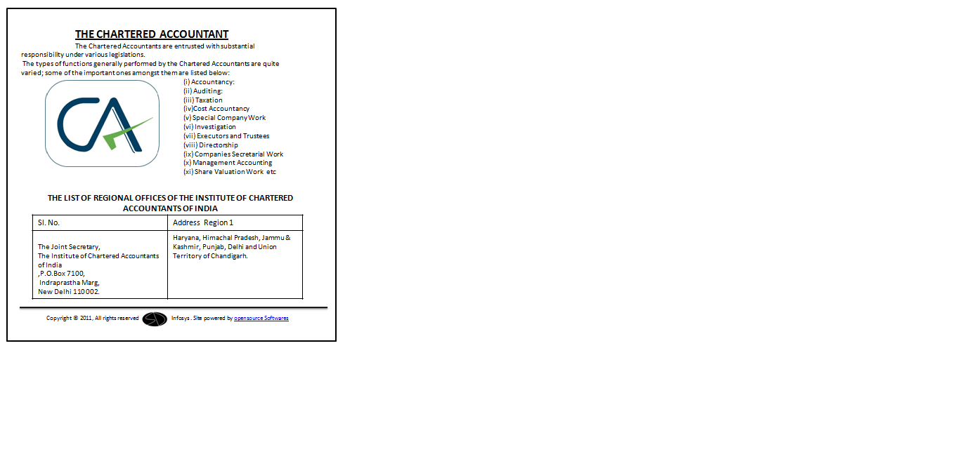

Consider the following while writing the HTML code :
- Title of the page should be “CA”
- Background colour of the page should be “purple”.
- Text style of the main heading should be “Arial bold” and colour should be blue.
- Image used is calogo.jpg.
- Table should have a 2 pixel thick border of colour green and the space between cell content and border is 15 pixels.
- The bottom image (sd.jpg) and the text “opensource software” are links to page “dobhri.html”

Paper Submitted By:
Name AMIT GARG
Email amit_garg84@yahoo.in
Phone No. 9814555800

