PRE BOARD EXAMINATION ( 2006 – 07 )
Subject: PHYSICS
Class : XII
M M :70 Time :3 h

General Instructions:
- All questions are compulsory.
- There is no overall choice. However, an internal choice has been provided in one question of two marks, one question of three marks and one question of five marks. You have to attempt only one of the choices in such questions.
- Question numbers 1 to 5 are very short answer questions, carrying one mark each.
- Question numbers 6 to 12 are short answer questions, carrying two marks each.
- Question numbers 13 to 24 are short answer questions, carrying three marks each.
- Question number 25 to 27 are long answer questions, carrying 5 marks each
- Use of calculators is not permitted. However, you may use log tables if necessary.
- You may use the following values of physical constants wherever necessary :
c = 3 x 10 ⁸ ms ^{–1}
h = 6.6 x 10 ^{–34} Js
e = 1.6 x 10 ^{–19} C
μ ₀ = 4π x 10 ^{–7} T m A⁻¹

1. Name the physical quantities that have the units : (a) Cm & (ii) JC⁻¹.

2. Define the term rms current and write its formula.

3. Name the types of communication on the basis the modes of transmission.

4. An electron traveling west to east enters a chamber having a uniform electrostatic field in north to south direction. Specify the direction in which a uniform magnetic field be applied to prevent the electron beam from deflection.

5. What is the effect on the velocity of the emitted photoelectrons if the wavelength of the incident light is decreased?

6. Define the terms ‘magnetic declination’ and ‘horizontal component’ of earth’s magnetic field. Establish the relation between them.

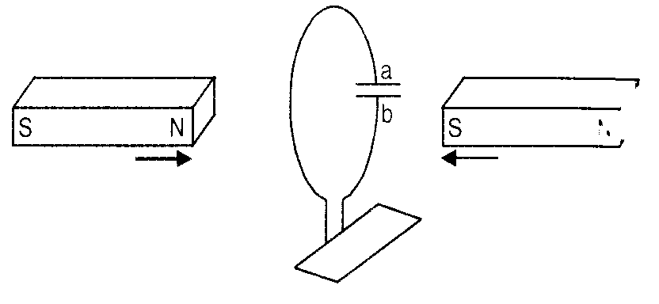
7. Define the term ‘self induction’. Write its formula. Enlist two important factors on which it depends.

8. Predict the polarity of the capacitor in the adjoining situation:

9. A point charge causes an electric flux of – 1.0 x 10³ Nm² C⁻¹ to pass through a spherical Gaussian Surface of 10.0 cm radius centered on the charge.
(a) If the radius of the sphere is doubled. How much flux would pass through the surface? (b) What is the value of the point charge?

10. Let two conducting spheres of radii r ₁ & r ₂ be joined by a thin wire and a total charge q be given to them. Prove that the charges on the spheres will be in the ratio of their radii.

11. The minimum deviation be a glass prism of angle 60⁰ is 30⁰. Calculate the velocity of light in glass.

12. The emf of a cell measured by a potentiometer is found to be 1.5V. An accurate voltmeter connected across the terminals of the cell reads 1.4V. Explain the discrepancy and calculate the ratio of the resistance of the voltmeter to the internal resistance of the cell.

OR
You are given a 8 Ω resistor. What length of constantan wire of resistance 120 Ω m⁻ ¹ should be joined in parallel with it to get a value of 6Ω?

13. A capacitor of capacitance C is charged to a potential V. Predict the effects on capacitance, charge and energy when:
(a) dielectric slab of dielectric constant K is filled in the space between the plates with batteries connected,
(b) batteries are first disconnected and then the dielectric slab of dielectric constant K is filled in the space between the plates.

14. Under what condition is the heat produced in an electric circuit:
(a) directly proportional , (b) inversely proportional,
to the resistance of the circuit?
A resistor is put in series with a voltmeter having electrodes made of metal of chemical equivalent E. A mass m of the4 metal gets deposited in a time t when a current is made to flow through the combination. Obtain an expression for the heat produced in the resistor during this time.

15. A 10m long wire AB of uniform cross section and 20Ω resistance is used as a potentiometer wire. This wire is connected in series with a battery of 5V and a resistor of 480Ω. An unknown emf is balanced at 600 cm of the wire. Calculate:
(a) the potential gradient for the potentiometer wire,
(b) the value of the unknown emf.

16. A 50mH inductor, a 80 μF capacitor and a 40 Ω resistor are connected in series with a 200 V a.c. supply. Calculate :
(a) the source frequency that derives the circuit at resonance &
(b) the impedance of the circuit and the amplitude of the current at the resonant frequency.

17. Derive an expression for the fringe width in the Young’s Double Slit Experiment.

OR
Justify the laws of reflection on the basis of the wave theory.

18. Electromagnetic waves with wavelength
(a) λ₁ are used to treat muscular strain, (b) λ₂ are used by a FM radio broadcast,
(c) λ₃ are used to detect fractures in bones & (d) λ₄ are absorbed by the ozone layer.
Identify and name the part of electromagnetic spectrum to which these radiations belong. Arrange these wavelengths in decreasing order of magnitude.

19. A electron and a photon each have a wavelength 1.0nm. Find
(a) their momenta,
(b) the energy o the photon &
(c) the kinetic energy of the electron.

20. What is ‘α decay’? Explain the phenomenon on the basis of the ‘tunneling of the nucleus’.

21. In the sequence of the decay shown below, what are the corresponding values for D₁, D₂ & D₄?
Activity of a radioactive substance having short half life is much more than a substance having long half – life. Explain why ?

22. The output of an unregulated d.c. supply needs to be regulated. Name the device that can be used for this purpose and draw the r3elevent circuit diagram.
Transistor is a current operated device. Justify.

23. Write two important features required in : (a) optical source & (b) optical detector in the optical communication system.
Mention two important advantages of optical communication system.

24. A ground receiver station is receiving a signal at (a) 5 MHz (b) 100 MHz; transmitted from a ground transmitter at a height of 300m located at a distance of 100 km from receiving station. Identify whether the signal is coming via space or sky wave propagation or satellite transponder. Radius of the earth is 6.4 x 10⁶m, N_{max} for ionosphere = 10¹²m³.

25. Explain with the help of a labeled diagram the principle, construction and working of a Cyclotron.

26. What are the main conditions to be kept in mind while designing the ‘objective’ of an astronomical telescope?
Obtain an expression for the angular magnifying power and the length of the tube of an astronomical telescope in its ‘normal adjustment’ position.
An astronomical telescope having an objective of focal length 2m and eyepiece of focal length 1cm is used to observe a pair of stars with an actual angular separation 0.75. What should be their observed angular separation as seen through the telescope?

OR
What are the two ways of adjusting the position of the eyepiece while observing the final image in a compound microscope? Which of these is usually preferred and why?
Obtain an expression for the magnifying power of a compound microscope. Hence explain why:
(a) we regard both the objective and eyepiece to have small focal length? and
(b) we regard the length of the microscope tube to be nearly equal to separation between
the focal length of its objective and the eye piece?
Calculate the magnification produced by a compound microscope having an objective of focal length 1.5cm and eyepiece of focal length 2.5 cm and a tube of length 30cm.

27. A semiconductor has equal electron and hole concentrations of 2x 10⁸ m⁻³. On doping with a certain impurity, the hole concentration increases to 4x 10¹⁰ m⁻³.
(a) What type of semiconductor is obtained on doping?
(b) Calculate the new electron hole concentration of the semiconductor.
(c) How does the energy gap vary with doping?

How can an OR gate exclusively be obtained from a NAND gate?

