Guess Paper – 2007
Class XII
Informatics Practices

TIME : 3 HR MM : 70

Note :
- This Question Paper is divided into 3 sections.
- Section A consist of 30 marks .
- Section B and Section C are of 20 marks each.
- Answer the questions after carefully reading the text.

Section - A

Q 1. Answer the following questions :
- How is geography linked to other three building block of an information system? 2
- What is the difference between analysis and design ? Can one begin to design without analysis ? Why ? 2
- Identify the various types of relationships from the following and also show them diagrammatically :
    - A student enroll for various courses in a college
    - A department is headed by a faculty member 2
- Write a short note on client/server computing. Give an example also. 2
- What do you understand by three tier computing model ? 2

Q 2. Answer the following questions :

- Name some common properties of following control : 2 text box , label , option button , checkbox, list box .
- What is the usage / significance of variant data type ? 2
- What do you understand by the control constructs ? How would you classify them ? 2
- What do you mean by scope of a variable ? how many types of scope are supported in VB ?2
- What is DSN ? write steps to create a DSN for ODBC . 2

Q 3 Answer the following questions :
- How can you combine all the steps of cursor management ( declare ,open , fetch and close ) into one ? give example. 2
- What are comments ? what are different ways of adding comments in PL/SQL? 2
- What is subquery ? what is the functionality of ANY , ALL , EXITS ? 2
- Compare char and varchar2 datatypes. 2
- what are the contents of the correlation variables NEW and OLD when trigger associated with various DML statements are executed ? 2

Section – B
Q 4. A software company wants to conduct few tests and interviews for the posts of web designers and developers . The data regarding the performance of the candidates is gathered using the following interface :

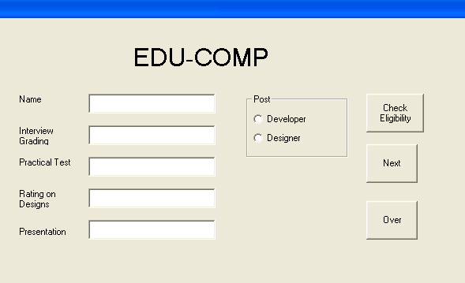

The list of above form is as follows:
Object type | Object name
Form  Text box  Option button  Command button | Frmsoftware  Txtname  Txtintgrade  Txttest  Txtrate  Txtpresentation  Optdeveloper  Optdesigner  Cmdcheck  Cmdnext  Cmdover

Write code for the following enhancements to the application : 2
- The prompt on the label “Rating on Designs” should be set to
    - ‘Rating on illustrated designs ‘ when the user select the options optdesigner.
    - ‘Rating on illustrated projects ‘ when the user select the options optdeveloper.

- The label lblpresentation and test field txtpresentation should be visible only if the option button optdeveloper is selected . 2
- A function validatedata() has already been defined to check the validity of data . it returns TRUE , if the data is valid and FALSE otherwise. When the user click cmdcheck button ,this function should be called and if the data is valid then eligibility should be checked and a message should be displayed as per following rules : 4
    - Interview grading should be >=8
    - Test marks >=75 and rating on illustrated designs / project >7
    - for the developers , grading in presentation should be either B+ or A.
- when the user clicks the cmdNext button all fields should get cleared and option buttons should be set to the default choice of developer. 2

Q 5. Answer the following questions :
- Find the errors from the following code segment and rewrite the corrected code underlining the correction made : 2
Dim value = 29 , k as integer
K=5
Do
K=k-2
If value > 28
Value = 89;
Else
Value = value- 5
Loop until (k>5)

- Find the output of the following code segment : 2
    - Print Lcase (left(mid(“INFORMATICS”, 7,4),3))
    - Format (now , “dddd,mmmm dd, yyyy”)

- Rewrite the following code segment using select case instead of if else : 3

Dim sal as integer
If sal >=10000 then
Msgbox (“ new year bonus is 2000”)
Elseif sal>=12000 and sal <=15000 then
Msgbox (“ new year bonus is 5000”)
Elseif sal= 20000 then
Msgbox (“ new year bonus is 7000”)
Else
Msgbox (“ Bonus not applicable”)
End if

- Write the visual Basic function to calculate the factorial of user input number .For example Factorial of 5 = 5*4*3*2*1 . 3

Section –C
Q 6. Read the question given below and answer accordingly :
- Write the output produced by the following part of the code in PL/SQL : 3

DECLARE
X NUMBER :=8;
Y NUMBER := 13;
Z NUMBER(4);
BEGIN
WHILE (Z<=50)
LOOP
Z:= X+Y;
X:= Y;
Y:= Z; IF X*Y <=200 THEN
DBMS_OUTPUT.PUT_LINE( TO_CHAR(X) );
DBMS_OUTPUT.PUT_LINE( TO_CHAR(Y) );
ELSE
EXIT;
END IF;

END LOOP ;
END;

- Find the error from the following PL/SQL code and rewrite the corrected code underlining the correction made : 2

DECLARE
R NUM
Q NUMBER
BEGIN
P=7;
FOR Q = 1 TO 4
P=P+Q;
DBMS.OUTPUT_PUT.LINE( TO_CHAR(P) );
NEXT Q;
END;
- What are the restrictions on the PL/SQL statements used in the trigger body ? 2
- Write a PL/SQL function Checkdiv that takes two numbers as an argument and returns the value 1 if the first argument passed to it is divisible by the second argument, else will return the value 0. 3

Q. 7. Answer the questions based on the table employee given below :

Column Name | Data Type | Size | Constraint
ID  FIRST_NAME  LAST_NAME  EMAIL_ID  SALARY | NUMBER  VARCHAR2  VARCHAR2  VARCHAR2  NUMBER | 4  12  23  14  10 | PRIMARY KEY  NOT NULL  NOT NULL  NOT NULL  NOT LESS THAN Rs. 5000
- Write the SQL command to create the table employee including the constraints.2
- Write the sql command to display the details of all the employee whose salary is the same as the salary of employee id number 1221. 2
- Write PL/SQL procedure to find out whether the salary of an employee with id = 2132 is less than 5570 or not . If it is less than 5570 , modify the salary of employee by increasing it 15%. 3
- Write PL/SQL code to create two statement level triggers ASD_employee and DSA_employee before and after DELETE statement respectively on the table employee which display the message ‘ready for deletion ‘ and ‘records Deleted ‘ respectively. 3

