Guess Paper – 2008
Class XII
Informatics Practices

TIME : 3 HR MM : 70

Note :
- This Question Paper is divided into 3 sections.
- Section A consist of 30 marks .
- Section B and Section C are of 20 marks each.
- Answer the questions after carefully reading the text.

Section - A

Q 1. Answer the following questions :
- What is data mining ? Why is it termed as a revolutionary technology ?How it works ?Name two commonly used techniques for data mining . 2
- What is UML and UML DIAGRAM? Name two UML diagrams. 2
- How is conceptual data modeling of DDLC different from logical data modeling ? 2
- Define 1) LINUX II) MOZILLA 2
- Why is database is a key component of transaction processing system? 2

Q 2. Answer the following questions :

- What is control array ? How it is different from menu control array ? 2
- Differentiate between pre-tested and post –tested loop .Give two example of each. 2
- What is module? What are the different types of modules that can be created in VB ? Define all of them. 2
- What are built – in functions ? Define all the type of Library function . 2
- What do you understand by the term data – bound controls ? name any two data-bound controls that ca be used on a form. 2

Q 3 Answer the following questions :
- What is a join ? Give example of Equi join and Natural Join. 2
- Write a query that generates a sequence of odd numbers in the range 100 -200. if the upper limit is reached , it should again begin from 100 . 2
- What is the difference between %TYPE and %ROWTYPE attributes ? 1
- What are functions? How are they different from procedures ? 2
- compare triggers , procedures and cursors with example . 3

Section – B

Q 4 . Read the following case study and answer the questions that follow :
The Basera restaurant has computerized its billing. The following the data entry screen used at their outlet. The outlet offers two different types of foods, vegetarians and non vegetarians. the price of a regular vegetarian THALI is Rs. 140 and that of a non vegetarian THALI is Rs. 290. the user can choose to have three different types of extra supplements if he wants. Each extra supplement costs Rs. 80.

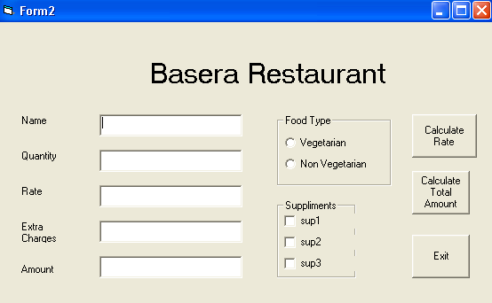

The list of above form is as follows:
Object type | Object name
Form  Text box  Option button  Command button  Check box | Frmrestro  Txtname  Txtqty  Txtrate  Txtextracharge  Txtamount  Optveg  Optnonveg  Cmdcalrate  Cmdcalamount  Cmdexit  Chksup1  Chksup2  Chksup3

- write the commands to disable the textboxes txtrate, txtextracharge ,txtamount and cmdamount ,and set the focus on textbox txtname. 2
- Write the code for cmdrate to calculate the rate of the food and display it in txtrate depending on the type of food selected by the customer . 3
- Enable the cmdamount button .Write the code for cmdamount to calculate the total amount and display it on txtamount.If the quantity is more than 10 give 16% discount on supplement . 3
- Write the code for cmdexit to close the application , before closing the application it should display a message “ Do you really want to close the program(yes/no) ?” .if user select yes it should close the program otherwise set the focus on textbox txtname . 2

Q 5. Answer the following questions :
- Find the errors from the following code segment and rewrite the corrected code underlining the correction made : 2

X=90
Do while x<=100
If x mod 6 =0
Print x-9
Else
Print x

X=x*3.4 + 45.98
Loop while x<=100
- Find the output of the following code segment : 2
Sum=0
For I = 23 to 27
If (I mod 3 = 0 ) then
Sum = sum +i*7
Else
Sum = (sum + i*5) -3
End if
Next i
Print sum

- Rewrite the following code segment using For … Next instead of Do ..until: 2

Dim total as integer
Dim n as integer
Dim I as integer
N= val (text1.text)
Do until i< = n
Total =total +i
I=i+1
End do
- Write the visual Basic procedure to print Fibonacci series up to 21 using FOR loop . The Fibonacci series ia as follow 0 ,1 ,1,2,3,5,8,13,21 ………… 4

Section –C
Q 6. Read the question given below and answer accordingly :
- Write the output produced by the following part of the code in PL/SQL :

DECLARE 3
I NUMBER(2);
SGN NUMBER(2);

BEGIN
X:=1;
SGN :=+1;
WHILE (I <=40)
LOOP
I:= I *SGN;
DBMS_OUTPUT.PUT( I || ‘ ‘ );
I:=I+3;
SGN:= SGN * -1;
END LOOP ;
DBMS_OUTPUT.PUT_LINE( ‘ ‘ );
END;

- Find the errors from the following code segment and rewrite the corrected code underlining the correction made : 2
Declare
Y INTEGER;
X INTEGER;
BEIGN
Y=5;
FOR X INTO <=4
LOOP
X+Y := Y;
DBMS_OUTPUT.PUT_LINE(Y);
END;

- What do you understand by mutating table and constraining table ?how are these used by row level triggers ? 2
- Write a PL/SQL function oddeven to return value true if the number passed to it is even else will return false . 3

Q. 7. Answer the questions based on the table customer given below :

Column Name | Data Type | Size | Constraint
Cust_id  Custname  Permanent_address  Postall_address  Tot_purchase_cost | Number  Varchar2  Varchar2  Varchar2  number | 7  30  20  20  7,2 | Primary key  Not null  Not less than 2000
- Write the SQL command to create the table customer including the constraints. 2
- Write the SQL command to display the details of all the customer whose name start with A alphabet and total purchase cost is more than 7000.. 2
- Write PL/SQL code to give 12 % discount if the purchase is over Rs. 10000 . 4
- Write PL/ SQL code using explicit cursor to display the details of all the customers whose customer id is less than 3456 and the purchase made by them is less than 4000. 4

