Guess Paper – 2007
Class XII
Informatics Practices

TIME : 3 HR MM : 70

Note :
- This Question Paper is divided into 3 sections.
- Section A consist of 30 marks .
- Section B and Section C are of 20 marks each.
- Answer the questions after carefully reading the text.

Section - A

Q 1. Answer the following questions :
- How is a back-end linked to a database and a server ? Give one major difference between front end technology and back end technology in term of software projects. Give one example of each. 2
- What are different part of decision table ? Give function of each part . 2
- What is the role of data dictionary and metadata in data warehouse? 2
- What is the significance of object modeling ? What tool can be used for object modeling?2
- Distinguish between initial investigation and feasibility study ? 2

Q 2. Answer the following questions :

- What is the difference between unloading and hiding of a form? 2
- What is the difference between SDI and MDI interface ? 2
- What is variable life time ? What is the life time of a local , a public and a module variable ?2
- What do you understand by file system controls ? What is their significance ? 2
- How are the connection , command and result set objects related to each other ? 2

Q 3 Answer the following questions :
- What are views ? how are they useful ? 2
- What do following command do : COMMIT , ROLLBACK , SAVEPOINT ? 2
- Differentiate between sql and pl/sql. Distinguish between Anonymous and Named blocks as supported by PL/SQL. 2
- What for %ISOPEN and %FOUND attributes are used ? 2
- Define trigger . What do triggers basically do ? How are triggers similar to constraints ?2

Section – B

Q 4 . Read te following case study and answer the questions that follow :
Mr. Anil Dutpuri works in karma Textile as a programmer . He is required to develop a employee record. The company have two types of employee , regular and casual stored in list box, with different job status. The company also offers 10 % of their salary as an incentive to all the employee if they do not take any leave during a month time. Also there is a bonus equal to one month salary to the regular employee in the month of January.
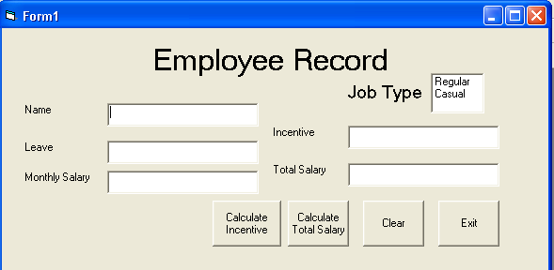

The list of above form is as follows:
Object type | Object name
Form  Text box  List box  Command button | Frmempre  Txtempname  Txttotalleave  Txtmonthlysalary  Txtincentive  Txttotalsalary  Listjobtype  Cmdcalincentive  Cmdcaltotalsalary  Cmdclear  cmdexit

- Write the commands to disable the textboxes txtincentive, txttotalsalary ,and set the focus on textbox txtempname. 1
- Write the code for cmdclear command button to clear all the text boxes and set the focus on cmdexit command button. 1
- Write the code for cmdcalincentive to calculate the incentive of the employee and display it in txtincentive depending on the leave records . 2
- Write the code for cmdcaltotalsalary to calculate the total amount of january and display it on txttotalsalary on the basis of job type .Remember the bonus condition given in the beginning of a question for the regular employee. 4
- Write the code for cmdexit to close the application , before closing the application it should display a message “ Do you really want to close the program(yes/no) ?” .if user select yes it should close the program otherwise set the focus on textbox txtempname . 2

Q 5. Answer the following questions :
- Find the errors from the following code segment and rewrite the corrected code underlining the correction made : 2

X=190
Do until x>=100 then
If x mod 6 =0
Print x*8
Else
Print x-4

X=x*1.4 + 65.98
Loop until x>=100
- Find the output of the following code segment : 2
Sum=0
For I = 3 to 7
If (I mod 2 = 0 ) then
Sum = sum +i*17
Else
Sum = (sum + i*5) -13
End if
Next i
Print sum

- Rewrite the following code segment using For … Next instead of Do ..until: 2
Dim total as integer
Dim n as integer
Dim I as integer
N= val (text1.text)
Do until i< = n
Total =total +i
I=i+1
End do

- Write the visual Basic function that display the sum of all the multiple of 13 up to 2000. 4

Section –C
Q 6. Read the question given below and answer accordingly :
- Write the output produced by the following part of the code in PL/SQL : 3

DECLARE
X NUMBER :=1;
Y NUMBER := 4;
Z NUMBER(4);
BEGIN
LOOP
Z := ( 2*X+ 3*Y) -13 ; IF X+Y <=13 THEN
DBMS_OUTPUT.PUT_LINE( TO_CHAR(Z) );
ELSE
EXIT;
END IF;
X:=X+4;
Y:= Y-2;
END LOOP ;
END;

- Find the errors from the following code segment and rewrite the corrected code underlining the correction made : 2
Declare
Y INTEGER;
X INTEGER;
BEIGN
Y=5;
FOR X INTO <=4
LOOP
X+Y := Y;
DBMS_OUTPUT.PUT_LINE(Y);
END;
- How is implicit cursors different from explicit cursors ? 2
- Write a PL/SQL procedure to which takes year as argument and display whether the year is a leap year or not . 3

Q. 7. Answer the questions based on the table customer given below :

Column Name | Data Type | Size | Constraint
Cust_id  Custname  Permanent_address  Postall_address  Tot_purchase_cost | Number  Varchar2  Varchar2  Varchar2  number | 7  30  20  20  7,2 | Primary key  Not null  Not less than 2000
- Write the SQL command to create the table customer including the constraints. 2
- Write the SQL command to display the details of all the customer whose name start with A alphabet and total purchase cost is more than 7000.. 2
- Write PL/SQL code to give 12 % discount if the purchase is over Rs. 10000 . 3
- Write PL/ SQL code using explicit cursor to display the details of all the customers whose customer id is less than 3456 and the purchase made by them is less than 4000. 3

