Sample Paper – 2007
Class – XII
Physics

MAX MARKS: 70 TIME: 3hrs.

General Instruction:
- Answer all questions
- Internal choices are provided for some questions
- Question numbers 1 to 5 are very short answer questions and carry 1 mark each.
- Question numbers 6 to 12 are short answer questions and carry 2 marks each.
- Question numbers 13 to 24 are also short answer questions and carry 3 marks each.
- Question numbers 25 to 27 are long answer questions and carry 5 marks each.
- Use log tables if necessary.

- Electromotive force is not a force. Give reason.
- The magnetic field in a plane electromagnetic wave is given by B_{y}=2x10⁻⁷Sin(0.5x10³X+1.5x10¹¹t). Write an expression for the electric field?
- The light photons of energy 1eV and 2.5 eV respectively incident on a metallic plate one after the other. Find the work function of the metal, if the ratio of maximum kinetic energy of the photoelectron emitted is ¼.
- How many alpha and beta particles are emitted when Actinium ₈₉Ac²²⁷ decays to Platinum, ₇₈Pt¹⁹⁵?
- Consider an optical communication system operating at λ = 800nm. Suppose only 1% of the optical source frequency is the available channel bandwidth for optical communication. How many channels can be accommodated for transmitting audio-signals requiring a bandwidth of 8KHz.
- There are two concentric hollow spheres of surface charge density +σ and – σ of radii ‘r’ and ’2r’. Find the potential at the centre.
- Give the reactions which takes place at the anode and cathode of a lead acid accumulator while charging.
- A silver wire has a resistance of 2.1Ω at 27.5⁰C and a resistance of 2.7Ω at 100⁰C. Determine the temperature coefficient of silver.
- A square coil of side 10cm is placed in the east west plane. A magnetic field of 0.1T is set up in 0.7s and in the north-east direction through the coil. The coil has a resistance of 0.7 Ω, what is the magnitude of the induced emf and current?
- Theoretically prove that the electromagnetic waves are transverse in nature.
- One face of a prism of refracting angle 30⁰ and refractive index 1.414 is silvered. At what angle must a ray of light fall on the unsilvered surface so that after refraction into the prism and reflection at the silvered surface, it retraces its path?
- If the input wave is given across the terminals A and C and the
B
C
D
A
output is obtained across B and D. Draw the output wave form for
the given input wave form.

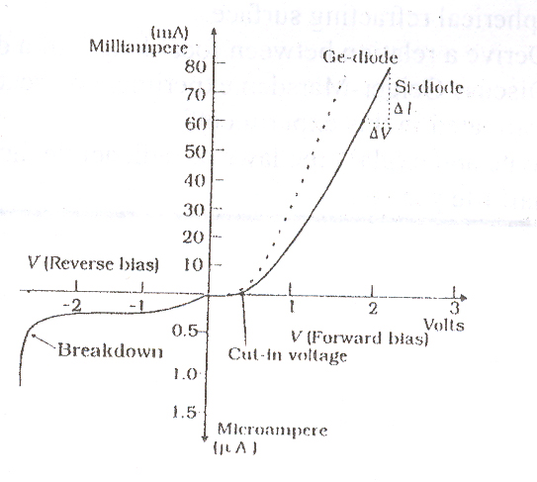
(OR)
The V-I characteristics of a silicon diode is given in the figure. Calculate the diode resistance is in (a)Forward bias at V = +1V and (b)Reverse bias at V = −2V.

- An electric dipole with moment$\vec{P}$is placed in a uniform electric field of intensity $\vec{E}$. Write the expression for the torque $\vec{τ}$experience by the dipole. Identify two pairs of perpendicular vectors in the expression. Show diagrammatically the orientation of the dipole in the field for which the torque is (i)maximum (ii)half the maximum value (iii)zero.
- Derive the expression for the energy stored in a parallel plate capacitor. How the energy density of this capacitor could be increased.
15v
90Ω
G
5 Ω
l
20μF
4 Ω
3 Ω
2V
A
B
- In the circuit diagram given, the potential difference across the wire AB is 1 metre long and it has a resistance of 10Ω. Find the balancing length ‘l’ in the galvanometer when it shows null deflection.

- Derive an expression for dipole moment of the atom. (OR) What are dia, para and ferro magnetic materials? Discuss their important properties.
- Derive an expression for effective value of alternating current.
- A sinusoidal voltage of peak value283V and frequency 50Hz is applied to a series LCR circuit in which R = 3Ω, L = 25.48mH and C = 796 µF. Find (a)the impedence of the circuit (b)the phase difference between the voltage across the source and the current (c)the power dissipated and the circuit.
- The total magnification produced by a compound microscope is 20. The magnification produced by the eye piece alone is 5. The microscope is focused on a certain object. The distance between the objective and eye piece is observed to be 14cm. If least distance of vision is 20cm, calculate the focal length of the objective and eyepiece.
- Describe Davisson and Germer experiment to depict the wave nature of electron.
- In a silicon transistor, the base current is changed by 20μA. This results in a change of 0.02V in base to emitter voltage and a change of 2mA in the collector current. (i)Find the input resistance, β_{ac} and transconductance of the transistor. (ii) the transistor is used as an amplifier with the load resistance 5kΩ, what is the voltage gain of the amplifier?(iii) What will happen if emitter be reversed biased and collector be forward biased in a transistor?
- How a NOR gate is realized? Explain. Construct with the help of NOR gates to obtain an output of $Y=A⋅\bar{B}$.
- With the help of circuit diagram explain the process of amplitude modulation and demodulation.
- What is a laser? Describe the basic principle involved in the working of laser.
- Find the frequency of electric field to be applied between dees of a cyclotron to accelerate charge particles by it. (OR) Find the torque acting on the rectangular current loop suspended in a uniform magnetic field, when placed inclined at an angle ‘θ’ with the direction of magnetic field.
- Prove that$\frac{−μ_{2}}{u}+\frac{μ_{1}}{v}=\frac{μ_{1}−μ_{2}}{R}$ when refraction occurs from denser to rarer medium at a convex spherical refracting surface. (OR) Derive a relation between focal length of a double convex lens and its radii of curvature.
- Discuss Geiger-Marsden experiment on scattering of alpha particles. How is the size of the nucleus estimated in this experiment? (OR) State and explain the laws of radioactive disintegration. Hence define disintegration constant and half life period.
***************************
THE INDIAN SCHOOL, KINGDOM OF BAHRAIN
II MODEL EXAMINATION – 2006

