Sample Paper – 2007
Class – X
Mathematics
Time: 3 Hours Max. Marks: 80
General Instructions:
1. All questions are compulsory
2. The question paper consists of 25 questions divided into three sections A, B and C. Section A contains 7 questions of 2 marks each, Section B is of 12 questions of 3 marks each and Section C is of 6 questions of 5 marks each.
3. There is no overall choice. However, internal choice has been provided in two questions of two marks each, two questions of three marks each and two questions of five marks each.
4. In question on construction, the drawing should be neat and exactly as per the given measurement.
5. Use of calculators is not permitted. However, you may ask for Mathematical tables.

SECTION-A
1. Solve the following system of equations : $\frac{5}{x} −2y = \frac{\text{17}}{3} , \frac{2}{x}+3y=\frac{−\text{16}}{3}$ x ≠0
OR
Solve for x and y : ax + by = b-a, bx - ay = -(a + b)
2. If the second term of an A.P. is 4 and seventh term is -11, find its 16th term.
3. If the sum of first n terms of an A.P. is 3n² -2n, find the A.P. and its 19th term.
4. A loan has to be returned in two equal semi-annual instalments. If the rate of interest is 16% per annum, compounded semi-annually and each instalment is Rs. 1458, find the sum borrowed.
OR
A loan of Rs 22,000 has to be repaid in two equal annual instalments. If the interest is charged at the rate of 20% per annum, compounded annually, find the amount of each instalment.

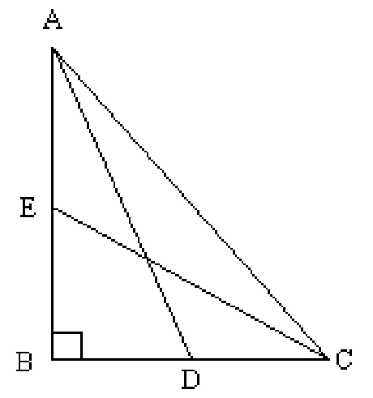
5. In fig., ABC is a right triangle, right angled at B.
Medians AD and CE are of respective lengths 5 cm
and $2\sqrt{5}$cm. Find the length of AC.

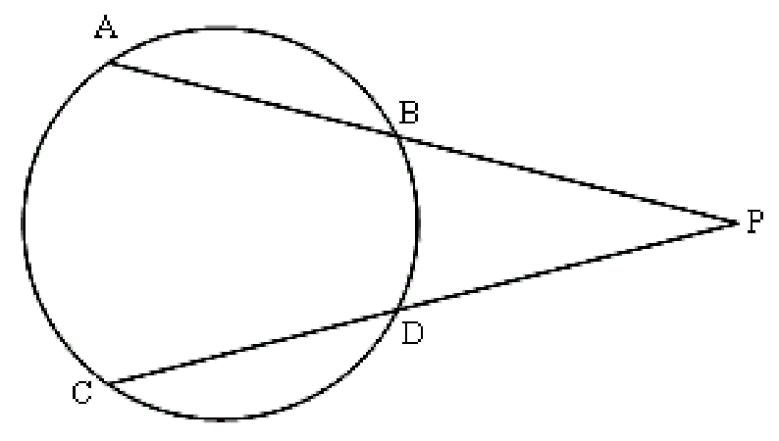
6. In fig., AP = 6 cm, CD = 2.8 cm and
DP = 4.2 cm. Find the length of BP.

7. From a well shuffled pack of 52 cards, black aces and black queens are removed. From the remaining cards, a card is drawn at random. Find the probability of drawing a king or a queen.

SECTION B
8. Solve the following system of linear equations graphically :
3x + 2y + 4 = 0,
3x - 2y + 8 = 0
Also find the coordinates of the vertices of the triangle formed by the lines representing the above equations and the y- axis.
9. Find the GCD and LCM of the polynomials 3(x⁴ -y⁴) and
2x³ +4x²y-2xy² -4y³
10. If $P = \frac{x + 2}{x^{3} −1} − \frac{1}{x^{2} −1}$, $Q = \frac{2x^{2}−3x +1}{x^{3} +1}$ and R = $R = \frac{4x^{2}−1}{x^{4}+x^{2} +1}$,
Find (P × Q) ÷R
11 A point P is at a distance of $\sqrt{\text{10}}$ from the point (2, 3). Find the coordinates of the point P if its y coordinate is twice of the x coordinate.
12. A and B are the end-points of a diameter of a circle having its centre at (1, 2). If the coordinates of A are (-3, 5), find the coordinates of the point B.
13. The radius of a solid iron sphere is 3cm. It is melted and recast into a solid right circular cylinder of diameter 2 cm. Find the height of the cylinder so formed, assuming that there is no wastage of metal in the process.

14. Prove that $\frac{\text{sec}θ +\text{tan}θ−1}{\text{sec}θ −\text{tan}θ+1} =\frac{1+\text{sin}θ}{\text{cos}θ}$
OR
Without using trigonometric tables, evaluate the following :
$$\text{cos}{\text{ec}}^{2}{\text{31}}^{0} − {\text{tan}}^{2}{\text{59}}^{0} + \frac{\text{sin}{\text{25}}^{0}\text{cos}{\text{65}}^{0} +\text{cos}{\text{25}}^{0}\text{sin}{\text{65}}^{0}}{3\text{tan}{\text{30}}^{0}\text{tan}{\text{45}}^{0}\text{tan}{\text{60}}^{0}}$$
15. Draw a APQR in which PQ = 5cm, ∠Q = 45° and QR = 5.4 cm construct the incircle of ΔPQR.
16. A fan is marked at Rs. 970 cash or for some cash down payment followed by three equal monthly instalments of Rs. 260 each. If the rate of interest charged under instalment plan is 16% per annum, find the amount paid as cash down payment.
17. An isosceles triangle ABC is inscribed in a circle. If AB = AC = 13cm and BC = 10cm, find the radius of the circle.
18. D, E and F are respectively the mid-points of the sides BC, CA and AB of ΔABC. Find the ratio of the areas of ΔDEF and ΔABC.
19. The number of hours spent by a school going student on various activities on a working day are given below :
Activity | Number of Hours
School  Sleep  Home Work  Other jobs | 7  8  5  4

Represent the above information by a pie-chart.

SECTION C
20. A two digit number is such that the product of the digits is 20. If 9 is subtracted from the number, the digits interchange their places. Find the number.

21. The external radius of a hollow right circular cylindrical pipe is 9cm and its height is 14cm. The volume of the metal used to make the pipe is 748cm³. Find the thickness of the pipe.
OR
The internal radii of the ends of a bucket, full of milk and of internal height 16cm, are 14cm and 7cm. If this milk is poured into a hemispherical vessel, the vessel is completely filled. Find the internal diameter of the hemispherical vessel.

22. A vertical flagstaff stands on the top of a building. The height of the flagstaff above the building is 6m. The angles of elevation of the top and bottom of the flagstaff at a point on the level ground are 45° and 30° respectively. Find the height of the building.
23. Ramesh has a monthly salary of Rs. 31250 (excluding HRA). He contributes Rs. 7000 per month towards GPF during the year and pays a quarterly premium of Rs. 2500 for his LIC policy. He invests Rs. 10000 in NSCs. He has donated Rs. 16000 to a charitable trust (50% deduction for income tax). Calculate the income tax liability of Ramesh if he has paid Rs. 2500 per month as income tax for the first 11 months of the year.
Use the following for calculating income tax :
(a) Savings : 100% exemption for savings upto Rs 1,00,000.
(b) Rates of income tax :
Slab Income Tax
Upto Rs 1,00,000 | No tax
From Rs 1,00,001 to Rs 1,50,000 | 10% of the taxable income above Rs 1,00,000
From Rs 1,50,001 to Rs 2,50,000 | Rs 5,000 + 20% of the amount exceeding Rs 1,50,000
From Rs 2,50,001 and above | Rs 25,000 + 30% of the amount exceeding Rs 2,50,000

(c) Education Cess : 2% of the tax payable
24. If a line touches a circle and from the point of contact, a chord is drawn, prove that the angles which this chord makes with the given line are equal respectively to the angles formed in the corresponding alternate segments.
Using the above, prove the following :
Prove that the tangent drawn to the circumcircle of an isosceles triangle is parallel to the base.
OR
Prove that the ratio of the areas of two similar triangles is equal to the ratio of squares of their corresponding sides. Using the above, prove the following :
Prove that the area of the equilateral triangle described on the side of a square is half the area of the equilateral triangle described on its diagonal.

25. If the mean of the following frequency distribution is 188, find the missing frequencies f₁ and f₂.
Classes | 0-80 | 80-160 | 160-240 | 240-320 | 320-400 | Total
Frequency | 20 | 25 | f₁ | f₂ | 10 | 100

