Sample Paper – 2007
Class - XII
INFORMATICS PRACTICES

Marks: 70 Time : 3hrs
Note:- All questions are compulsory.

- Answer the following:-
  - What is FLOSS? (2)
  - What is Generalisation and Specialisation? (2)
  - What is data modeling? Explain its Usage? (2)
  - What is Financial Accounting Systems? Explain with example? (2)
  - What is TOMCAT? (2)

  - What are parameters? What are actual and formal parameters? (2)
  - Differentiate between ADODB project reference and ADODC in a form using example. (4)
  - Define the Common Dialog box? How do we add a Common dialog box to a form? (2)
  - What are conditional or decision control statements? Name two conditional statements used in Visual Basic? (2)

  - What is NULL value? What is the result of an arithmetic operation containing a NULL value? (2)
  - Differentiate between IN, OUT and INOUT parameters modes (2)
  - Explain the Equi Join with an example. (2)
  - Differentiate between ROW level and Statement level triggers? (4)
- Read the following Case Study, Study the form the shown in the figure shown below:- the form below indicates a Coffee Day coffee shop in your town . It has the computerized billing system for the beverages. The cost of Tea in this coffee shop is Rs 15/- and that of coffee is Rs.25/- There are extra option which can be selected by the user. each extra toppings has Rs 10/-
Object Type | Object Name
Text Box | txtName
 | txtRate
 | txtAmount
 | txtToppings
 | txtQuantity
Commands | cmdRate
 | cmdAmount
 | cmdExit
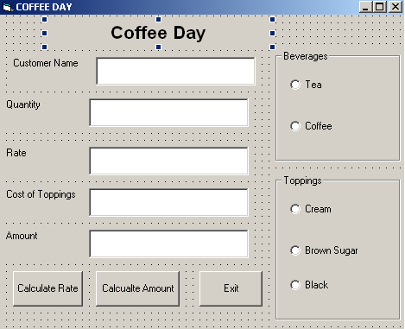
  - Write the commands to disable the text boxes txtRate, txtAmount and txtToppings. (2)
  - Write the command and event the exit the application (2)
  - Write a code segment to calculate the rate and amount according to the options selected by the user (4)
  - Write the segment or name of property to display the cost of toppings when the user has mouse over the toppings (1)
  - Write a segment to display a message box saying select the beverage type first (1)
- Answer the following questions:-
  - Find the errors from the following code segment and rewrite the corrected code : Dim num=10, I as integer
I=1
Do while I<5
I=I+2
If num>15
num=0
else
num=num-3
endif
end while
  - Give the output of the follwing statements:
    - INSTR(LTRIM(“ INFORMATICS”), “ma”)
    - INT(40-20*4/3+5)
  - Change the following code using FOR loop without affecting the output:
Dim count, ans
ans=1
count=15
do
ans=ans*count
count=count-2
loop until count<=10
print ans
  - Write the Visual Basic Function which checks whether the number is a prime number or not. 4

Answer the questions based on the table Employee given below :
Table : Employee

Column Name | Data Type | Size | Constraint | Description
Emp_ID | NUMBER | 8 | PRIMARYKEY | Employee's Indentification No.
First_Name | VARCHAR2 | 25 | NOT NULL | First name of employee
Last_Name | VARCHAR2 | 25 |  | Last name of employee
Date_Join | DATE |  |  | Date of joining
Basic_Sal | NUMBER | 8, 2 |  | Basic salary
Dept_ID | NUMBER | 3 |  | Department number
(a) Write the SQL command to create the table Employee including the constraints 2
(b) Write the SQL command to display first name, date of joining and department id of employees from the Employee table who are hired between March 20, 1991, and December 31, 1991. Order the query in ascending order of date of joining. 2
(c) Write a PL/SQLcommand to create a view, which contains Emp_ID and Bonus where Bonus is 12% of the Basic_Sal. 2
(d) Write a PL/SQL block to delete all the rows of a particular department from the table Employee where the department id to be deleted is accepted from the user. 4
7.
Read the questions given below and answer accordingly:
- Write the output produced by the following part of code in PL/SQL: 2
DECLARE
A NUMBER: = 10;
B NUMBER: = 2;
BEGIN
WHILE B < 12 LOOP
IF A > B THEN
DBMS_OUTPUT.PUT_LINE (TO_CHAR(A));
ELSE
DBMS_OUTPUT.PUT_LINE(TO_CHAR(B));
END IF;
A : = A — 4;
B : = B + 3;
END LOOP;
END;
- Find the errors from the following PL/SQL code and rewrite the corrected code underlining the correction made. 2
CREATE ASWELLAS REPLACE TRIGGER DEPT_UP
AFTER UPDATE ON DEPT FOR_EVERY ROW
DECLARE
v_num NUMBER (3);
BEGIN
SELECT COUNT (*) INTO v_num FROM Emp WHERE Dept ‘1O1’;
IF v_num > 5
Raise_application_error (—20001, ‘Cannot exceed 5’);
END;
- What do you understand by % ROWCOUNT with reference to cursors? What will happen if you use the %ROWCOUNT attribute of a cursor that is not open? 2
- Write a PL/SQL procedure called SUM that takes an integer as parameter, finds its sum of n odd numbers and display it. 2
- Write a PL/SQL Function called DAT that takes an date and inetger as parameter, finds the no of date after the number of days specified. 2

