Guess Paper – 2007
Class – X
Mathematics

Pre-board examination 2007, X Class (Mathematics)
Time : 3 Hrs Max Marks: 80.
General Instructions.:01) All questions are compulsory
02)The question paper consists of 25 questions divided into three sections A,B and C. Section A contains 7
questions of 2 marks each. Section B contains 12 questions of 3 marks each.. Section C contains 6
questions of 5 marks each.
03) There is no overall choice . However, an internal choice has been provided.
04) In questions on construction, the drawing should be neat and exactly as per the given measurements.
05) Use of calculator is NOT permitted..

Section – A
01) A and B are friends and their ages differs by 4 years, A is elder to B. A’s father D is twice as old as A and
B is twice as old as his sister C. The ages of D and C differs by 38 years. Find the ages of A and B. (OR)
Solve : b x – a y + a + b = 0 and b x – a y + 2 a b = 0.
a b
02) Simplify : x + 1 – x – 1 – . 3x² .
x – 1 x + 1 x² – 1
03) Using quadratic formula, Solve the following equation : a² b² x² – ( 4 b⁴ – 3 a⁴ )x – 12 a² b² = 0. (OR)
There are three consecutive positive integers such that the sum of the square of the first and the product of
the other two is 154. What are the integers ?
04) The H.C.F of the polynomials x³ – 2x² + px + 6 and x² – 5x + q is x – 3, Find the value of 5q + 6p.
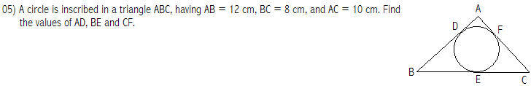
06) A brief case is available for Rs.800 cash or Rs.500 down payment and Rs.350 to be paid after six months.
Find the rate charged under this installment plan.
07) From a pack of 52 playing cards, Jacks, Queens and Kings and Aces of red colour are removed. From the
remaining, a card is drawn at random. Find the probability that the card drawn is
a) A red card b) A face card.

Section – B
08) Solve graphically : - 2y + x = – 3
x + y = 4, and x = – 1, shade the region bounded by the lines representing the above equations
09) If ( x – 1 ) ( x + 2 ) is the HCF of the polynomials p (x) = ( x² + 3x – 4 ) ( 2 x² + x + a ) and
q (x) = (x² – 3x – 10 ) ( 3 x² – bx + 2 ). Find the values of ‘a’ and ‘b’
10) Derive : Sn = n { 2a + ( n – 1 ) d } (OR)
2
Find the sum of all three digit numbers which are divisible by 7.
11) Two boys on bicycles started from the same point and are traveling towards North and West. The speed of
first boy is 5 km/hr more than other boy. After 2 hrs if the distance between the two boys is 50km. find the
speed of the first boy.

12) A builder announces sale of flats for Rs.30,00,000 cash or for Rs.10,31,600 cash down payment and three
equal quarterly instalments. If the rate of interest is 10 % p.a. compounded quarterly, Compute the value of
each instalment under the instalment scheme. Also, find the total interest.
13) Evaluate the following without using the trigonometric tables
Cot A Tan (90⁰ – A) – Sec (90⁰– A) Cosec A + Sin² 25⁰ + Sin² 65⁰ + \/3 (Tan 5⁰ Tan45⁰ Tan 85⁰) (OR)
If Sin A + Cos A = m, Sec A + Cosec A = n ,Prove that n ( m ² – 1 ) = 2m.
14) If P (2, –1), Q (3, 4 ), R (–2, 3 ) and S (–3, –2 ) be four points in a plane, Show that PQRS is a rhombus,
But not a square .
15) Percentage of different products of a village in a particular district are given below: Draw a pie-chart
representing this information.
Items Wheat Pulses Cotton Ground nuts Vegetables
Percentage 125 % 125 % 25 % 50 % 25 %
3 6 2 3 3
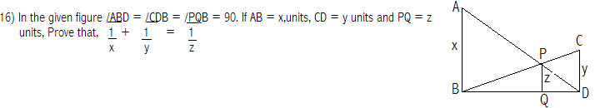17)A rectangular tank is 22m long and 18m wide. If the speed of water through a circular pipe of diameter
21cm is 9km/hr. Calculate the rise in the level of water in the tank in 4 hours.
18) Construct a quadrilateral ABCD, in which AB = 6cm, BC = 5cm, CD = 5.5cm,DA=6.5cm and /B = 75⁰
Then construct another quadrilateral A’BC’D’ which is 5/4th of the given quadrilateral.
19) In a trapezium ABCD, ‘O’ is the point of intersection of AC and BD, AB // CD and AB = 2CD. If the area
Of triangle AOB = 84 cm². Find the area of triangle COD.

Section – C
20) Prove that, the degree measure of an arc of a circle at the centre is twice the angle subtended by it at any
Other point of the alternate segment of the circle with respect to the arc.
By using the above thereom, In a quadrilateral ABCD in which AB = AC = AD, Show that
/BAD = 2 (/CBD + /CDB ) (OR)
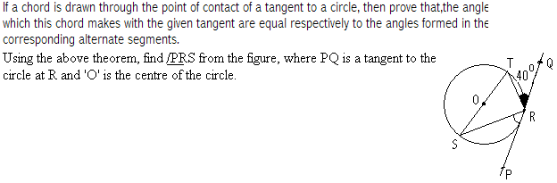

21) State, and Prove “Thales theorem” (Basic proportionality theorem)
Using the above theorem, Prove that any line parallel to the parallel sides of a trapezium divides the non
parallel sides proportionally.
22) If the angle of elevation of a cloud from a point 7m above the lake is 30⁰, and the angle of depression of its
Reflection in the lake is 60⁰,Find the distance of the cloud from the point of observation. (OR)

From a point on the ground the angle of elevation of an aero plane which is flying at a height of 1200mts
is found to be 60⁰,after 20 seconds, it is found at an angle of elevation of 30⁰, Find the speed of the
aero plane in km/hr.
23) The height of a cone is 30cm, A small cone is cut off at the top by a plane parallel to the base. If its volume
be 1 of the volume of the given cone. At what height above the base is the section made ?
27
24) If the A.M. of the following frequency distribution is 41.7 , Find the values of f₁ and f₂

Class Interval | 10 – 20 | 20 – 30 | 30 – 40 | 40 – 50 | 50 – 60 | 60 – 70 | Total
Frequency | 11 | f₁ | 20 | 22 | f₂ | 18 | 100

25)Annual salary of Mr.Prakash is Rs.8,96,000 (Excluding HRA)during the year 2005 – 2006. He pays an
Half-yearly premium of Rs.10,500 to LIC, and contributes Rs.5,000 per month towards GPF. He pays
Rs.14,000 towards Mediclaim, donated Rs.10,000 to Mother Theressa Trust ( 50 % tax exemption ) and
Rs.5,000 towards the school fee of his daughter. Calculate the tax to be paid by him every month If, he
wishes to pay the tax equally for all the 12 months ?

- Total savings should not exceed Rs.1,00,000
- Maximum limit on Mediclaim is Rs.10,000.
- Maximum limit on Children school fee is Rs.8,000 (A part of Savings)
- Slab rates for computation of Income-Tax.

Up to Rs.1,00,000 No tax
From Rs.1,00,001 to Rs.1,50,000 10 % of the amount exceeding Rs.1,00,000

From Rs.1,50,001 to Rs.2,50,000 Rs.5,000 + 20 % of the amount exceeding Rs.1,50,000
Above Rs.2,50,000 Rs.25,000 + 30 % of the amount exceeding Rs.2,50,000.
- Surcharge : 10. 5 % of the tax, If the annual income exceeds Rs. 10,00,000.
- Educational cess : 2 % of the tax payable.

#####@@@#####
If you have any suggestions, You may send an e-mail to beeviyaar71@rediffmail.com

BVR.Murthy

