

Sample Paper- 2015
Subject: Mathematics
Class 10th
( Co-ordinate,perimeter & area of plane fig.,circle, sector & segment, vol. surface area of solids)
Timeallowed: 3hrs Marks: 90
Instructions:-
1.All questions are compulsory. 2. This Q.P consists of 31 questions divided into four sections A,B,C,D. 3. section A comprises of 4 questions of 1 mark each, section B comprises of 6 questions of 2 marks each, section C comprises of 10 questions of 3 marks each,section D comprises of 11 questions of 4 marks each.
Section A( 1 X 4 =4 )
Q1. If (0,0), (3,), (3, P) are the vertices of an equilateral triangle, then find the value of P.
Q2.Find the area of an isosceles triangle, each of whose equal sides is 13 cm and whose base is 24 cm.
Q3. Find the perimeter of a quadrant of a circle of radius ‘r’ .
Q4. A metallic cube of edge 1 cm is drawn into a wire of diameter 4 mm , then find the length of the wire.
Section B( 2 X 6 =12)
Q5. Show that the points (- 4, 0 ), (4, 0 ) and ( 0, 3 ) are vertices of an isosceles triangle.
Q6.The diameter of a circle wheel is 21 cm. How many revolutions will it make to travel 1.98 km?
Q7. A cubical solid block of metal 49 cm X 44 cm X 18 cm is melted and formed into a solid sphere. Calculate the radius of the sphere.

Q8. Solid spheres of diameter 6 cm are dropped into a cylindrical beaker containing some water and are fully submerged. If the diameter of the beaker is 18 cm and the water rises by 40 cm in the beaker, find the number of solid spheres dropped in the water.
Q9. Find the area of such that

Q10. In the given fig: P( 5, - 3 ) and Q( 3, y ) are the points of trisection of the line segment joining A( 7, -2 ) and B( 1, - 5), then find the value of y . A P Q B
(7, -2 ) (3,y) (1, -5)
Section C( 3 X 10 = 30)
Q11.For the triangle ABC formed by the points A( 4, -6 ), B( 3, -2 ) and C( 5, 2 ), verify that median divides the triangle into two triangles of equal area.
Q12. Find the area of a parallelogram ABCD if three of its vertices are A( 2, 4 ), B(2 + and C( 2, 6 )

Q13. In fig., OABC is a square of side 7 cm. If OAPC is a quadrant of a circle with centre O, then find the area of the shaded region.
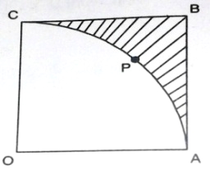

Q14. Three cows are tethered with 10 m long rope at the three corners of a triangular field having sides
42 m, 20 m and 34 m. Find the area of the plot which can be grazed by the cows, also, find the area of the remaining field ungrazed.
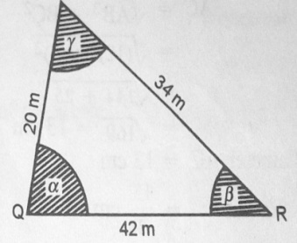

Q15. Find the area of shaded region in fig; if PQ = 16 cm, PR = 12 cm and O is the centre of circle. 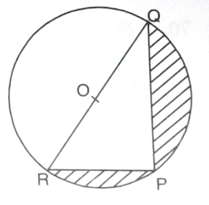
Q16. A toy is in the form of a cone mounted on a hemisphere of same radius 7 cm. If the total height of the toy is 31 cm, find its total surface area.

Q17. Water running in a cylindrical pipe of inner diameter 7 cm, is collected in a container at the rate of 192.5 litres per minute. Find the rate of flow of water in the pipe in Km/h.

Q18. The radii of circular ends of a solid frustum of a cone are 33 cm and 27 cm and its slant height is
10 cm. Find its total surface area.

Q19 . A solid cone of base radius 10 cm is cut into two parts through the mid-points of its height, by a plane parallel to its base. Find the ratio in the volumes of the two parts of the cone.

Q20. A hemispherical bowl of internal radius 9 cm is full of water. Its contents are emptied in a cylindrical vessel of internal radius 6 cm. Find the height of water in the cylindrical vessel.
Section D( 4 X 11 = 44 )
Q21. If mid-points of sides of are ( 1, 2 ), ( 0, 1 ), ( 1, 0 ) then find the coordinates of the three vertices of triangle PQR.
Q22. If the points A(1 , -2 ), B( 2, 3 ), C( -3, 2 ) and D( - 4, - 3 ) are the vertices of parallelogram ABCD, then taking AB as the base, find the height of this parallelogram.
Q23. A point P divides the line segment joining the points A( 3, - 5 ) and B( - 4, 8 ) such that 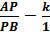 . If P lies on the line then find the value of k
Q24. A child prepares a poster on ‘Save Energy’ on a square sheet whose each side measures 60 cm. At each corner of the sheet, he draws a quadrant of radius 17.5 cm in which he shows the way to save energy. At the centre, he draws a circle of diameter 21 cm and writes a slogan in it. Find the area of the remaining sheet. 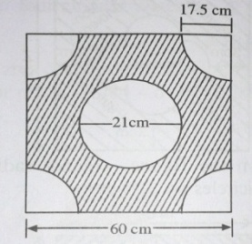
Q25.In the adjoining fig. ABCD is a square of sides 6cm. Find the area of the shaded region.
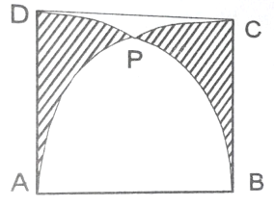
Q26. In fig. O is the centre of the circle with AC = 24 cm, AB = 7 cm and Find the area of the shaded region.
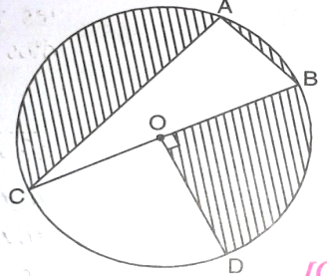
Q27. Floor of a room is of dimensions 5 m X 4 m and it is covered with circular tiles of diameters 50 cm each. Find the area of floor that remain uncovered with tiles.
Q28. In the adjoining fig, AB and CD are two diameters of a circle with centre O perpendicular to each other and OD is the diameter of the smaller circle. If OA = 7 cm, find the area of the shaded region.
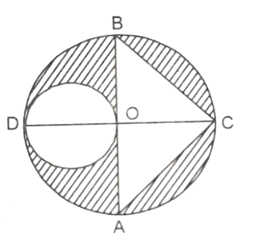
Q29. The height of a cone is 30 cm. A small cone is cut off at the top of a plane parallel to the base. If its volume be 1/27 ^{th} of the volume of the cone, at what height above the base is the section made?
Q30. A conical vessel of radius 6 cm and height 8 cm is completely filled with water. A sphere is lowered into the water and its size is such that when it touches the sides, it is just immersed. What fraction of water overflows?
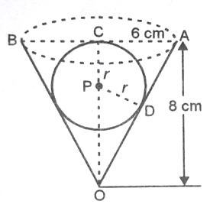
Q31. A right triangle, whose sides are 15 cm and 20 cm, is made to revolve about its hypotenuse. Find the volume of the double cone so formed. ( Take )

Mob:-9934086854

