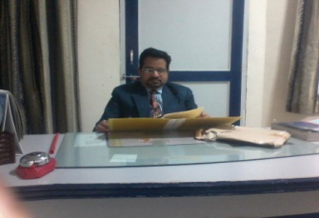 | ASHUTOSH SINHA [AGE-48 YEARS , EXPERIENCE-25]  M.COM,M.A[ECONOMICS],B.ED,DCA [PRODUCT OF ALLAHABAD UNIVERSITY]  PRINCIPAL-AAKANKSHA INTERNATIONAL SCHOOL,NAGAUR RAJASTHAN  MOB-9460077156, 9314858136  E-MAIL:-[1]-shreyanshsankalp@gmail.com, [2]-sartak2004@gmail.com  PERMANENT ADDRESS:- LIG-335 GOVINDPUR COLONEY, ALLAHABAD U.P  LOCAL ADDRESS:- 2/253 RAJASTHAN HOUSING BOARD, NAGAUR RAJASTHAN

(A):  ACCOUNTING  ACCORDING TO AMERICAN INSTITUTE OF CERTIFIED PUBLIC ACCOUNTS:  ACCORDING TO BIERMAN AND DERBIN  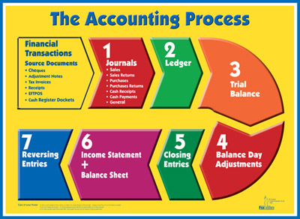  IGNORES CHANGES IN PRICE LEVEL  WINDOW DRESSING[KKJ-1.9]  VALUE BASED QUESTION  (B):  ACCOUNTING CYCLE  [ACCOUNTING PROCESS]  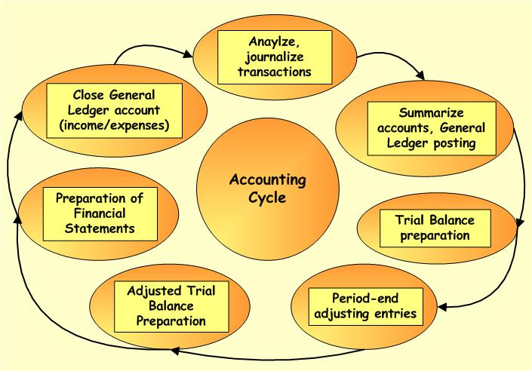  ACCOUNTING CYCLE  ASSIGNMENT  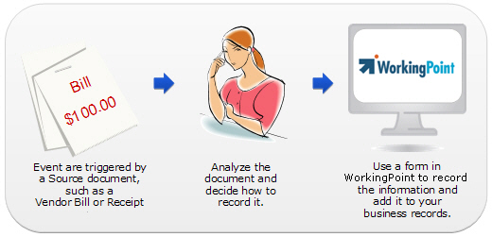  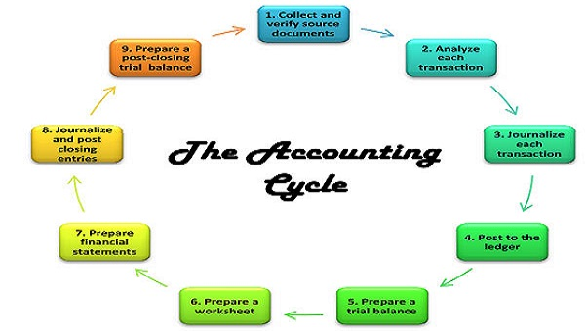  (C):  EVENTS[ECONOMIC EVENTS]  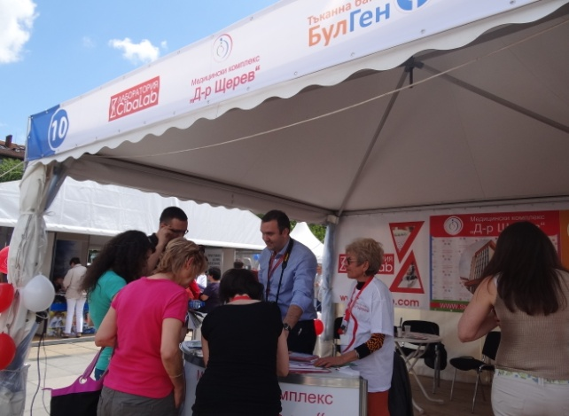  EVENTS WHICH ARE NOT BUSINESS TRANSACTION[KKJ-2.2  (D):  ENTITY-[BUSINESS ENTITY]  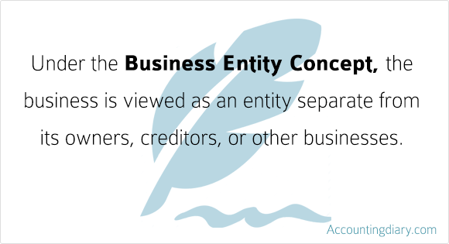  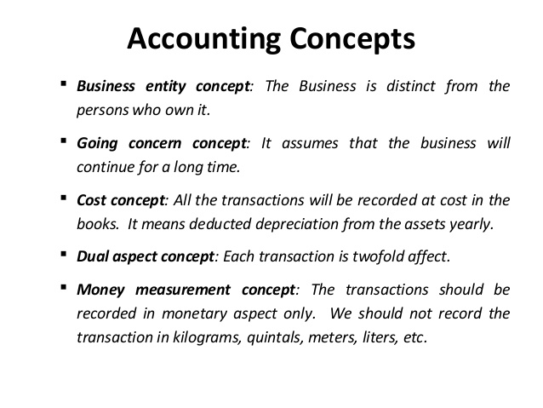  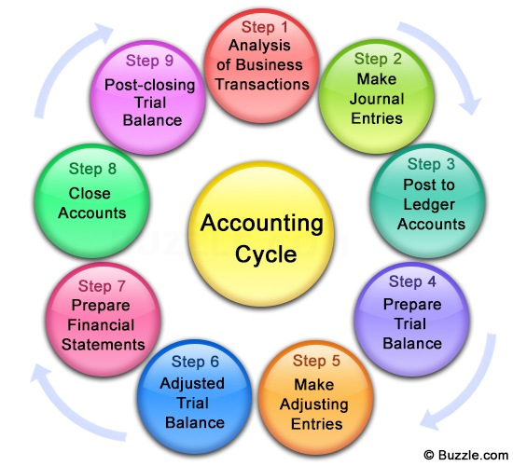  (E):  TERMINOLOGY[KEY TERMS]  ASSIGNMENT[CA-CPT]-ANALYSIS  ASSIGNMENT[CA-CPT]-ANALYSIS  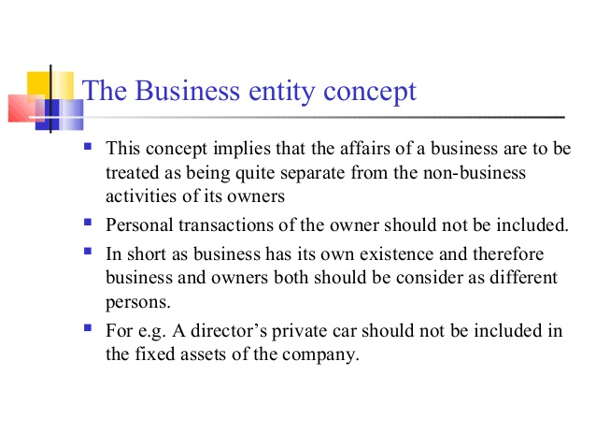  ASSIGNMENT[RECORDING]  [F]:  ATTRIBUTES/ACTIVITIES OF ACCOUNTING:  ASSIGNMENT  LEDGER  PRIMARY BOOKS OF ACCOUNTS  ASSIGNMENT  ASSIGNMENT  ASSIGNMENT  ASSIGNMENT  (E):  PROJECT-WORKS  (F):  HOME ASSIGNMENTS  VALUE BASED QUESTION  ASSIGNMENT[CA-CPT]-ANALYSIS  ASSIGNMENT  (G):  MAJOR DISTINCTIONS  ASSIGNMENT[CA-CPT]-ANALYSIS  ASSIGNMENT[CA-CPT]-ANALYSIS |  | I  II  III  IV  V  I  II  III  III  I  II  III  I  II  III  IV  V  I  II  III  IV  I  II  III  III  IV  Q1  Q2  QI  Q2  Q3  Q4  Q5  Q6  Q7  I | **MEANING:  - It refers to Art of identifying, Classifying, Recording, Summarising and interpreting the Business Transaction.  - It refers to Process of identifying measuring and communicating Economic Information to Users for Vital Decision Making (American Accounting Association-1966)  **ADVANTAGES:-  - It helps in ascertaining the profit Earned or LOSSES SUFFERED and financial position (Status) of the Business.  - It helps in MANAGING THE ASSETS of the Business.  - It provides documentary Evidence and can be used as a proof in the court of law.  - It replaces memory as all accounting Transaction is in writing which can be retrieved whenever required.  - It helps in resolving Tax Matters.  - It helps the manager in planning, Decision Making and controlling the business operations  **LIMITATION:(TW-10)  - It is Not exact as it is based on different estimates made by different people.  - INSTANCE-I:- It is not possible to predict accurately the actual useful life of fixed Assets for the purpose of depreciation expense.  - INSTANCE-II:- ACCOUNTANT may select any method of Depreciation and valuation of stock.  - It is historical as it ignores Price Level Changes.  - It records only monetary Transaction and ignores NON MONETARY Transaction  - Window Dressing (Manipulation) e.g. over or undervaluation of closing Stock  **OBJECTIVE OF ACCOUNTING:  - Identification & maintenance of records  - To Identify Business Transaction  - To Records into Appropriate Books of Accounts.  - CALCULATION OF PROFIT & LOSS A/C  - To calculate Profit & Loss for appropriate period.  - To evaluate the performance of Business.  - DEPICTION OF FINANCIAL POSITION:  - It depicts Financial Position of Business through balance Sheet.  - To prepare cash flow statement.  - INFORMATION TO USERS:  - To communicate Accounting Information to users  - To furnish Reports, Graphs, Statements and Charts.  TYPES(BRANCHES)SUBFIELDS OF ACCOUNTING:  - Financial Accounting  - Cost Accounting  - Management Accounting  - Tax Accounting  - Social Responsibility Accounting  **MEANING:  - It refers to process BEGINNING WITH recording of transaction and ENDING with preparation of final Accounts. (PCT-1.6)  - Accounting Cycle refers to steps starting from journalising of economic Transaction and ending on preparation of final accounts  **STEPS INVOLVED:[CONCEPT-I]  - To journalise the Economic Transaction.  - To post to respective Ledger Accounts.  - To Balance the Ledger Accounts  - To Prepare Trial Balance.  - To prepare Following Final Accounts:  **CONCEPT-II-SAS-26[STEPS INVOLVED]  - IDENTIFICATION of Economic Events.  - CLASSIFICATION of Business Transaction [Assets, liability, Expenses, income]  - MEASUREMENT in terms of Rupees  - RECORDING of Business Transaction  - SUMMARIZING the business transaction (Journal, ledger, trial balance and Balance sheet.)  - ANALYSIS AND INTERPRETATION OF THE business transactions. (Various reports, ratio etc.)  - COMMUNICATION (provide information to internal and external users.)  - Income Statements Viz. Trading & Profit and Loss Accounts  - Positional Statements viz. Balance Sheet  **DIAGRAMATIC PRESENTATION:  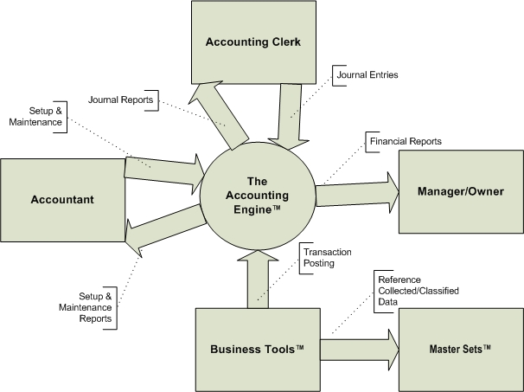  **MEANING:  - It refers to Economic Business Transaction which can be measured in terms of money.  - It refers to Economic Transaction measurable in terms of money.  **INSTANCES:  - EXTERNAL EVENTS  - Purchase of Goods  - Sale Of Goods  - Purchase of assets  - INTERNAL EVENTS-(V.IMP)  - Payment of Salary to Staff  - Supply of Raw Material by purchase Department to Production Department.  DIFFERENCE B/W EVENT & TRANSACTION[IMP]  - An event can be termed as a happening, occurrence or an incident. KKJ-2.2]  - Every transaction is an event but every event may not be transaction  - Thus an event is different from a transaction.  **MEANING:  - It refers to Economic Unit performing Economic Activities. Viz. TISCO, BIRLA, RELIANCE.  - It refers to Profit making and Non-Profit making Organisation.  - It refers to Anything having definite Existence viz. Ram, ABC ltd  **INSTANCES:  - Tata Ltd  - Reliance Industries  - Vimal Industries  **TYPES[KINDS]:  - Business Entity  - Non-Business Entity  **BUSINESS ENTITY:  - MEANING:  - It is formed for Earning Income by providing Services or Selling Goods  - INSTANCE:  - Tata Industries  - Birla  - Vimal Industries  **NON-BUSINESS ENTITY:  - MEANING:  - It is formed for Service Motive.  - INSTANCES:  - Delhi University  - Punjab University  **ACCOUNTANCY:  - It refers to entire body of theory and practice of Accounting.  - It refers to Systematic knowledge of Principle and technique applied in Accounting.  - It refers to conceptual knowledge of accounting and Its proper application and communication to interested parties  **BOOK-KEEPING:  - MEANING:  - It refers to ART OF RECORDING Business transaction in the books of ORIGINAL ENTRY AND LEDGERS.  - It is a part of accounting and concerns with RECORD - KEEPING or maintenance of books of Accounts.  - It refers to Primary and Basic function in the process of Accounting and concerned with recording and maintenance of books of Accounts only.  - PROCESS/ACTIVITIES INVOLVED:  - To identify Business transaction having Financial Character.  - To measure transaction in terms of money.  - To record transaction in the books of Original Entry.(Ledger)  - To clarify transaction w.r.t ledger Accounts. (V.W.-1.6)  **INTERPRETATION:  - It means to EXPLAIN THE USERS about the following:  - What has happened?  - Why it has happened?  - What is likely to happen?  **ENTRY:  - It refers to records made in the books of Accounts w.r.t transaction or Event.  - It refers to systematic recording of day to day Business Transaction both in words and in numbers in the books and Accounts (TW-21)  **IDENTIFYING - [IDENTIFICATION OF ACTIVITIES]  - MEANING:  - Business is full of events- Financial and non-financial.  - But only financial events are recorded in the accounting books.  - RECORDABLE FINANCIAL TRANSACTIONS:  - Purchase of goods or Assets  - Payments or incurring of Expenses such as salary, rent  - Receipt or earning of income.  - Payments to creditors  - Payments received from debtors  - Cash deposited or withdrawn from the bank  - NON-RECORDABLE[NON-FINANCIAL TRANSACTION]  - Placing an order for purchase of goods  - Receiving an order for sale of goods  - Death or retirement of an employee  **MEASURING IN TERMS OF MONEY:  - Only that transaction can be recorded which can be measured in terms of money.  - FOR INSTANCE: sale of 5000 bales of cotton @8000 per bale. Then it will be recorded in the books at40,000  **RECORDING:  - After identification and measuring, Transaction will be recorded in the books.  - Recording means entering a Business Transaction into Primary Books of accounts  - FOR INSTANCE: all cash transaction are first entered in a specific subsidiary Books called cash Book.  **CLASSIFYING:[KKJ-1.2]  - After recording, They are again posted to main accounting books [Ledger]  - Posting a transaction to the account to which it is related is called classification of transaction.  - Posting Transaction into Ledger is called Classifying the transaction.  **SUMMARISING:[KKJ-1.2]  - At THE end of accounting year, all business Transactions are summarised to know the profit and Financial Position of the business.  - Preparation of profit & Loss Account and Balance Sheet is called summarising  - PROCEDURE:  - All the ledger accounts are balanced and closed.  - With the help of balances of accounts, Trial Balance is prepared to know the arithmetical accuracy of the accounting  - Income Statements [Profit & Loss account] is prepared to know the net profit earned during the year.  - Positional Statement[Balance Sheet] is prepared to know the financial position of the Business  **PASTE THE BOX-I, PG:03 OF NCERT  Heading: History & Development of Accounting.  **PASTE THE BOX-II.; PG-6, NCERT  Heading: Why do users want Accounting Information?  **WHAT IS THE LAST STEP OF ACCOUNTING  AS A PROCESS OF INFORMATION?  ANSWER:-COMMUNICATION (MARK:01)  **WHAT IS END PRODUCT OF FINANCIAL  ACCOUNTING?  ANSWER:- (a): Final Accounts  (b): Reports Based on it  **FROM-CBSE-KVS-NOTES  Write Any Two Users Of Financial Statements.  ANS:- 1.Public 2.Regulatory agencies  **WRITE ANY ONE ADVANTAGE OF  ACCOUNTING.  ANS:-Provide information in systematic order  **WRITE ANY ONE EXAMPLE OF VOUCHER.  ANS: cash memo  *WRITE ANY TWO EXAMPLES OF CURRENT  ASSETS.  Ans. 1.Stock 2.Debtor  **HOTS PROBLEM-[KKJ-1.2]:  Is accounting a science or an Art? Or both. Discuss.  SOLUTION:  - ACCOUNTING AS AN ART:[PROOF]-[KKJ-1..2]  - Accounting is an art because it is practical application of knowledge of accounting concepts and conventions  - Recording of transaction uses certain accounting concepts and Conventions  - ACCOUNTING AS SCIENCE[KKJ-1.2]  - Accounting is science because is based on certain basic principles of its own which have universal applications.  **BETWEEN BOOK-KEEPING AND ACCOUNTANCY
  According to the art of recording, classifying and summarising in a significant manner and in the terms of money,the transactions and the event which are in part at least of a financial character and interpreting the result thereof
  Accounting may be defined as identifying, measuring, recording and communicating the financial information
  MAIN TYPES OF ACCOUNTING
  ARE AS FOLLOWS:
  - Financial Accounting
  - Management Accounting
  - Government Accounting
  - Tax Accounting
  - Forensic Accounting
  - Project Accounting
  - Social Accounting
  - Assets are recorded at their cost price instead of market price. It means accountancy ignores changes in price level [i.e. inflation or deflation]
  - Changes in price level on value of fixed assets is not taken into consideration.
  - The effect of this is that balance sheet does not disclose the true financial position of the Business
  - Window dressing means impressive but not real or true
  - Accountant may resort to window dressing in the balance sheet by showing:
  - Debtors without provision for bad debt.
  - Stock [over or under valued]
  - Stock with obsolescence
  WHICH VALUE IS THE MOST IMPORTANT FOR A GOOD ACCOUNTANT?
  SOLUTION
  - An accountant should be honest and shrewd.
  - He must ensure that all the accounting entries are posted in the books of accounts
  - There should be no hiding of facts in the books of accounts
  - There may be situation that the accountant is put under pressure to hide certain facts in the accounting to evade tax or any other purpose
  - He should not get into pressure and behave in a shrewd way
  All fixed assets are put together and all current assets are put together, under which of the following accounting stage?
  - Recording
  - Communication
  - Analysis
  - Interpretation
  ANSWER – [C ]-ANALYSIS
  - Appointment of a sales person
  - Promise to sell goods
  - Exchange of thousand rupees for ten hundred rupees
  - Organising a Birthday party
  - Strike by employee
  Wrong valuation of spares and tools was made but it was disclosed that wrong valuation is made Which statement is correct
  - It does not present true and fair view even if disclosure is made
  - It gives true and fair view because it is disclosed
  - It is irrevalent
  - None of these
  ANSWER – [A ]
  All of the following are function of accounting except:
  - Decision making
  - Measurement
  - Forecasting
  - Ledger posting
  ANSWER – [D ]
  - In Accounts recording is made of:
  - Only Financial Transaction
  - Only Non-Financial Transaction
  - Financial as well as non-financial
  - Personal Transaction of proprietor
  ANS [1]
  Financial Position of the business is ascertained on the basis of:
  - Record prepared under book keeping process.
  - Trial Balance
  - Accounting Report
  - All of the above
  ANSWER – [C ]
  - Ledger is register which contains several pages.
  - Each separate page is assigned to:
  - Each person and party related to business
  - Each item of income and expenses
  - Asset and liabilities
  - Each of such page is called an account
  - For Instance-
  - Page allotted to Ram is called Ram’s Account
  - Page allotted to sales is called sales Account
  - Journal
  - Subsidiary books
  - Purchase Book
  - Sales Book
  - Purchase Return Book
  - Sales Return Book
  - Cash book
  Govt raised funds through taxes and spent them for the public expenditure. The deficit or surplus at the end of the year is:
  - Transaction
  - An event
  - Transaction as well as event
  - none
  ANSWER – [B ]-EVENT
  Which of the following is not a sub field of the accounting
  - Management Accounting
  - Cost accounting
  - Financial Accounting
  - Book keeping
  ANSWER – [D]
  Book keeping is mainly concerned with:
  - Recording of financial data
  - Designing the system in recording, classifying and summarising the recorded data
  - Interpreting the data for internal and external users
  - None of the above
  ANSWER – [A ]
  Financial accounting is the part of:
  - Accounting
  - Book keeping
  - All the above
  - None of the above
  ANSWER – [A]
  Mr Suresh is an accountant of ABC Firm. He found an error in the accounting entry in the books of accounts. However, he did not disclose it to the management of the firm fearing that it will risk his job which value is not followed by Mr. Suresh?
  SOLUTION
  - Mr. Suresh is not following the value of Honesty as he should ensure that any error in the accounting should be rectified
  - He should not afraid in admitting his mistake
  Users of accounting Information are:
  - Creditors/Suppliers
  - Lenders
  - Customers
  - All the above
  ANSWER – [D]
  Financial Statement donot consider
  - Assets expressed in monetary terms
  - Liabilities expressed in monetary terms
  - Only Assets expressed in monetary terms
  - Assets and liabilities expressed in non-monetary terms
  ANSWER – [D]
  On January-01, Sohan paid rent5,000. This can be classified as
  - An event
  - A transaction
  - A Transaction as well as event
  - None of the above
  ANSWER – [B]
  On March 31,2011 after sale of goods worth 2,000. He is left with the closing inventory of10,000. This is:
  - An event
  - A Transaction
  - A transaction as well as event
  - None of the above
  ANSWER – [A]
  Basis | Booking-Keeping | Accountancy
  NATURE | Concerned with recording of financial data in orderly and significant manner | Concerned with recording, classifying and summarizing the recorded data
  SCOPE | Narrow Scope because it is a part of Accounting | Broad Scope because it involve more than Book Keeping
  Knowledge | It requires only an Elementary Knowledge of Accounting | It requires high level of Knowledge ,conceptual understanding and  Analytical Skill
  Interested Parties | Outsiders do not have any interest in it | Various outside group are interested in it
  Result of Business | It does not show the Net Result of Financial Position of Business | It tells us about the Profit earned and About the Assets & Liabilities
ASHUTOSH SINHA [AGE-48 YEARS EXPERIENCE-25]
M.COM,M.A[ECONOMICS],B.ED,DCA [PRODUCT OF ALLAHABAD UNIVERSITY]
PRINCIPAL-AAKANKSHA INTERNATIONAL SCHOOL,NAGAUR RAJASTHAN
MOB-9460077156, 9314858136
E-MAIL-[1]-shreyanshsankalp@gmail.com, [2]-sartak2004@gmail.com
PERMANENT ADDRESS:- LIG-335 GOVINDPUR COLONEY, ALLAHABAD U.P
LOCAL ADDRESS:- 2/253 RAJASTHAN HOUSING BOARD, NAGAUR RAJASTHAN

