(A):  POVERTY ALLEVIATION  PROGRAMME  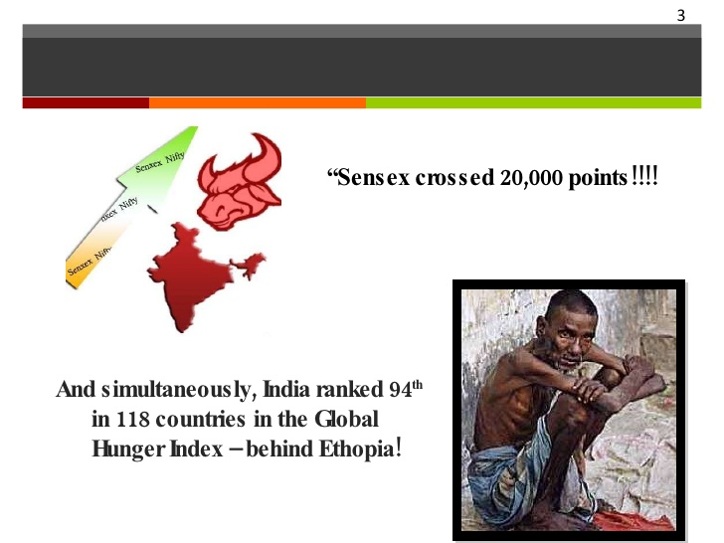  FIRST 5-YEAR PLANS & URGE  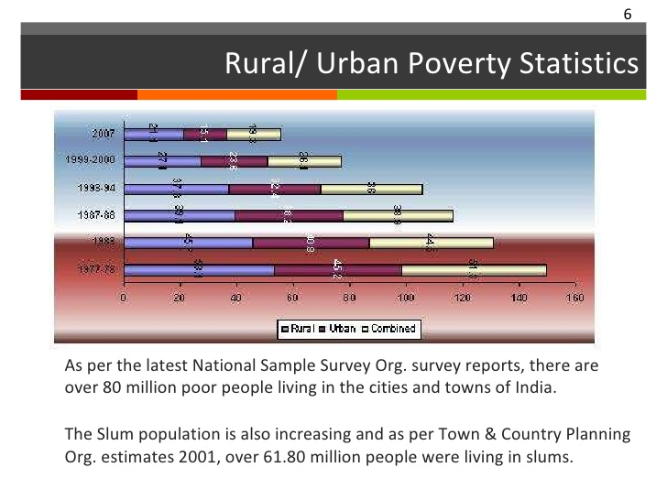  SECOND 5-YEAR PLANS & URGE  [B]:  THREE DIMENTIONAL GOVT.APPROACH  FOOD FOR WORK PROGRAMME  SELF EMPLOYMENT PROGRAMME:  (C):  JAWAHAR GRAM SAMRIDHI  YOJNA (JGSY)  ECONOMIC GROWTH  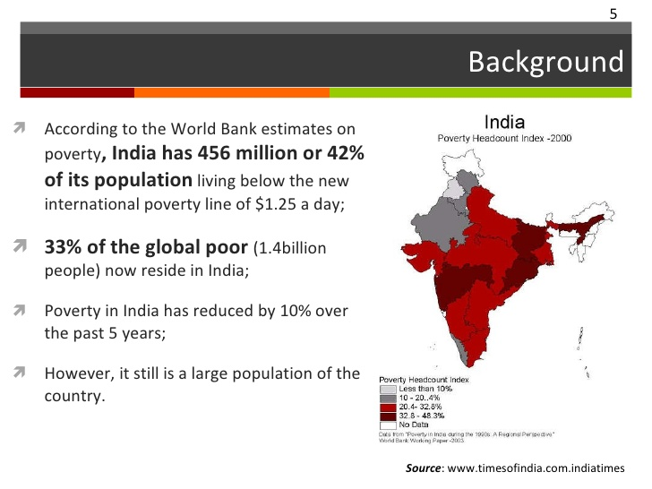  (D):  SAMPOORNA GRAMIN ROJGAR YOJNA(SGRY)  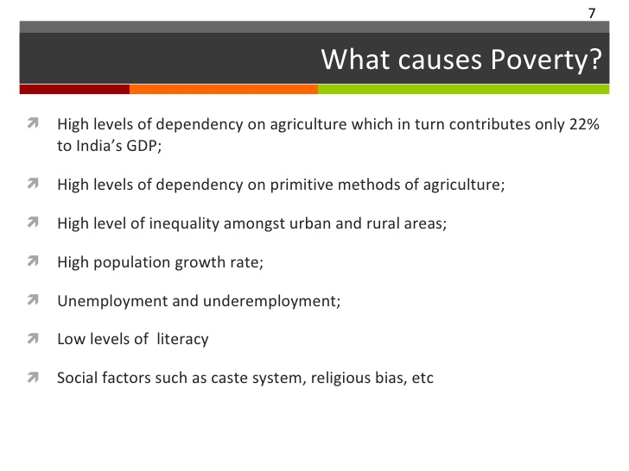  (E):  PRADHAN MANTRI GRAMODAYA YOJNA  (PMGY)  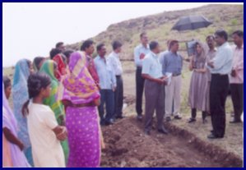  (F):  SWARNAJAYANTI GRAM SWAROZGAR YOJNA  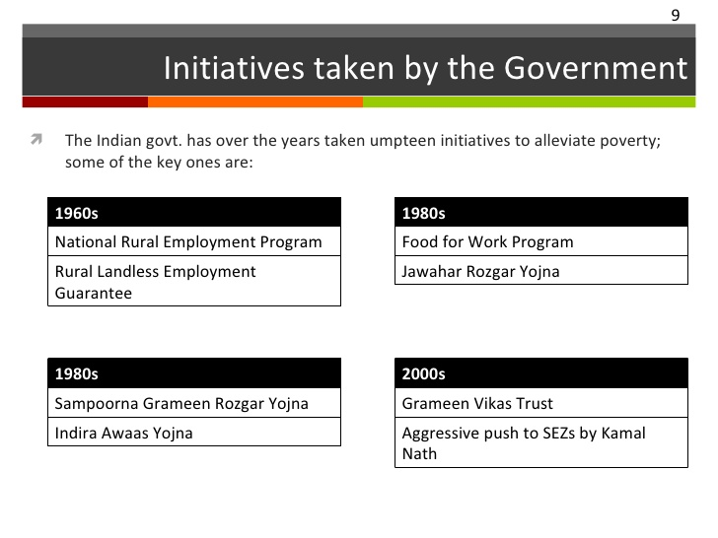  (G):  INDIRA AWAS YOJNA  (H):  ANNANPURNA YOJNA  YOJNA(VAMBAY)  (I):  VALMIKI AMBEDKAR AWAS  (VAMBAY)  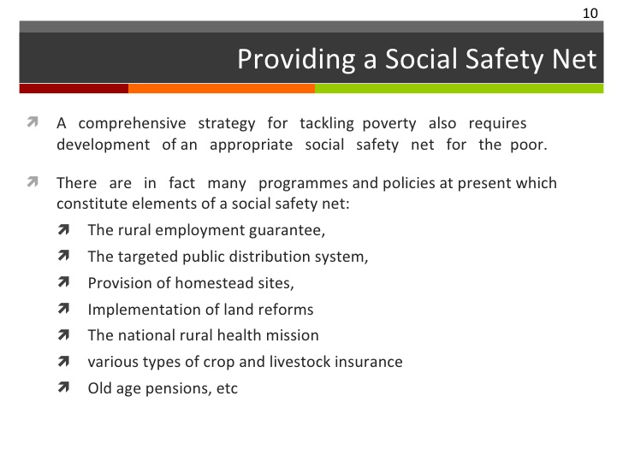 | I  II  III  IV  V  VI  I  II  III  I  II  III  I  II  III  IV  I  II  III  I  II  I  II  I  II  III  IV  I  II | **MEANING:  - It refers to Redistribution and supplementary measures to remove the poverty in India.  - The Indian Constitution and Five year Plan state Social Justice as the primary Objective of the developmental Strategies of the Govt. [NCERT-72-NEW]  **OBJECTIVE/PURPOSE:  - To encourage self employment opportunities  - To provide supplementary Wage employment.  - To reduce poverty by 2007.  **MAIN PROGRAMMES:  - Jawahar Gram Samridhi Yojna  - Sampoorna Gramin Rojgar Yojna  - Pradhan Mantri Gramodya Yojana  - Swarna Jayanti Gram Swarozgar Yojna  - Indira Awas Yojna  - Annapurna Yojna  - Valmiki-Ambedkar Awas Yojna  **REASONS FOR FAILURE:  - Financial Limit was fixed by Central without taking into account the actual cost.  - Implementation depends on the Govt. and Bank Officials who were corrupt, dishonest and in-efficient  - Poor could not take benefits because of Ignorance.  - No one is held responsible if Wrong Beneficiaries are chosen.  **POSITIVE RESULTS OR ACHIEVEMENTS:  - Per capita Income of poor increased.  - % age of Absolute Poor decreased in many States.  - Rise in Wages rural poor  - Rise in Nutritional Level  **STEPS REQUIRED TO ACHIEVE SUCCESS:  - Corruption and Wastes should be reduced.  - Accountability & Responsibility should be created.  - Co-operation should be increased through designing.  - Avoid duplication and overlapping Programmes.  **GROWTH ORIENTED APPROACH:  - POLICY [APPROACH]:  - It is based on the assumption that rapid increase in GDP and per capita income would spread to all sections of the society and this will trickle down to the poor sections also.  - This kind of planning was implemented in the 1950 and early 1960s  - It was assumed that rapid industrial development and transformation of Agriculture through the Green Revolution in selected region will benefit the under developed Regions and the more Backward Sections of the community  - FAILURE OF THIS CONCEPT-[NCERT-72]  - Growth of Agriculture and Industry have not been Impressive.  - Due to high population Growth, Per capita income was low  - Gap between poor and Rich widened actually.  - Green revolution exacerbated [make something bad worse] the disparities between large and small farmers  - Economists state that the benefits of Economic Growth have not trickled down the poor.  CREATION OF ADDITIONAL ASSETS[WORK GENERATION]  - It was initiated from third Five year plan[1961-66] and progressively enlarged  - One of the noted Programme initiated in the 1970s was Food for work  - Main Programmes implemented in this phase was:  - Self Employment Programmes  - Rural Employment Generation Programme [REGP]  - Prime Minister’s Rozgar Yojana [PMRY]  - Swarna Jayanti Shahari Rozgar Yojana [SJSRY]  **TO PROVIDE MINIMUM BASICS AMENITIES  - It was implemented through Public Expenditure on Social Consumption needs-viz. Provision of Food Grains at subsidized rates, Education, Health, Water Supply and Sanitation.  - Programmes are expected to supplement the consumption of the poor, create Employment Opportunities and bring about Improvements in Health and Education.  - Three Important Programmes for improving the Food and Nutritional Status of the poor are:  - Public Distribution System  - Integrated Child Development System  - Mid Day Meal  - Some other Attempts are:  - Pradhan Mantri Gram Sadak Yojana  - Pradhan Mantri Gramodaya Yojana  - Valmiki Ambedkar Awas Yojana  **IMPLEMENTATION:  - It was implemented through Gram-Panchyats  - It was restructured as Jawahar Gram Samridhi Yojna in 1999.  **WHO SPONSORS AND FINANCE:  - It is centrally sponsored scheme.  - Centre bears 75% cost and State finances 25% cost  - Cost sharing ratio is 75:25 between centre and State.  **OBJECTIVES:  - To create Basic Infrastructure in Rural Sector.  - To increase Employment Opportunities for Rural Youth.  - To provide Wage Employment to Rural living below Poverty Line.  - To provide Preferences to the following:  - Scheduled Castes  - Scheduled Tribes  - Physically Handicapped  **WHEN IMPLEMENTED & WHO FINANCE?:  - It was launched in Sept-2001  - Centre bears 75% cost.  - State Govt. bears 25% cost  **MERGERING OF FOLLOWING WITH SGRY  - Employment Assurance Scheme.  - Jawahar Gramin Samridhi Yojna.  - Restructured SGRY is effective from April-2002  **OBJECTIVES/PURPOSES:  - To provide Employment and Food security in Rural Areas.  - To construct Infrastructure for society and Rural Community.  - To Build Immovable Social And Economic Assets.  **CRITICAL EVALUATION:  - Cenral Govt. provided 50 Lakhs Tons Food Grains to States as free of Cost.  - Central Govt. spent Rs 51,000 crores in 2004-05 on this scheme.  **IMPLEMENTATION & FINANCE:  - It was introduced in 2000-01  - Central Govt. spent Rs 2,800 crores on this Scheme in 2004-05  **OBJECTIVES:  - To improve Standard of Living of Rural People.  - To pay special attention on the following:  - Health  - Drinking Water  - Housing  - Rural Roads  - Primary Education  **OTHER RELATED YOJNAS WITH PMGY:  - Pradhan Mantri Gram Sadak Yojna [launched in 25Th December 2000]  - Pradhan Mantri Gramin Awas Yojna  - Pradhan Mantri Rural Drinking Water Project  **IMPLEMENTATION & FINANCE:  - It was launched in April 01,1999.  - It is a centrally sponsored Scheme.  - Central Govt. bears 75% and State Govt bears 25% cost  - Centre-State cost sharing Ratio: 75:25  *AMALGAMATION OF FOLLOWING PROGRAMMES:  - Integrated Rural Development Programmes (IRDP)  - Development of Women and Children in rural areas (DWCRA)  **OBJECTIVES:  - To Construct house and to allot to poor’s free of Cost  - To convert Kutcha House into Semi-Pucca House of Poor.  **CRITICAL EVALUATION:  - 15 Lakhs Houses had been constructed or upgraded till 2006  **IMPLEMENTATION & FINANCE:  - LAUNCHED on April 01,2000  - 100% Centrally sponsored Programme.  - Since 2002-03,It was handed over to states.  **TARGET GROUP:  - Senior Citizens who do not get any pension.  **OBJECTIVES:  - To provide old age pension.  - To provide Food Grains to Citizens  **CRITICAL EVALUATION:  - 10 Kg of Food Grains to each old person free of cost  - It benefited 6.08 Lakhs.  **IMPLEMENTATION:  - Launched in 2001  - It was subsumed (Under any Law) to integrate  - Housing Slum Development Programme (HSDP)  **OBJECTIVES:  - To construct and upgrade dwelling Units for slims dwellers.  - To Build community Toilets under Nirmal Bharat Abhiyan
  IST FIVE YEAR PLAN-1951-56
  1ST FIVE YEAR PLAN URGE TO BRING Economic and Social Change under present Conditions
  It is outcome of the fact of poverty and Inequalities in Income, Wealth and Opportunities
  IST FIVE YEAR PLAN-1956-61
  2nd Five year Plan pointed out that the benefits of Economic Development must accrue more and more to relatively less privileged classes of society.
  The National Food for Work Programme) was launched in November, 2004 in 150 most backward districts of the country, identified by the Planning Commission in consultation with the Ministry of Rural Development and the State governments.
  The objective of the programme was to provide additional resources apart from the resources available under the Sampoorna Grameen Rozgar Yojana (SGRY) TO 150 most backward districts of the country
  so that generation of supplementary wage employment and providing of food-security through creation of need based economic, social and community assets in these districts are further intensified.
  The scheme was 100 per cent centrally sponsored. The programme has since been subsumed in National Rural Employment Guarantee Act
  200 identified districts of the country including 150 NFFWP districts.
  The Act provides 100 days of work guarantee to every rural household whose members volunteer to do unskilled manual work.
  It aims at creating Self Employment Opportunities in Urban Areas
  The Khadi And Village Industries Commission implements it
  Under this programme, one can get financial Assistance {bank loan] to set up small Industries
  DESTITUTE-DEFINED
        - lacking money or material possessions many families were left destitute by the horrible fire
        - utterly lacking in something needed, wanted, or expected ‹a lingering drought and a sky destitute of rain clouds
  It Means Rapid Increase In GDP And Per Capita Income
  TARGET GROUP
  INDIRA AWAS YOJANA]
  - People living below poverty line in Rural areas
  - Sc/ST and Freed Bonded Labourers.
  CRITICAL EVALUATION [VAMBAY]
  - 4,58,630 dwelling units were constructed and upgraded till 2006
  - 65,331 Toilets were made till 2006

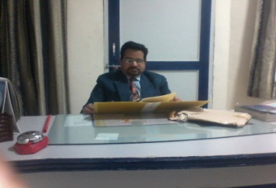  MOB-9460077156,9314858136 | ASHUTOSH SINHA [AGE-48 YEARS , EXPERIENCE-25]  M.COM,M.A[ECONOMICS],B.ED,DCA [PRODUCT OF ALLAHABAD UNIVERSITY]  PRINCIPAL-AAKANKSHA INTERNATIONAL SCHOOL,NAGAUR, RAJASTHAN  E-MAIL:- [1]-shreyanshsankalp@gmail.com, [2]:-sartak2004@gmail.com  PERMANENT ADDRESS:- LIG-335 GOVINDPUR COLONEY, ALLAHABAD U.P  LOCAL ADDRESS:- 2/253 RAJASTHAN HOUSING BOARD, NAGAUR RAJASTHAN

