Sample Paper- 2015
Subject: Computer Science
Class 12th

Q 1 : - (A) Define the following terms with an example : (2)
(i) Header file (ii) conio.h
(B) Observe the following C++ Code and write the name(s) of Header file(s) which will be essentially required to run it in C++ compiler ? (1)
int main()
{
Time t1(10, 50, 59);
t1.print(); // 10:50:59
Time t2;
t2.print(); // 06:39:09 t2.setTime(6, 39, 9);
t2.print(); // 06:39:09

if(t1.equals(t2))
cout << "Two objects are equal\n";
else
cout << "Two objects are not equal\n";

return 0;
}

(C) Observe the following C++ Code carefully and rewrite the same after removing all the syntax error(s) present in the code . Ensure that you underline each correction in this code . (2)
IMPORTANT NOTE :
-> All the desired Header files already included, Which are required to run the code.
-> Correction should not change the logic of programe.
#include [iostream.h]
void main( )
{ First=10, Second = 20;
Jumpto(First ; Second), Jumpto(second);
}
void Jumpto( Int n1, int n2=50)
{ n1= n1 + n2;
count << n1 >> n2;
}
(c) What will be the output of following code fragment, consider all essential header files are included ? (2)
- #include <cstdlib>
- #include <iostream>
- using namespace std;
- int main()
- {
- int ran = rand();
- cout << ran << endl;
- }

(D) Differentiate between Implicit and Explicit type conversion? (2)
(E) will be the output of following code fragment, consider all essential header files are included ? (2)
#include <stdio.h>
- #include <stdlib.h>
- #include <time.h>
- int main ()
- {
- srand (time(NULL));
- printf ("Random number: %d\n", rand() % 100);
- srand (1)
- return 0;
}

(f) Name the header files, to which the following built-in functions belong. (1)
(i) atoi() (ii) atof()

Q 2:- Answer the following questions:-
(a) What is function overloading and operator overloading? (2)
(b) What are the advantages of inheritance? (2)
(c) Answer the (I) and (II) after going through the following class : (2)
class player
{
int health, age;
public :
player()
{
health = 7;
age = 17;
} //constructor1
player( int h, int a)
{ health=h; age= a;
} // constructor 2
player(player &p)
{ ……} //constructor 3
~player()
{ cout << “\nMemory free”;
};
void main()
{ player p1(9,26); //statement 1
player p2 = p1; //statement 2
return 0;
}
(I) Write the name of construtor1, constructor2 and constructor3.
(II) When p2 object is created, specify which constructor gets invoked and why?

(D) Define a Class department with the following specifications :- (4)
private data members
protype string (50 char) // product name
list_price long
Discount float
dis_type char
calculate() The 20% discount on every product it sells . At the time of festival season the discount will be 10% after 20% regular discount. If
discount type is 'F' means festival and 'N' means non-festival. The calculate() will calculate the discount net price and net price on the basics
of following data

Product name list price(Rs)
printer 12000
laptop 41000
TV 35000
speaker 6000

Public members:-
constructor to initialize the string element with "NULL" , numeric element with 0 character elements with 'N'
Allow() :- ask to enter the product name ,list price and discount type and function will invoked calculate to calculate the net price and discount price.
show():- to generate the bill to the customer with all the details including net price and discount price.

(E) Consider the following C++ declaration and answer the questions given below: (4)
class A
{
void any( );
protected:
int a, b;
void proc( );
public: A();
void getA( );
void putA( );
};
class B : protected A
{
int c,d;
protected:
int e, f;
void getB( );
public:
int g; B ( );
void putB( );
};
class C : private B
{
int p;
protected:
int q;
void getC( );
public:
int r;
void showC( );
};
(i) Name all the member functions and data members which are accessible by the object of class C?
(ii) Name the base class and derived class of class B?
(iii) Name all the data members which are accessible from member functions of class C?
(iv) How many bytes will an object belonging to the class C require?

Q 3 (1) Write a function Swap2Change( int p[ ], int N) in C++ to modify the content of the array (3)
in such a way that elements, which are multiples of 10 swap with the values present in the very
next position in the array.
For Example:
If the content of the array P is:
91, 50, 54, 22, 30, 54
Then the content of the array should become:
91, 54, 50, 22, 54, 30

(2) An Array A[50][100] stored in the memory along the row with each of the elements occupying 4 bytes
.Find out the memory allocation of A[20][30] if the element A[15][20] is stored at the location 9300 ? (3)

(3) Write a programme in C++ to swap the two variables without using any third variable ? (2)

(4)Write a function to insert and delete a node congaing school information ( like school affiliation no , school code ,etc)from a circular queue of school ? (3)

(5) Evaluate the following POSTFIX notation. Show status of stack after every step of evaluation. (2)
False ,and, NOT ,false ,or, true, AND, true, false, OR, AND

(6) difference between constructor and destructor .Explain with an example ? (1)

4. (a) Observe the program segment given below carefully and fill the blanks marked as Statement 1 and Statement 2 using seekp() and seekg()
functions for performing the required task. (1)
#include class Item
{
int Ino;
char Item[20];
public: //Function to search and display the content from a particular //record number
void Search(int ); //Function to modify the content of a particular record number
void Modify(int); };
void Item::Search(int RecNo)
{
fstream File;
File.open(“STOCK.DAT”,ios::binary|ios::in); ______________________ //Statement 1
File.read((char*)this,sizeof(Item));
cout<<Ino<”<<Item<>Ino;cin.getline(Item,20); ______________________ //Statement 2
File.write((char*)this,sizeof(Item));
File.close();
}

(b) Write a function in C++ to count the vowel, space, special character ,consonent and no. in "vowel.txt" file ? (2)

(c) Write a function in C++ to search for the details (Numbers & Calls) of those Mobiles, which have more than 200 calls from a binary file “Mobile.DAT”. Assuming that the binary file contains the records of the following class Mobile: (3)
class Mobile
{
char Number[20];
int Calls;
public:
void Enter( )
{
gets(Number) ;
cin>>Calls ;
}
void Billing( )
{
cout<< Number << ”#” << Calls << endl;
}
int GetCall( )
{
return Calls ;
} };

Q5 (a) :- what is the difference between primary key and foreign key , with suitable example? (2)

(b) Consider the following table FLIGHT and FARES. Write the SQL commands for the statements (i) to (iv) and output from (v) to (viii). ( 6)

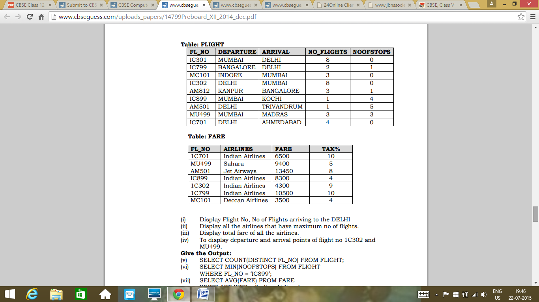
i) Display the NO_FLIGHTS ,FL_NO which are from jet airways .
ii) Display the TAX% and FARE which are departure from DELHI.
iii) update FARE from fare table where Sahara airlines the fare is 4000.

Display the outputs of the following :

i) SELECT MIN(NOOFSTOPS) FROM FLIGHT WHERE FL_NO = ‘MC101’ and FL_NO='MU499;
ii) SELECT FL_NO, NO_FLIGHTS FORM FLIGHT WHERE DEPARTURE=’KOCHI’;
iii) SELECT COUNT(DISTINCT FL_NO) FROM FLIGHT;

6. (a) Verify the following using truth table: (2)
(i) 𝑋 + 0 = 𝑋 (ii) 𝑋 + 𝑋 ′ = 1

(b) Verify the following algebraically and write the POS form (2)
(A'+B').(A+B)=A'.B+A.B'
(c) Write the equivalent Boolean Expression for the following logic circuit. (2)

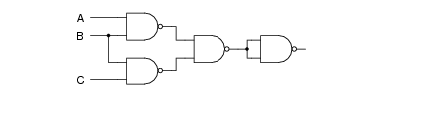

(d) Reduce the following Boolean expression using K-map: (3)

ƒ(P, Q, R, S) = Σ ( 1, 3, 5, 7, 10, 12,13,15)

Q7 :-
i) What is Firewalls ? (1)
ii) What is TCP/IP ? (1)
iii) What is Ethernet ? (1)
iv) give the full form of the following :- (1)
i) GSM ii) CDMA iii)HSPDA iv) MODEM

V) The DELTA INFOTECH has set up its new branch at west Bengal for its office and web designing work. it has its 3 wings as bellow :-

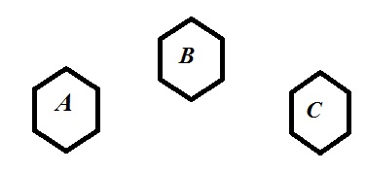
CENTER TO CENTER DISTENCE BETWEEN WINGS

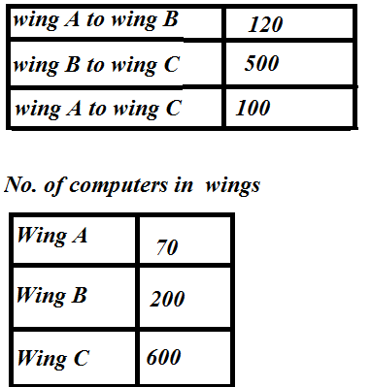

I) Suggest a most suitable cable layout of connection among the wings and topology ? (1)
II) Suggest the placement of the following devices with justification : (1)
a) Switch/Hub b) Repeater/Modem
III) This organizaation is planing to link its head office situated in west bangal with the offices as Delhi,Suggest a way to connect it . (1)

Name Akash Sejwal
Email akashsejwal004@gmail.com

