Sample Paper
Subject: Mathematics
Class 10th

(EXPECTED QUESTIONS)
Timeallowed: 3hrs Marks: 90
Instructions:-
1.All questions are compulsory. 2. This Q.P consists of 31 questions divided into four sections A,B,C,D. 3. section A comprises of 4 questions of 1 mark each, section B comprises of 6 questions of 2 marks each, section C comprises of 10 questions of 3 marks each,section D comprises of 11 questions of 4 marks each.
Section A( 1 X 4 =4 )
Q1. If the common differences of an A.P. is 3, then what is a₂₀ − a₁₅ is
Solution:
Let the first term of the A.P. be a.
a_{n} = a + (n-1)d
a₂₀ – a₁₅
_{ans}
Q2. A tower stands vertically on the ground. From a point on the ground which is 25 m away from the foot of the tower, the angle of elevation of the top of the tower is found to be 45°. Then the height (in meters) of the tower is
Solution:
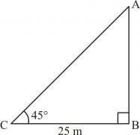
Let AB be the tower and C be the point on the ground 25 m away from the foot of the
tower such that ∠ACB = 45°.
In right ⊗ABC:
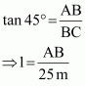
⇒ AB = 25 m
Thus, the height of the tower is 25 m.

Q3. If the diameter of a semicircular protractor is 14 cm, then find its perimeter.
Solution:
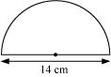
Diameter = 14 cm
Radius =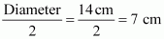
Length of the semicircular part = πr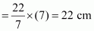
Total perimeter = Length of semicircular part + Diameter
= 22 cm + 14 cm
= 36 cm
Thus, the perimeter of the protractor is 36 cm.

Q4. What is the distance between the points A(c, 0) and B(0, −c)?

Solution:
Using distance formula, the distance between the points A(c, 0) and B (0, −c) is given by:
AB = 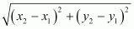
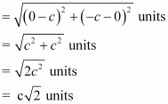
Thus, the distance between the given is .

Section B( 2 X 6 =12)
Q5. Find the value of p for which the roots of the equation px (x − 2) + 6 = 0, are equal.

Solution:
The given quadratic equation is px(x − 2) + 6 = 0.
Let us factorize the given quadratic equation.
px(x − 2) + 6 = 0
∴ px² − 2px + 6 = 0
Since the roots of the given quadratic equation are equal, its discriminant is equal to 0.
⇒ D = 0
⇒ b² − 4ac = 0
⇒ (− 2p)² − 4 × p × 6 = 0 [a = p, b = −2p, c = 6]
⇒ 4p² − 24p = 0
⇒ 4p (p − 6) = 0
⇒ 4p = 0 or p − 6 = 0
⇒ p = 0 or p = 6

Q6. Find the common differnece of an A.P. whose first term in 4, the last term is 49 and the sum of all its terms is 265.

Solution:
It is known that the sum of n terms of an AP whose first term is a and last term is l is given as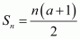
Here, first term, a = 4
Last term, l = 49
Sum of n terms (Sn) = 265
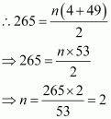
Therefore, the series has 10 terms.
It is known that the n^{th} term of an AP is given by, an = a + (n − 1) d
49 = 4 + (10 − 1) d
49 − 4 = 9d
45 = 9d
d = 5
Thus, the common difference of the AP is 5.

Q7. In the following figure, two circles touch each other externally at C. Prove that the common tangent at C bisects the other two common tangents.
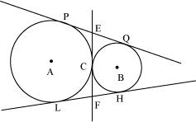

Solution:
We know that the lengths of tangents drawn from an external point to a circle are equal.
∴EC = EP and EC = EQ
⇒ EP = EQ
Also, FC = FL and FC = FH
⇒ FL = FH
This shows that EF bisects the tangents PQ and LH.

Q8. Find the perimeter of the shaded region in Figure 4, if ABCD is a square of side 14 cm and APB and CPD are semicircles. 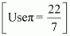
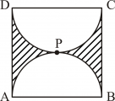

Solution:
The length of the sides of square ABCD is 14 cm.
∴ AB = BC = CD = AD = 14 cm
Radius of each semi-circular portion 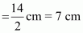
Perimeter of the shaded region = Perimeter of semi-circle APB + perimeter of semi-circle CPD + BC + AD
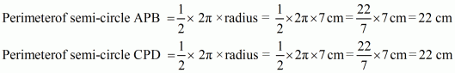
∴ Perimeter of the shaded region = 22 cm + 22 cm + 14 cm + 14 cm = 72 cm

Q9. A ticket is drawn at random from a bag containing tickets numbered from 1 to 40. Find the probability that the selected ticket has a number which is a multiple of 5.

Solution:
Let E be the event that the selected ticket has a number that is a multiple of 5.
Total number of outcomes = 40
The favourable outcomes of event E are 5, 10, 15, 20, 25, 30, 35 and 40.
Number of favourable outcomes of event E = 8
Probability that the selected ticket has a number that is a multiple of 5
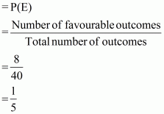
Thus, the probability that the selected ticket has a number that is a multiple of 5 is.

Q10. A box contains 5 red balls, 4 green balls, and 7 white balls. A ball is drawn at random from the box. Find the probability that the ball drawn is
(a) White
(b) Neither red nor white

Solution:
The box contains 5 red balls, 4 green balls, and 7 white balls.
Therefore, total number of balls in the box = 5 + 4 + 7 = 16
(a) Probability that the ball drawn is white = 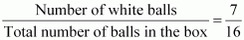
(b) Probability that the ball drawn is neither red nor white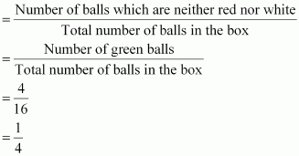

Section C( 3 X 10 = 30)
Q11. Solve the following quadratic equation for x:
x² − 4ax − b² + 4a² = 0

Solution:
The given quadratic equation is x² − 4ax − b² + 4a² = 0
∴ x² + (−4a)x − (4a² + b²)= 0 [A = 1, B = −4a, C = 4a² − b²]
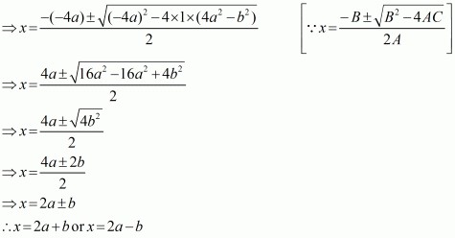
Thus, the solution of the given quadratic equation is x = 2a + b or x = 2a − b.

Q12. Find the sum of all multiples of 7 lying between 500 and 900.

Solution:
The multiples of 7 lying between 500 and 900 are 504, 511, 518, … , 896.
This is an A.P.
First term, a = 504
Common difference, d = 511 − 504 = 7
Last term = 896
Let there be n terms in the A.P.
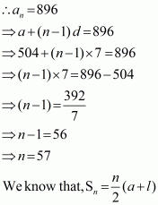
∴Sum of all the multiples of 7 lying between 500 and 900
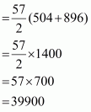
Thus, the sum of all the multiples of 7 lying between 500 and 900 is 39900.

Q13. In the given fig XP and XQ are tangents from X to the circle with centre O. R is a point on the circle
such that ARB is a tangent to the circle prove that :- XA + AR = XB + BR
R
A
B
P
Q
X

Solution: In the given fig XP and XQ are tangents from external point
∴ XP = XQ ........( i)
AR = AP...........(ii )
BR = BQ...........(iii )
[∵length of tangents are equal from external point]
Xp = XQ
XA+ AP = XB + BQ [By (ii) and (iii)]
XA+ AR = XB + BR [By (ii) and (iii)]
Q14. From the top of a vertical tower, the angles of depression of two cars, in the same straight line with the base of the tower, at an instant are found to be 45° and 60°. If the cars are 100 m apart and are on the same side of the tower, find the height of the tower. 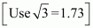

Solution:
The given information can be diagrammatically represented as follows:
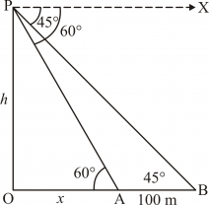
Here, OP is the tower. Point A and B are the positions of the cars.
Let h be the height of the tower i.e., OP = h.
It is given that ∠XPB = 45° and ∠XPA = 60°.
⇒ ∠PBO = ∠XPB = 45° and ∠PAO = ∠XPA = 60° (Alternate interior angles)
In ⊗OPA:
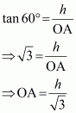
From ⊗OPB:
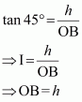
It is given that the distance between the two cars is 100 m.
∴ AB = 100 m
⇒ OB − OA = 100 m
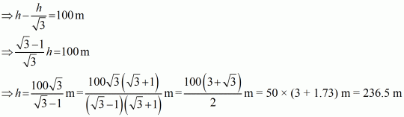
Therefore, the height of the tower is 236.5 m.

Q15. A chord of a circle of radius 14 cm subtends an angle of 120° at the centre. Find the area of the corresponding minor segment of the circle. 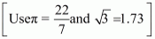

Solution:
Let O be the centre of the circle and AB be the chord that subtends an angle of 120° at the centre.
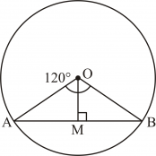
Here, OM ⊥ AB.
Radius of the circle, r = 14 cm
Area of the minor segment = Area of sector OAB − area of ⊗AOB
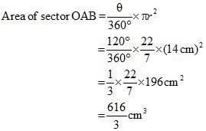
Now, OM ⊥ AB.
⇒ AB = 2AM
In ⊗OAM and ⊗OBM:
OA = OB [Radii of the same circle]
OM = OM [Common]
∠OMA = ∠OMB [Each 90°]
∴ ΔOAM ≅ ⊗OBM [RHS congruence criterion]
⇒ ∠AOM = ∠BOM [C.P.C.T]
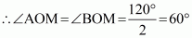
In ⊗AOD:
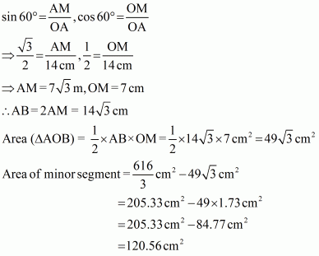
Thus, the area of the minor segment is 120.56 cm².

Q16. In Figure O is the centre of the circle with AC = 24 cm, AB = 7 cm and ∠BOD = 90°.
Find the area of the shaded region. [Use π = 3.14]
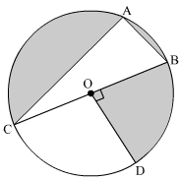

Solution:
O is the centre of circle.
Given: AC = 24 cm, AB = 7 cm and ∠BOD = 90°.
The angle in a semicircle is 90°.
∴ ∠BAC = 90°
So, ⊗ABC is a right-angled triangle.
Using Pythagoras Theorem in ⊗ABC, we have
(AC)² + (AB)² = (BC)²
∴ (24)² + (7)² = (BC)²
⇒ (BC)² = (576 + 49) cm²
⇒ (BC)² = 625 cm²
⇒ BC = 25 cm
BC is diameter of circle.
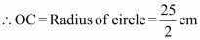
Area of the sector COD, A₂
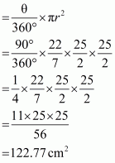
Area of circle, A₃ = πr²
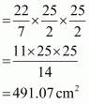
Area of the shaded region
= Area of circle − (Area of ⊗ABC + Area of sector COD)
= A₃ − (A₁ + A₂ )
= 491.07 cm² − (84 + 122.77) cm²
= 491.07 cm² − 206.77 cm²
= 284.30 cm²
Thus, the area of shaded region is 284.30 cm².

Q17. A solid sphere of radius 10.5 cm is melted and recast into smaller solid cones, each of radius 3.5 cm and height 3 cm.
Find the number of cones so formed. 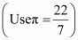

Solution:
Let the number of cones formed be n.
Given: Radius of sphere, r = 10.5 cm
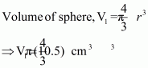
Given: Height of cone, h = 3 cm and radius of cone, R = 3.5 cm
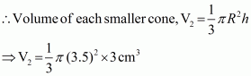
Since the solid sphere is melted and recast into smaller cones,
n × Volume of each smaller cone = Volume of the sphere
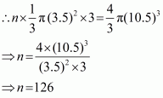
Thus, the number of smaller cones formed is 126.

Q18. A toy in the form of a cone is mounted on a hemisphere with same radius. The diameter of the base of the conical portion is 7 cm and the total height of the toy is 14.5 cm. Find the volume of the toy.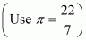

Solution:
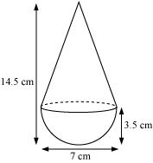
Diameter of the conical part = 7 cm
Therefore, radii of conical part, r = cm
It is given that the radius of the conical part and the hemispherical part is the same and is 3.5 cm.
Height of the hemisphere = Radius (r) = 3.5 cm
∴Height of the cone, h = 14.5 cm − 3.5 cm = 11 cm
Volume of the toy = Volume of the cone + Volume of the hemisphere
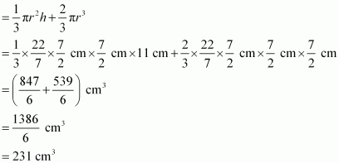
Therefore, the volume of the toy is 231 cm³.

Q19 . If the point C (−1, 2) divides internally the line segment AB in the ratio 3: 4, where the coordinates of A are (2, 5), then find the coordinates of B.
Solution:
It is given that a point C divides the line segment AB in the ratio 3: 4.
Let the coordinates of B be (x, y).
The coordinates of the points A and C are given as (2, 5) and (−1, 2) respectively.
Using section formula, we obtain
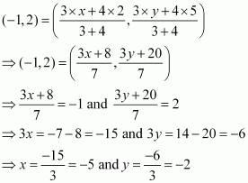
Hence, the coordinates of B are (−5, −2).

Q20. Show that the points A(5,6), B(1,5), C(2,1)and D(6,2) are the vertices of a Square

Solution:
Diagonal
Diagonal
Hence proved
Section D( 4 X 11 = 44 )
Q21. A train travels 180 km at a uniform speed. If the speed had been 9 km/hour more, it would have taken 1 hour less for the same journey. Find the speed of the train.
OR
Find the roots of the equation
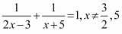 .
Solution:
Let the speed of the train be x km/h.
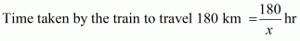
If the speed of the train had been 9 km/h more, then its speed would have been (x + 9) km/hr.
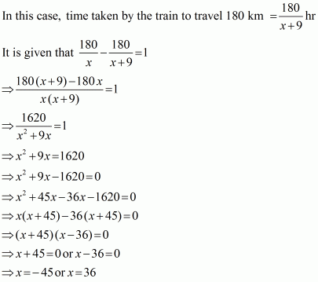
Since the speed of a train cannot be negative, x = 36.
Thus, the speed of the train is 36 km/h.
OR
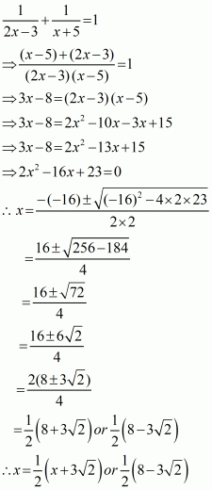

Q22. A Group consists of 12 persons, of which 3 are extremely patient, other 6 are extremely honest and rest are extremely kind. A person from the group is selected at random. Assuming that each person is equally likely to be selected, find the probability of selecting a person who is (i) extremely patient (ii) extremely kind or honest.
Which of the above values you prefer more?

Solution:
Since the group consists of 12 persons, sample space consists of 12 persons.
∴Total number of possible outcomes = 12
Let A denote event of selecting persons which are extremely patient
∴ Number of outcomes favourable to A is 3.
Let B denote event of selecting persons which are extremely kind or honest.
Number of persons which are extremely honest is 6.
Number of persons which are extremely kind is 12 − (6 + 3) = 3
∴ Number of outcomes favourable to B = 6 + 3 = 9.
(i) Probability of selecting a person who is extremely patient is given by P(A).
P(A) = 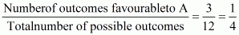 .
(ii) Probability of selecting a person who is extremely kind or honest is given by P(B)
P (B) = 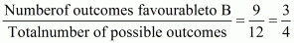

Q23. The numerator of a fraction is 3 less than its denominator. If 1 is added to the denominator, the fraction is decreased by .Find the fraction.

Solution:
Let the denominator of the fraction be x then the numerator will be (x − 3).
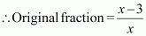
It is given that the new fraction is obtained after adding 1 to the denominator.
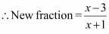
According to the given condition,
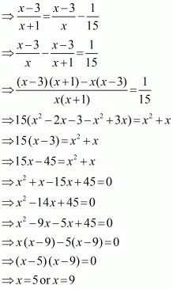
⇒ Denominator = 5 or 9
⇒ Numerator = 5 − 3 = 2 or 9 − 3 = 6
Hence, the fraction is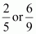.
Q24. Prove that the lengths of the tangents drawn from an external point to a circle are equal.
Solution:
The figure shows a circle with centre O. P is a point taken in the exterior of the circle. PA and PB are tangents from point P to the circle. We also construct OA, OB, and OP.
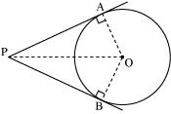
We need to prove that the lengths of the tangents drawn from an external point to a circle are equal, i.e., PA = PB.
It is known that the tangent at any point of a circle is perpendicular to the radius through the point of contact.
∴ PA and PB are perpendicular to OA and OB respectively.
⇒ ∠OAP = ∠OBP = 90°
In ΔOAP and ΔOBP:
OA = OB (Radii of the same circle)
OP = OP (Common)
∠OAP = ∠OBP (Each 90°)
∴ ΔOAP ≅ ΔOBP (RHS congruence criterion)
∴ PA = PB (CPCT)
Thus, the lengths of the tangents drawn from an external point to a circle are equal.
Hence, proved.

Q25. In fig.6 l and m are two parallel tangents to a circle with centre O, touching the circle at A and B respectively. Another tangent at C intersects the line l at D and m at E. Prove that ∠DOE = 90°.
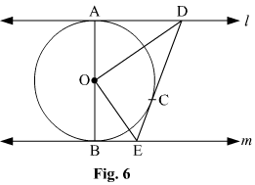

Solution:
Given: l and m at are two parallel tangents to the circle with centre O touching the circle at A and B respectively. DE is a tangent at the point C, which intersects l at D and m at E.
To prove: ∠ DOE = 90°
Construction: Join OC.
Proof:
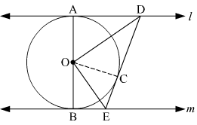
In ΔODA and ΔODC,
OA = OC (Radii of the same circle)
AD = DC (Length of tangents drawn from an external point to a circle are equal)
DO = OD (Common side)
ΔODA ≅ ΔODC (SSS congruence criterion)
∴ ∠DOA = ∠COD … (1) (C.P.C.T)
Similarly, ΔOEB ≅ ΔOEC
∠EOB = ∠COE … (2)
AOB is a diameter of the circle. Hence, it is a straight line.
∴ ∠DOA + ∠COD + ∠COE + ∠EOB = 180º
From (1) and (2), we have
2∠COD + 2 ∠COE = 180º
⇒ ∠COD + ∠COE = 90º
⇒ ∠DOE = 90°
Hence, proved

Q26.Draw a right triangle in which sides (other than hypotenuse) are of lengths 8 cm and 6 cm. Then construct another triangle whose sides are times the corresponding sides of the first triangle.

Solution:
Let us assume that right ΔABC has base BC = 6 cm, side AB = 8 cm, and ∠B = 90°. Let ΔA'BC' have sides that are times those of ΔABC.
Now, ΔABC and ΔA'BC' can be drawn as follows:
(1) Draw a line segment BC = 6 cm. Draw a ray BX making 90° with BC.
(2) Draw an arc of 8 cm radius taking B as its centre to intersect BX at A. Join AC. ΔABC is the required triangle.
(3) Draw a ray BY making any acute angle with BC on the other side of line segment BC.
(4) Locate 4 points B₁, B₂, B₃, and B₄ on ray BY such that BB₁ = B₁B₂ = B₂B₃ = B₃B₄
(5) Join B₄C. Draw a line through B₃ parallel to B₄C intersecting BC at C'.
(6) Through C', draw a line parallel to AC intersecting AB at A'. ΔA'BC' is the required triangle.
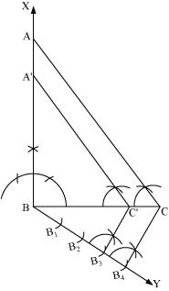

Q27. An aeroplane when flying at a height of 3125 m from the ground passes vertically below another plane at an instant when the angles of elevation of the two planes from the same point on the ground are 30° and 60° respectively. Find the distance between the two planes at that instant.
Solution:
The given information can be represented as
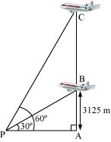
Let P be the point on the ground and let B and C be the two aeroplanes.
Since the aeroplane at point B is flying 3125 m above the ground,
AB = 3125 m
The distance between the two aeroplanes at that instant is given by BC.
In ΔAPB,
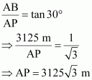
In ΔAPC,
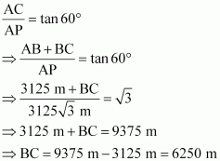
Thus, the distance between the two aeroplanes at that instant is BC = 6250 m.

Q28. The difference between the outer and inner curved surface areas of a hollow right circular cylinder, 14 cm long, is 88 cm². If the volume of metal used in making the cylinder is 176 cm³, find the outer and inner diameters of the cylinder. 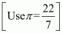
Solution:
Height of the cylinder, h = 14 cm
Let R and r be the outer and inner radii of the hollow cylinder.
It is known that, curved surface area of cylinder = 2 × radius × height
Therefore, according to the given information:
2πRh − 2πrh = 88 cm²
⇒ 2π (14) (R − r) = 88
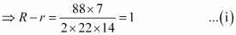
It is also given that the volume of the metal used in making the cylinder is 176 cm³.
∴ π (R² − r²)h = 176
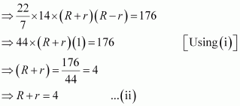
Adding (i) and (ii)
2R = 5
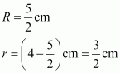
Thus, the outer diameter of the cylinder is 2R = 5 cm, and its inner diameter is 2r = 3 cm

Q29. A juice seller serves his customers using a glass as shown in Figure 6. The inner diameter of the cylindrical glass is 5 cm, but the bottom of the glass has a hemispherical portion raised which reduces the capacity of the glass. If the height of the glass is 10 cm, find the apparent capacity of the glass and its actual capacity. (Use π = 3.14)
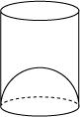
OR
Solution:
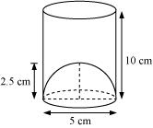
Apparent capacity of the glass will be the same as the capacity of the cylindrical portion having its base diameter as 5 cm and height as 10 cm.
Base radius = 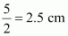
Apparent capacity = πr²h
= 3.14 × (2.5)² × 10
= 196.25 cm³
Actual capacity of the glass will be the difference between the cylindrical portion and the hemispherical portion.
From the figure, it is clear that the base radius of the hemispherical portion is alsocm or 2.5 cm.
Actual capacity of the glass =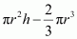
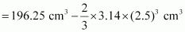
= 196.25 cm³ − 32.71 cm³
= 163.54 cm³
Thus, the apparent capacity of the glass is 196.25 cm³ and the actual capacity of the glass is 163.54 cm³.

Q30. All kings, queens and aces are removed from a pack of 52 cards. The remaining cards are well shuffled and then a card is drawn from it. Find the probability that the drawn card is
(i) a black face card.
(ii) a red card.

Solution:
Total number of cards in a pack = 52
A pack contains of 4 kings, 4 queens and 4 aces.
∴ Number of cards removed = 4 + 4 + 4 = 12
Remaining number of cards in the pack = 52 − 12 = 40
(i) Number of black face cards = 2 (jacks of spade and club)
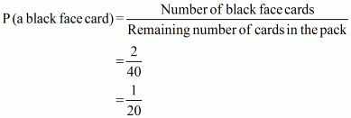
Thus, the probability of getting a black face card is.
(ii) Remaining number of red cards = 26 − (2 + 2 + 2) = 26 − 6 = 20
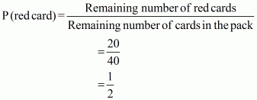
Thus, the probability of getting a red card is.

Q31. Find the area of triangle formed by joining the mid-points of the sides of the triangle whose vertices are A(2, 1), B(4, 3) and C(2, 5).

Solution:
Let ABC be the triangle such that A (2, 1), B (4, 3) and C (2, 5) are the vertices of the triangle.
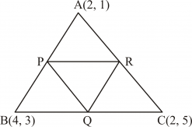
Let P, Q and R be the mid-points of sides AB, BC and CA respectively of ⊗ABC.
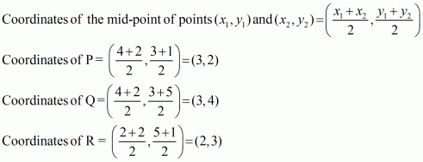
The area of the triangle whose vertices are (x₁ , y₁ ), (x₂ , y₂ ) and (x₃ , y₃ ) is given as follows:
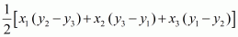
∴Area of ⊗PQR
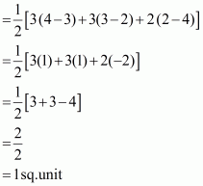
Thus, the area of the triangle formed by joining the mid-points of the sides of the given triangle
is 1 sq unit.


 Mob:-9934086854

