Guess Paper – 2007
Class – XII
Chemistry

Chemistry Revision Examination 2007

Time : 1 ½ hours Maximum Mark : 50
Date : 16/2/2007 Topics : p-Block Elements

General Instructions :

All questions are compulsory.
Questions 1-5 carry 1 mark each
Questions 6-12 carry 2 marks each
Questions 13-19 carry 3 marks each
Questions 20-21 carry 5 marks each
Use log tables if necessary. Calculators are not permitted.

- Define catenation. (1)

- Arrange the following in the increasing order of acidity. (1)
HOCl, HOClO,HOClO2,HOClO3.

- Compare the oxidation states of phosphorous in : (1)
  - H3PO3
  - POF3

- Why is the tetrahedral geometry in water more distorted than in H2S? (1)

- Complete : XeF2 + SbF3 →_____________ (1)

- (a) ‘All bonds in PCl5 are not equivalent’. Comment. (1)
(b) Among the noble gases, only Xenon forms compounds. Why? (1)

- SiF6 is known whereas SiCl6 is unknown. Explain? (2)

- In a laboratory experiment, a student is in attempt to prepare HI. He mixes NaI with conc. H2SO4. But, he doesn’t get the desired product. Why? (2)

9. Sulphur exhibits paramagnetism in vapour phase. Explain. (2)

10. Suggest possible reactions for the preparation of : (a) SnO (b) ClO2. (2)

11. (a) Lithium Aluminium hydride is an important reducing agent in Organic Chemistry. Suggest a method to prepare LiAlH4. (1)
(b) Give one use of carborandum. (1)

12. Why is carbon tetrachloride, a better solvent in aqueous conditions, in preferance to silicon tetrachloride? (2)

13. (a) Why is fluorine, the strongest oxidizing agent among halogens? (1)
(b) PbI2 is yellow in colour. What is the reason for its colour? (1)
(c) Observe and pick the odd one out of the following : ( ½ + ½ )
Cassiterite, galena, cerussite, anglesite. Support your answer.

14. (a) Write two balanced chemical equations to establish the amphoteric nature of aluminium oxide. (1 +1)
(b) Complete : Sn + KOH (aq) → __________ (1)

15. Complete the following equations :
(a) Pb3O4 + HNO3 → ___________ (1)
(b) P4O10 + HNO3 → ___________ (1)
(c) Zn3Sb2 + HCl → ___________ (1)

16. (a) Draw the structures of the two allotropes of Phosphorous. ( ½ + ½ )
(b) Which among the above allotropes is highly toxic? ( ½ )
(c) Why is AlCl3 used as a catalyst in Freidal Craft’s reaction? (1½)

17. (a) Stating reason, arrange the following in the decreasing order of stability
GeBr2, SiBr2, CBr2, PbBr2, SnBr2. (1+1)
(b) How does phosphorous trichloride react with oxygen? (1)

18. (a) While phosgene is a gas, ammonia is a liquid. How is this possible, despite
Fact that both phosphorous and nitrogen belong to group 15. (1)
(b) Write one chemical method to prepare poisonous phosgene gas. (1)
(c) How is elemental phosphorous prepared from Ca(OH)2? (1)

19. (a) Name one compound of Silica used as :
(i) catalyst (ii) piezoelectric substance (iii) electrical insulator ( ½ + ½ + ½ )
(b) How is (CH3CH2CH2)2SiCl2 prepared. (1)
(c) Suppose this compound is A.
A + H20 → B
Write the structural formulae for a polymer of B. ( ½ )

20. (a) Phosphinic acid is monoprotic. Justify. (1)
(b) Despite being the most electronegative element, HF is least acidic. Why? (1)
(c) Why are interhalogen compounds unstable? (1)
(d) Complete : Ba(OH)2 + H2O2 + ClO2 → _____________ (1)
(e) Why is (SiH3)3N planar in shape. (1)

21. (a) Name one compound isoelectronic with ClF. ( ½ )
(b) Draw the geometrical shape of (i) P4O10 (ii) BrF3. (2)
(c) SF6 cannot be easily hydrolysed. Support the statement with a suitable diagram. (1+1)
(d) Complete : SCl2 +NaF →(CH3CN, 350K) _________ ( ½ )

OR

- Explain the extraction of alluminium from its ore. (2)
- Draw the structures of (a) peroxodisulphuric acid (b) dithionic acid (2)
(c) Identify the silicate given below:
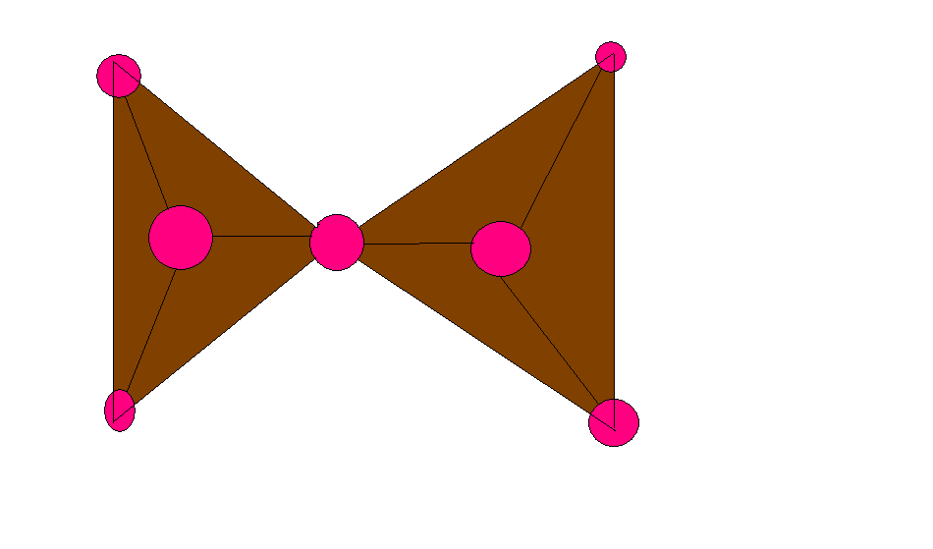
Give the structural formulae and write the group which it belongs to. ( ½ + ½ )

