Guess Paper
CLASS-XII
SUBJECT-MATHS
M.M.-100TIME-3hrs.
GENERAL INSTRUCTIONS:
1. All questions are compulsory.
2. The question paper consist of 26 questions divided into three sections A, B and C. Section
A comprises of 6 questions of one mark each, section B comprises of 13 questions of four marks each and section C comprises of 07 questions of six marks each.
3. All questions in Section A are to be answered in one word, one sentence or as per the exact requirement of the question.
SECTION-A

Q-1. Write the order & degree of the differential equation: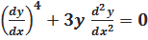.
Q-2. Write the integrating factor of the differential equation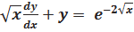.

Q-3. If 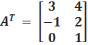& B 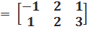 then find .

Q-4. Write the principal value of 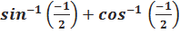 .

Q-5. Integrate 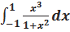 .

Q-6. Find the slope of the normal to the curve
x=, y=2t at t=2.

SECTION-B
Q-7.Solve the following for x: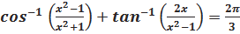.
Q-8. Let A=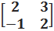 , then show that . Using this result, calculate also.

Q-9. Using the properties of determinants, solve the following for x: 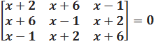

Q-10. If f (x) =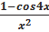 , when x<0
, when x=0
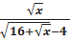 , when x>0
andfunction continuous at x=0, find the value of a.

Q-11. If prove that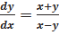.

Q-12. Find the interval (s) in which function is increasing or decreasing: f(x) = sin x + cos x, 0≤x≤2π.
Q-13. Find the equations of tangents to the curve y=x³+2x+6 which are perpendicular to the line x +14y+4=0.

Q-14. Evaluate 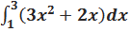as a limit of sums.

Q-15.Evaluate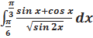.

Q-16. Evaluate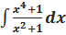.

Q-17. Solve the following differential equation
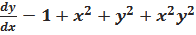, Given that y=1 whenx=0.

Q-18. Solve the following differential equation
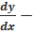3y cot x =sin 2x, given that y=2
when x= .

Q-19. Using properties of determinants prove that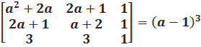.
SECTION-C

Q-20. Two institutions decided to award their employees for the three values of resourcefulness, competence and determination in the form of prizes at the rate of Rs. x, Rs. y and Rs. z respectively per person. The first institution decided to award respectively 4, 3, and 2 employees with a total prize money of Rs. 37000 and the second institution decided to award respectively 5, 3 and 4 employees with a total prize money of Rs.47000. If all the three prizes per person together amount to Rs. 12000, then using matrix method, find the value of x, y and z what value are described in this question .

Q-21. If = prove that
- 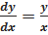 2)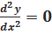.

Q-22. A square tank of capacity 250 has to be dug out. The cost of land is Rs.50 per sq.m. . The cost of digging measures with the depth and cost per the whole tank is 400(depth)² rupees. Find the dimensions of the tank for the least cost.

Q-23. Evaluate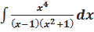.

Q-24. Using the method of integration find the area of the region bounded by the lines
3x- 2y+1=0, 2x+3y-21=0 and x-5y+9=0.

Q-25. Show that the differential equation 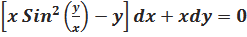 is homogeneous. Find the particular solution of this differential equation, given that y= when x=1.

Q-26. Evaluate 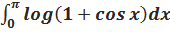.

Name: ALPANA BHATNAGAR
Email: alpana.bhatnagar@rediffmail.com

