Sample Paper – 2007
Class – XI
Informatics Practices

MARKS: 70 TIME: 3hrs

- Answer the following in short:-
  - “VB is not a object oriented language”. Justify the statement 2
  - What is Focus? Name any two controls, which don’t receive focus? 2
  - Define Event , Message 2
  - Differentiate between the timer control and timer event? 2
  - Name and explain any two common properties between label, text and command? 2

- Differentiate between the following:- (2 marks each)
  - Image and picture box
  - Text box and Label
  - Option and Check box
  - List box and Combo Box
  - Command and Label

- Explain the following properties and Name the control which has this property:- (1 mark each)
  - MaxLength
  - Control Box
  - Caption
  - Value
  - List Item
  - Text
  - Minvalue
  - Enabled
  - Password Char
  - Multiline
- Answer the following:-
  - LOAD event
  - CLICK event
  - GOTFOCUS event
- Observe the QUIZ MASTER shown below:- and answer the following questions
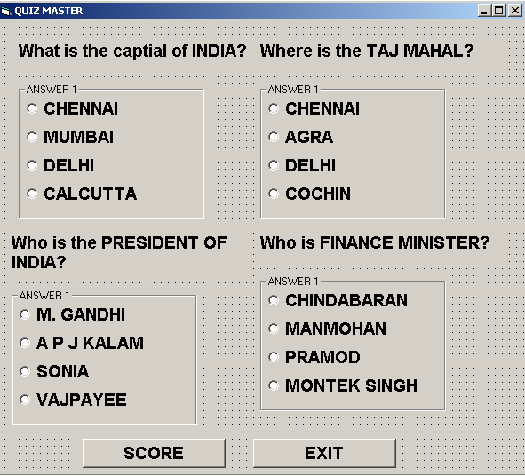
  - Which property of the form is used to give the name of the application? 1
  - Which control is used to select the answer of the given questions? 1
  - What command would be given to exit the application and where? 2
  - When the user selects the answers if 1 answer is correct display TRY AGAIN 2 answers are correct display YOU CAN DO BETTER 2 answers are correct display YOU CAN DO BETTER 3 answers are correct display WELL DONE ALL answers are correct display YOU ARE THE BEST! 4
  - Write a code to display A message box when the application begins saying ALL THE BEST to the user? 2
- Answer the following based on the application given below:-
  - Give a name of the property and name of the control to display 1 at the time when the application starts? 1
  - Write the Code as to Display the cursor in the Name Textbox? 1
  - Write a code to calculate the annual for all the components Basic, Hra, Dra ,Total 4
  - Write a procedure to clear all the textboxes on the clear button. 4

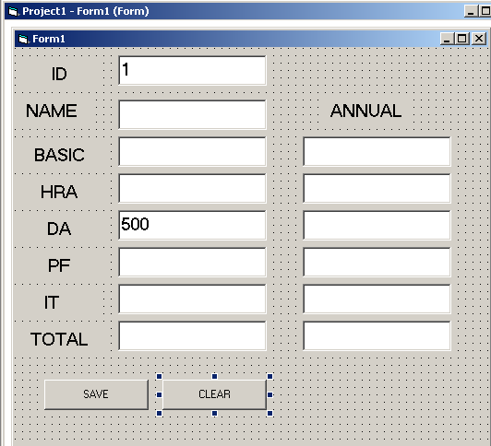
  - What are Read Only Views? 2
  - How is Primary Key different Unique constraint? 2
  - Write the Create Table Command? 2
  - What is a sequence 2
  - What is a View? Give Syntax 2

