Sample Paper- 2016
Subject: Informatics Practices
Class 12th
Time allowed: 3 hours Maximum Marks: 70
Note: Read the instruction
- Attempt all the questions.
- Attempt questions in sequence.
Q1 | a) | ANSWER THE FOLLOWING QUESTIONS:-  How is Co-axial cable is different from Optical Fibre? | 1
 | b) | What do you understand by firewall? | 1
 | c) | Define any two threats to Network security? | 2
 | d) | Differentiate between MAC address and IP address? | 1
 | e) | What is font? | 1
 | f) | Name any two encoding used for Indian Language Computing? | 1
 | g) | What is Ogg Vorbis? | 1
 | h) | What are these softwares used for:-  - Linux ii) PHP iii) Python iv) Apache | 2
Q2. ANSWER THE FOLLOWING QUESTIONS:
- How many types of Inheritance does JAVA have? 1
- Which loop execute atleast once explain with an program? 2
- How length() function is different from capacity() function? 1
- What is an expression? Differentiate between Boolean and compound expression? 2
- Define any two jump statements of java with an example? 1
- Name any methods associated with JOptionPane window? 1
- Write a Java method that accept a no as parameter and method should return 1 if number is
multiple of 2 else return 0. 2

Q3. Answer the following. 10
a) Create a database customer in mysql if It does not exist?
b) Anita wants to replace all the NULL values of column discount with 50%
c) Explain ‘ALL in None’ in context of transaction handling
d) Write any 4 atributes of <body> tag?
e) Define any two attributes of <table> tag?
f) Explain XML is a language in which own created tags can be taken justify your answer?
g) Explain the role of Commit and Savepoint command of mysql?
h) Explain foreign key with an example?
I) Give one example of web browser and web server
j) Explain the components of URL

Q4. Answer the following questions
- Rewrite the following java code into if-else if-else 2
Char ch;
switch (ch) {
case ‘N’ : jLabel1.setText(“NORTH”);
break;
case ‘E’ : jLabel1.setText(“EAST”);
Break;
case ‘W’ : jLabel1.setText(“WEST”);
break;
case ‘S’ : jLabel1.setText(“SOUTH”);
break;
default : jLabel1.setText(“wrong character”); }
- Underline the error and correct the following java code:- 2
int principal =jTextField1.getText();
int time = jTextField2.getText();
float int = principal*0.08*time;
Joptionpane.showMessageDialog(“interest is”, int);
- What will be displayed in jTextArea1 after the execution of the following loop ? 2
for (int I=5; I>=2;I– –)
jTextArea1.setText(jTextArea1.getText()+ " "+Integer.toString(I*I));
- Give the output of the following Java code : 1
String name="Chennai Express";
int TM=name.length();
int TN=80–TM;
jTextField2.setText(Integer.toString(TM.concat(TN));
- Write Java statement to make a jTextfield1 disabled. 1
- Ms Pragati works at a Recreation Park as a system analyst. She has created the following GUI. When a group arrives at the Recreation Park, the number of people in the group and whether the group wants to enjoy the Water Park or not is entered. Entry fees is < 500 per person. The person can choose to play at Water Park by selecting the checkbox. Rides of Water Park will cost 250 per person.
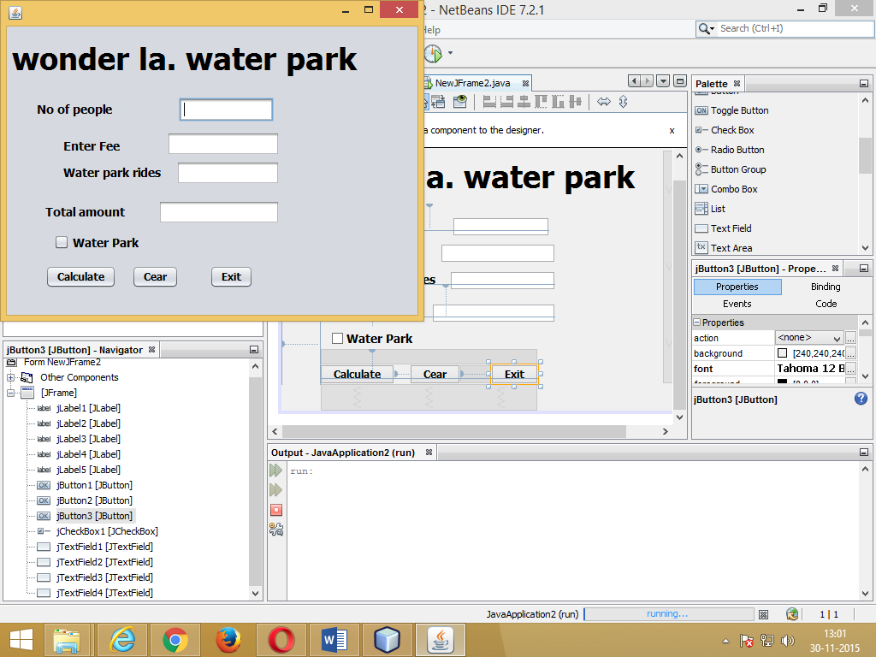
Help her to write code for the following : 3
- On the click of command button ‘Calculate’, textfield for ‘Entry Fees’ should display Entry Fees per person  Number of people. If ‘Water Park’ checkbox is selected, textfield for ‘Water Park Charges’ should display Water Park Charges per person  Number of people. Textfield for ‘Total Amount’ should display sum of Entry Fees and Water Park Charges for all the people in the group.
(ii) Write Java code to clear all Textboxes on the click of ‘Clear’ button. 1
(iii) Write Java code to close the application on the click of ‘Exit’ button. 1
g) Explain term OOPS. 1
h) Differentiate class and object. 1
Q5. Answer the following questions
- What is join? Explain eui join. 2
- Answer the questions based on the table Apartment given below: 8
Table: Apartment
Column Name Data Type Size Constraint
Ap_No int (4) PRIMARY KEY
Ap_Category CHAR (1) default ‘s’
Pur_Name VARCHAR 30
Cost decimal
Dt_Sold DATE
a) Write the SQL command to create table Apartment including the constraints.
b) Write the SQL command to display the category and number of apartments in each category.
c) Increase the apartment cost by 5%
d) Add new column dt_cancel as date type
e) Display the details of apartment whose cost greater than 10 lakhs and ap_category is “luxuries”
f) Display the names of those purchaser names whose name start with letter ‘p’ in ascending order.
g) Modify the width of column pur_Name varchar(40).
h) Delete the above table if exist.
Q6. Answer the following questions
- Observe the given two tables:-
Table:- Student
Scholarno | Name | Class | Sec | rollno | Address | MOBILENO
101 | Aashish | 12 | A | 1 | B-14 | 9222222390
102 | Ravina | 11 | B | 19 | G-13 | 921222296
103 | Gunjan | 12 | C | 11 | Null | 9333222345
104 | Amit | 10 | A | 2 | AS-13 | 9123472345
105 | Samay | 12 | B | 26 | A1-17 | 9999992345
106 | Vijay | 11 | C | 39 | Null | 9777772345
TABLE:- SPORTS
Scholarno | Game | Coachname | Grade
106 | Cricket | Mr. Ravi | A
105 | volleyBall | Ms. Chandan | A
101 | VolleyBall | Mr. Govardhan | B
102 | Basket Ball | Mr. Tewani | B
103 | Tennis | Mr. Goverdhan | A
Write SQL queries for the following:-
- To display Name, class from students table and the corresponding Grade from Sports tables. 2
- To display the details of students along with their coach name in ascending order of Game. 2
- To count how many addresses are not having Null values in their address column of STUDENT TABLE?1
- Identify the Primay key and foreign key in above tables. 1
- After cross join and natural join find the degree and cardinality of above tables. 2
- What is term constraints, explain any two constraints? 2
Q7. Answer the following questions
a) Explain the benefits of E-learning for rural area children also give a domain name for it? 2
b) Give two addresses of E-Governance sites? 1
c) Steeve Antony works for HM Academy. He wants to create controls on a form for the following
Operations. Choose appropriate controls from Text box, Label, Radio Button, List box, Combo box, Check box and Command button. 2
S.NO | FUNCTION | CONTROL USED
1. | Enter Name of Employee
2. | Select Department from a list of department names
3. | Gender out of options M and F
4. | Submit form

Mrs. sangeeta asnani a
panjwani_sangeeta@rediffmail.com

