Sample Paper- 2016
Subject: Informatics Practices
Class 12th
Maximum Marks: 70
Note: Read the instruction
- Attempt all the questions.
- Attempt questions in sequence.
Q1 | a) | ANSWER THE FOLLOWING QUESTIONS:-  What do you mean by DNS? | 1
 | b) | What are hubs? | 1
 | c) | Define Snooping and Eavesdropping? | 2
 | d) | Differentiate between Star and Bus topology? | 1
 | e) | What is the significance of unicode? | 1
 | f) | Name any two open standard formats? | 1
 | g) | Menka says that following number indicate an address: 217.43.12.177  Above address called? To which object/device is it assigned? | 1
 | h) | Explain the following terms:-  - Shareware ii) FLOSS iii) Proprietary software iv) Freeware | 2
Q2. ANSWER THE FOLLOWING QUESTIONS:
- Differentiate executeQuery() and executeUpdate() with an example? 1
- What is selection statements of java explain along with examples? 2
- What is the API class of jPasswordField , jTextArea, jRadioButton and jList controls? 1
- Explain the term extends along with an example? 1
- Which text controls allow text entry in them, also explain container controls? 1
- Differentiate between isSelected() and setSelected() method of java with an example? 1
- Given a string namely subject having value “123” stored in it. What will be the result of following
Code. JOptionPane.showMessageDialog(null, “ ”+(subject.length()+Integer.parseInt(subject)); 1
- Write java code that accept a no and display its table using for loop only. 2
Q3. Answer the following. 10
- Display the list of the existing tables in database namely “PET”?
- Anita wants to replace all the NULL values of column discount with 50%
- Explain role of commit and rollback command in transaction handling
- Write any 3 atributes of <Font> tag?
- What are HTML form controls , name them?
- What is Prolog ?
- Write a query that display employee number, name, salary, salary *12 as “Annual Salary” whose commission is not null in table employee?
- What are multi row functions, name them?
- What is Client Server computing give an example?
- Explain the components of URL

Q4. Answer the following questions
- Rewrite the following java code into if-else if-else 2
Char ch;
switch (ch) {
case ‘N’ : jLabel1.setText(“NORTH”);
break;
case ‘E’ : jLabel1.setText(“EAST”);
Break;
case ‘W’ : jLabel1.setText(“WEST”);
break;
case ‘S’ : jLabel1.setText(“SOUTH”);
break;
default : jLabel1.setText(“wrong character”); }
- Underline the error and correct the following java code:- 2
int principal =jTextField1.getText();
int time = jTextField2.getText();
float int = principal*0.08*time;
Joptionpane.showMessageDialog(“interest is”, int);
- What will be displayed in jTextArea1 after the execution of the following loop ? 2
for (int I=5; I>=2;I– –)
jTextArea1.setText(jTextArea1.getText()+ " "+Integer.toString(I*I));
- Give the output of the following Java code : 1
String name="Chennai Express";
int TM=name.length();
int TN=80–TM;
jTextField2.setText(Integer.toString(TM.concat(TN));
- Write Java statement to make a jTextfield1 unEditable. 1
- Mr.Karthik works at a Recreation Park as a system analyst. He has created the following GUI. When a group arrives at the Recreation Park, the number of people in the group and whether the group wants to enjoy the Water Park or not is entered. Entry fees is < 500 per person. The person can choose to play at Water Park by selecting the checkbox. Rides of Water Park will cost 250 per person.
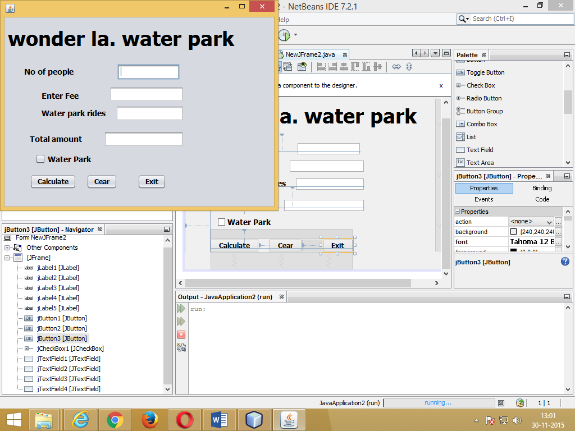
Help him to write code for the following : 3
- On the click of command button ‘Calculate’, textfield for ‘Entry Fees’ should display Entry Fees per person  Number of people. If ‘Water Park’ checkbox is selected, textfield for ‘Water Park Charges’ should display Water Park Charges per person  Number of people. Textfield for ‘Total Amount’ should display sum of Entry Fees and Water Park Charges for all the people in the group.
(ii) Write Java code to clear all Textboxes on the click of ‘Clear’ button. 1
(iii) Write Java code to close the application on the click of ‘Exit’ button. 1
g) Explain term OOPS. 1
h) Differentiate class and object. 1
Q5. Answer the following questions
- Differentiate between order by and group by clause ,to justify the answer write sql query 2
- Answer the questions based on the table Apartment given below: 8
Table: Apartment
Column Name Data Type Size Constraint
Ap_No int (4) PRIMARY KEY
Ap_Category CHAR (1) default ‘s’
Pur_Name VARCHAR 30
Cost decimal
Dt_Sold DATE
- Write the SQL command to create table Apartment including the constraints.
- Write the SQL command to display the category and number of apartments in each category.
- Increase the apartment cost by 5%
- Add new column dt_cancel as date type.
v) Display the details of apartment whose cost greater than 10 lakhs and ap_category is “luxuries”
- Display the names of those purchaser names whose name start with letter ‘p’ in ascending order.
- Apply concat(), left() function in above table.
- Delete the above table if exist.
Q6. Answer the following questions
- Observe the given two tables:-
Table:- Student
Scholarno | Name | Class | Sec | rollno | Address | MOBILENO
101 | Aashish | 12 | A | 1 | B-14 | 9222222390
102 | Ravina | 11 | B | 19 | G-13 | 921222296
103 | Gunjan | 12 | C | 11 | Null | 9333222345
104 | Amit | 10 | A | 2 | AS-13 | 9123472345
105 | Samay | 12 | B | 26 | A1-17 | 9999992345
106 | Vijay | 11 | C | 39 | Null | 9777772345
TABLE:- SPORTS
Scholarno | Game | Coachname | Grade
106 | Cricket | Mr. Ravi | A
105 | volleyBall | Ms. Chandan | A
101 | VolleyBall | Mr. Govardhan | B
102 | Basket Ball | Mr. Tewani | B
103 | Tennis | Mr. Goverdhan | A
Write SQL queries for the following:-
- To display Name, class from students table and the corresponding Grade from Sports tables. 2
- To display the details of students along with their coach name in ascending order of Game. 2
- To count how many addresses are not having Null values in their address column of STUDENT TABLE?1
- Identify the Primary key and foreign key in above tables. 2
- After cross join and natural join find the degree and cardinality of above tables. 2
- What is relation? What is the difference between tuple & attribute? 1
Q7. Answer the following questions
a) Explain the benefits of E- Governance for common man. Give a domain name for it? 2
b) Give two addresses of E-Learning sites? 1
c) Mr Roy works for A MNC. He wants to create controls on a form for the following
Operations. Choose appropriate controls from Text box, Label, Radio Button, List box, Combo box, Check box and Command button. 2
S.NO | FUNCTION | CONTROL USED
1. | Enter AGE of Employee
2. | To allow selecting one or many food item
3. | To allow entering feedback in the form of a paragraph
4. | To allow to Input grade out of ‘A’ to ‘D’

Mrs. sangeeta asnani a
panjwani_sangeeta@rediffmail.com

